CONTENT

**1. AGENT**

**1.1. Agent signs up**

**1.2. Steps to sign up**

**1.3. Activation of agent account from admin panel**

**1.4. Agent login**

**2. B2B Dashboard**

**2.1. Before booking**

**2.2. After booking**

**3. Profile**

**4. Settings**

**4.1. Markup**

**4.2. Before adding the markup**

**4.3. Steps to add the markup**

**4.4. After adding markup**

**4.4.1. Change the password in agent dashboard**

**4.4.2. Cancel Account**

**5. Deposit**

**5.1. Steps to add the deposit**

**5.2. Approve deposit amount from admin panel**

**6. Control panel**

**6.1. B2B, B2C user**

**6.2. Markup Management**

**6.3. Booking report**

**6.4. Manage Home page**

**6.5. CMS (social link)**

**7. Flight**

**7.1. Search flight**

**7.2. Markup**

**7.3. Markup for B2B Flight**

**7.4. Before adding the Markup for flight Admin panel (B2B)**

**7.5. Front End without adding markup (B2B)**

**7.6. Steps to add markup for Flight (B2B) Admin panel**

**7.7. Markup list admin panel for B2B**

**7.8.** **Front end with Markup (B2B)**

**7.9. Activation and Inactivation for markup**

**7.9.1. Booking for Flight (B2B)**

**7.9.2. Voucher page for Flight (B2B)**

**8. HOTEL**

**8.1. Search hotel**

**8.2. Hotel displayed on front end**

**8.3. MARKUP for Hotel (B2B)**

**8.4. Before adding the Markup for Hotel Admin panel (B2B)**

**8.5. Front End without adding markup (B2B)**

**8.6. Steps to add markup for hotel (Admin panel)**

**8.7. Markup list admin panel for B2B**

**8.8. Front end with Markup (B2B)**

**8.9. Activation and Inactivation for markup**

**8.9.1. Booking for Hotel (B2B)**

**8.9.2. Voucher page for Hotel (B2C)**

**9. CAR**

**9.1. Search car**

**9.2. Car displayed on Front End**

**9.3. Active and Inactive for car**

**9.4. MARKUP for Car**

**9.5. Before adding the Markup for car**

**9.6. Add markup step by step**

**9.7. There are two types of markup value**

**9.8. Front End without adding markup (B2B)**

**9.9. Markup list in admin panel for B2B**

**9.9.1. Front end with Markup (B2B)**

**9.9.2. Activation and Inactivation for markup**

**9.9.3. Booking for Car**

**9.9.4. Voucher page**

**10. BUNDLE DEALS**

**10. BUNDLE DEALS**

**10.1. Before adding bundle deals**

**10.2. Steps to add bundle deals (Flight+Hotel+Car)**

**10.3. Flight segment Management**

**10.4. Before adding segment**

**10.5. Steps to add flight segment**

**10.6. After adding segment**

**10.7. Add Bundle Flight Pricing Management**

**10.8. Before adding the price**

**10.9. Steps to add the price**

**10.9.1. Add/View Room type**

**10.9.2. Before adding room type**

**10.9.3. Steps to add the room type**

**10.9.4. After adding room type**

**10.9.5. Room Management (Add new room)**

**10.9.6. Before adding room**

**10.9.7**. **Steps to add the new room**

**10.9.8. After adding the new room**

**10.9.9. Gallery management**

**11. before adding gallery**

**11.1. Steps to add the gallery**

**11.2**. **After uploading**

**11.3. Car Pricing**

**11.4. Before adding car pricing**

**11.5. Steps to add car price**

**11.6. Created bundle deal (B2B)**

**11.7. Front End (B2B)**

**11.8. Booking Page (B2B)**

**11.9. Voucher Page (B2B)**

**11.9.1. MARKUP for Bundle deals (B2B)**

**11.9.2. Markup for B2B Bundle deal**

**11.9.3. Before adding the Markup for bundle Admin panel (B2B)**

**11.9.4. Front End without adding markup (B2B)**

**11.9.5. Steps to add markup for bundle (B2B) Admin panel**

**11.9.6. Markup list admin panel for B2B**

**11.9.7. Front end with Markup (B2B)**

**11.9.8. Activation and Inactivation for markup (B2B)**

**12. (Flight Hotel)**

**12.1. Flight segment Management**

**12.2. Add Bundle Flight Price Management**

**12.3. Add/View Room type**

**12.4. Room Management (Add New Room)**

**12.5. Gallery management**

**12.6. Created bundle deals**

**12.7. Front End**

**12.8. Booking Page**

**12.9. Voucher Page**

**12.9.1. Without Markup Bundle deals (B2B), (Hotel Flight)**

**12.9.2. Add Markup from Admin panel for bundle deals (B2B)**

**12.9.3. With Markup Bundle deals (B2B), (Hotel Flight)**

**13. (Hotel Car)**

**13.1. Add/View Room type**

**13.2. Room management (add room)**

**13.3. Gallery management**

**13.4. Car Pricing**

**13.5. Created bundle deals (Hotel Car)**

**13.6. Front End**

**13.7. Booking Page**

**13.8. Voucher Page**

**13.9**. **Without Markup Bundle deals (B2B), (Hotel Car)**

**13.9.1. Add Markup from Admin panel for bundle deals (B2B)**

**13.9.2. Add Markup from Admin panel for bundle deals (B2B)**

**14. BOOKINGS (Agent dashboard)**

**14.1. Check flight booking**

**14.2. Check hotel booking**

**15. White label**

**16. Booking Statement**

**___________________________________________________________________**

**1) AGENT:**

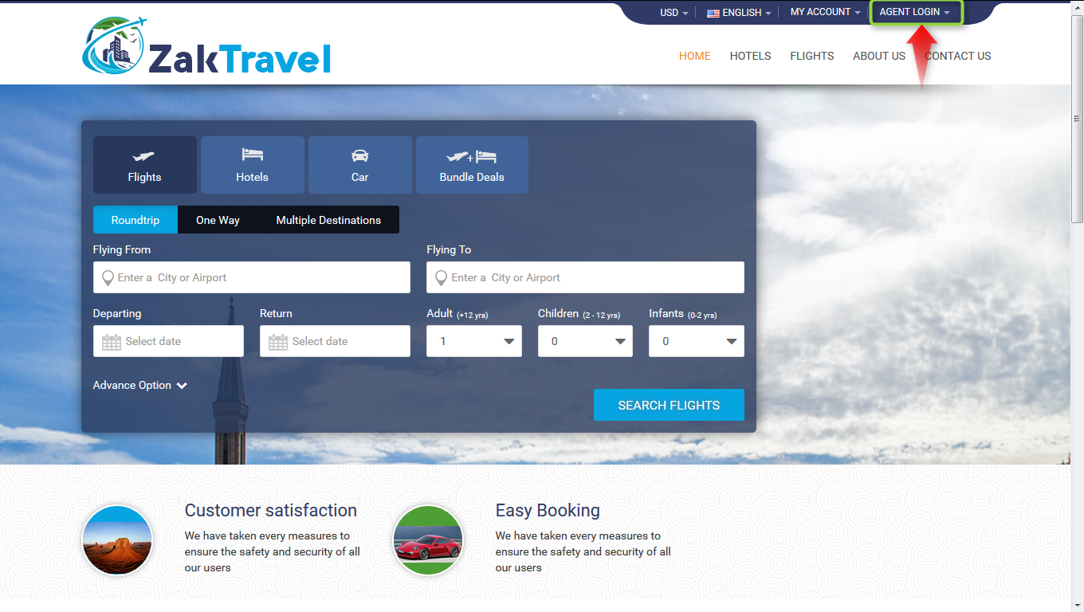

* 1. **Agent signs up:** Agent can sign up from front end and the email address that agent has given at the time of sign up it will display in Admin list (B2B user management). And admin have to activate that email address after that Agent will be able to login.
  2. **Steps to sign up :** Click onAgent login now click on sign upand enter the name, email address ,password, select the country, enter the city name and click on sign up.

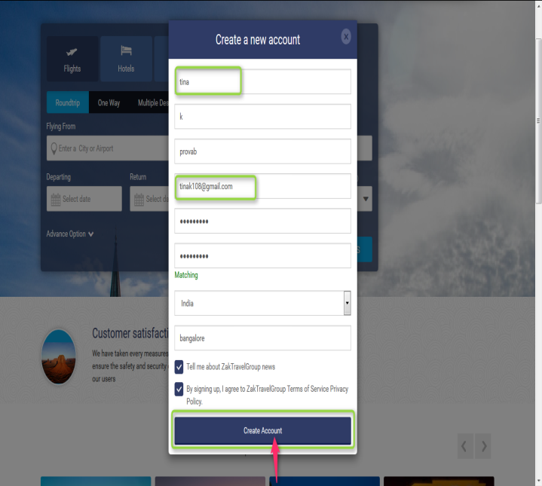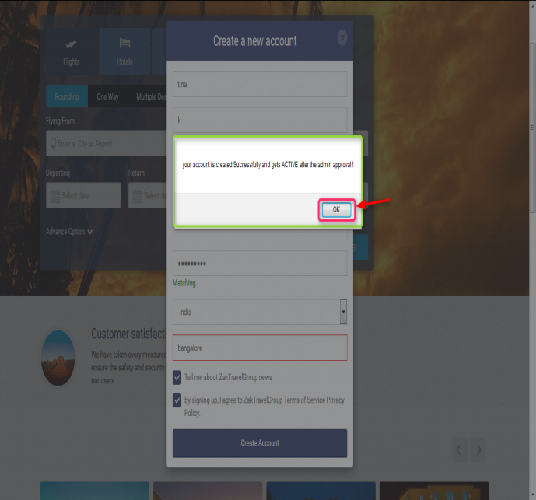

* 1. **Activation of agent account from admin panel:** After signing up for agentthe email address that agent has given at the time of sign up it will display in Admin list (B2B user management). And admin have to activate that email address after that Agent will be able to login.

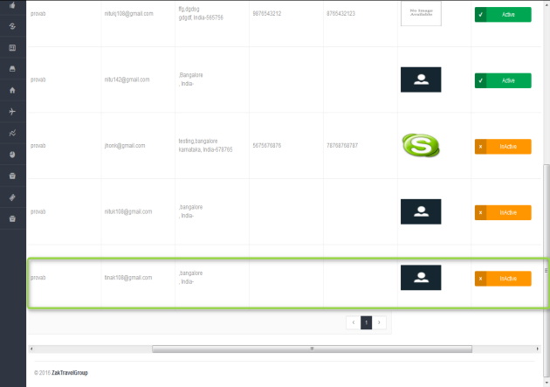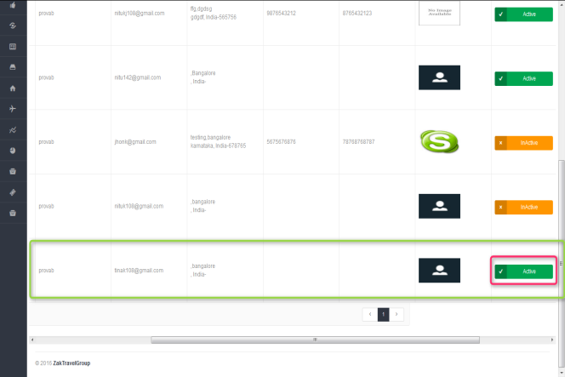

* 1. **Agent login:** After activation the account agent can be login using the same credential.

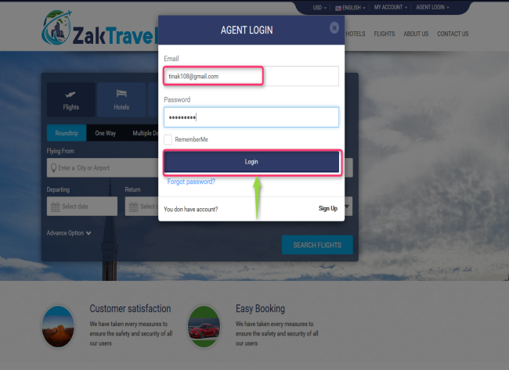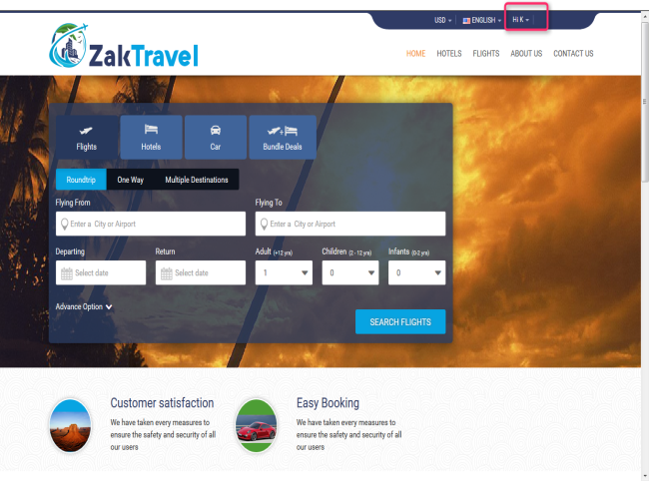

1. **B2B Dashboard:** The B2B agent can login using his credentials to view the dashboard, where he can able to maintain or edit his complete personal details and booking details...- After Login Go to header menu select “agent name->dashboard “to see the B2B dashboard. In dashboard home agent can see the progress of his booking and overall status.

**2.1. Before booking:** Status of booked flight, hotel, car, and bundle will be displayed 0

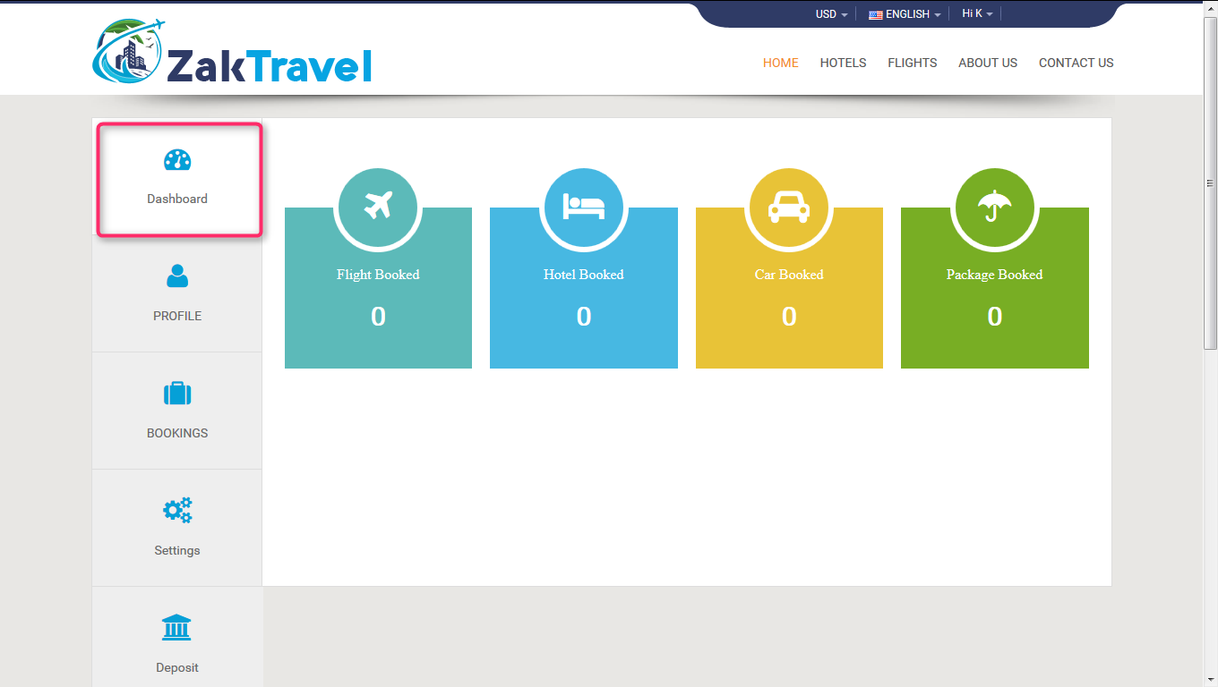

**2.2. After booking:** Status will display how many bookings have been done.

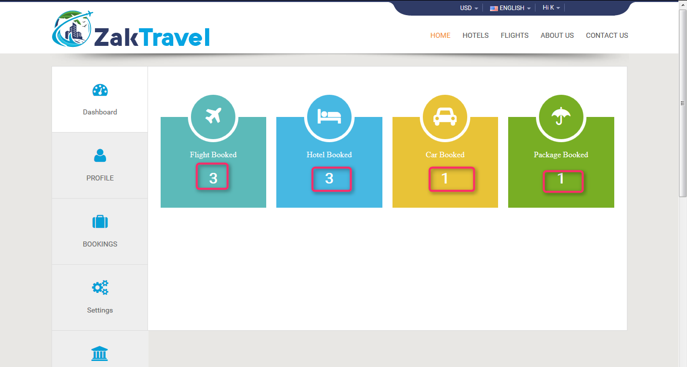

Profile page where Agent can edit the personal details. Bookings page shows all booking details with respect to each module.

**3. Profile:** Agent is able to edit there profile.

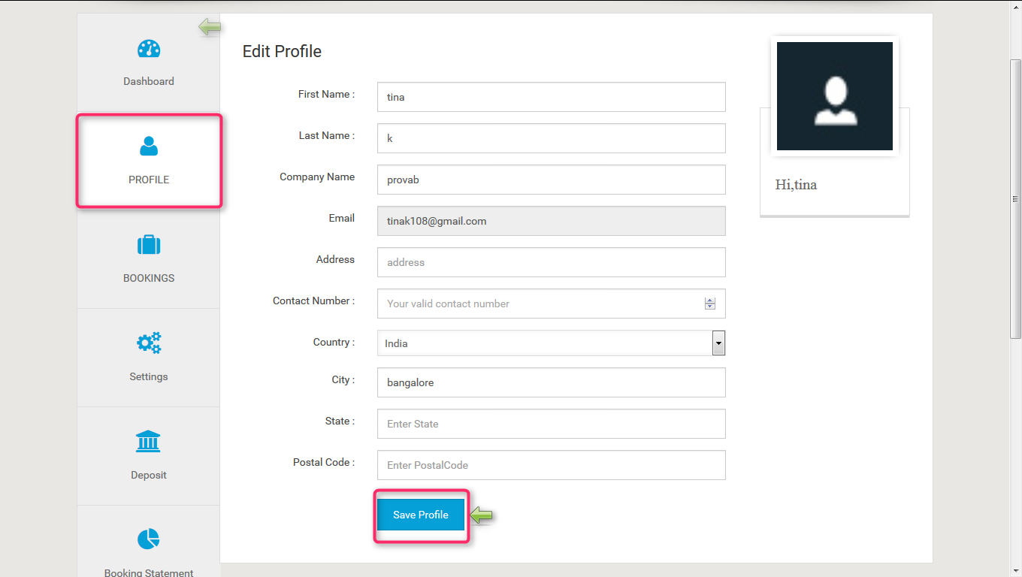

**4. Settings:** In Settings agent can create and update his mark up .They can Change His password.

They can deactivate the Account. White label is to set up own domain.

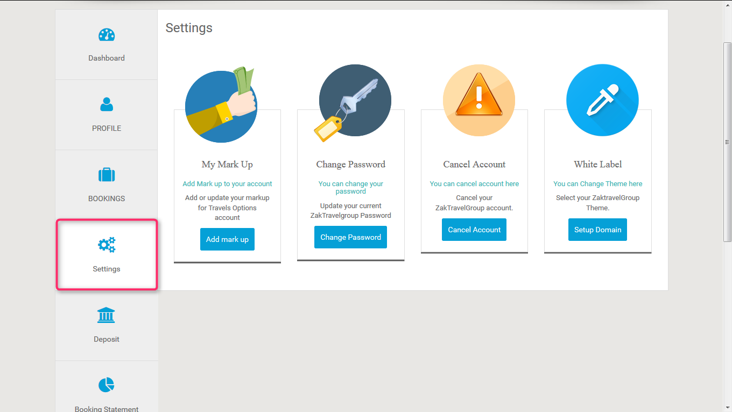

**4.1. Markup:** Here admin can add the markup and added markup will be displayed with total fare on front end.

**4.2. Before adding the markup:**

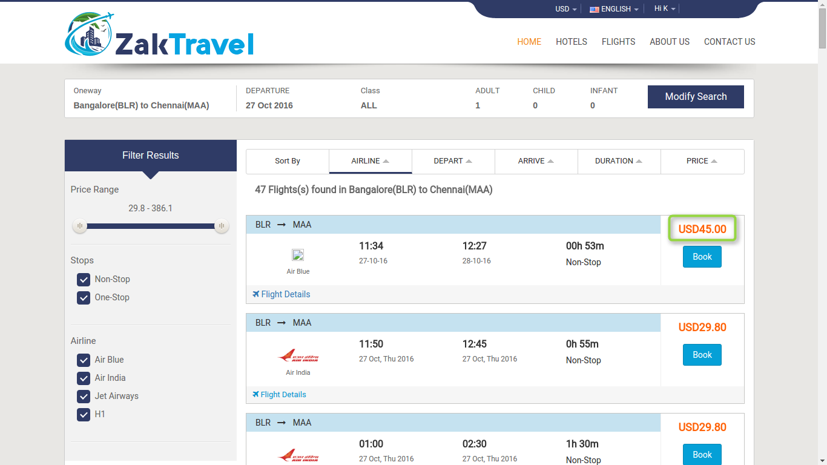

**4.3. Steps to add the markup:** Now go to the setting in admin dashboard click on add markup tab, select the Markup Value Type in flight and enter the Markup Value.

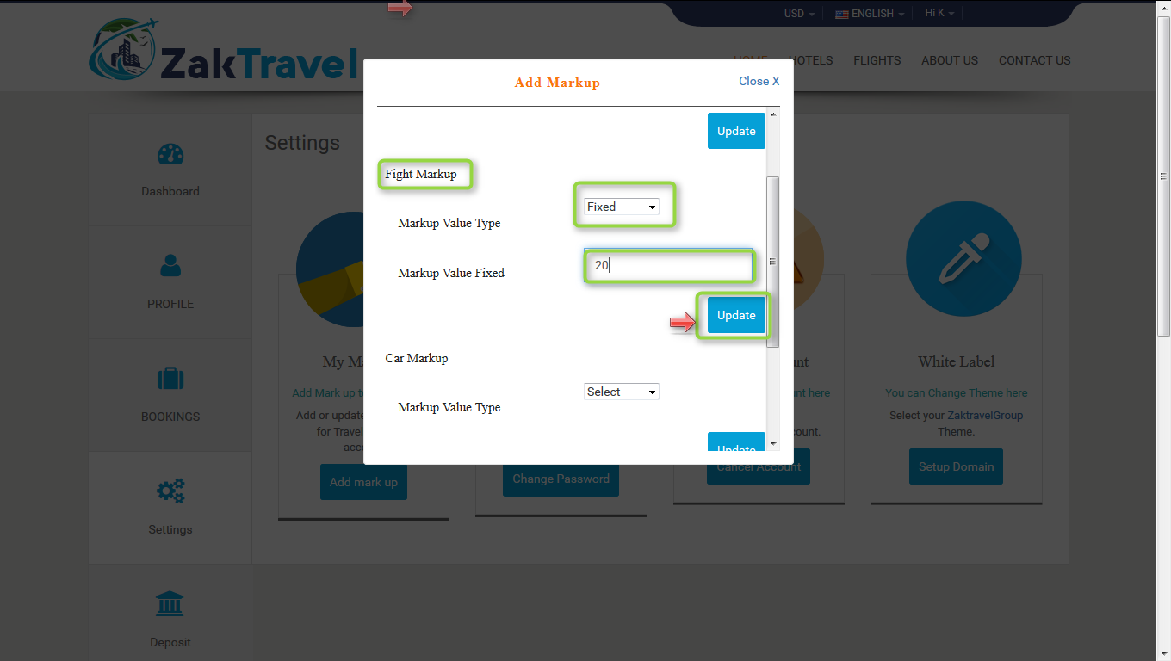

**4.4. After adding markup:** Markup will be added with total fare and displayed on front end.

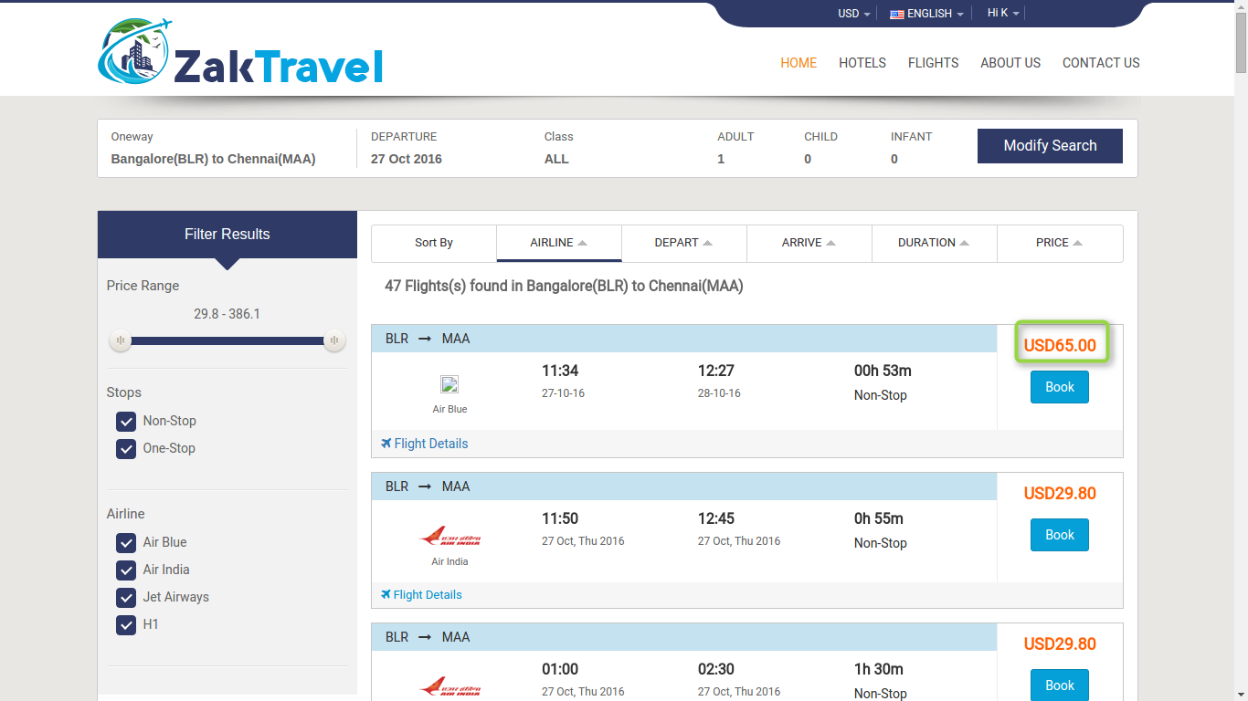

After and before adding the markup in fare rules.

**Before After**

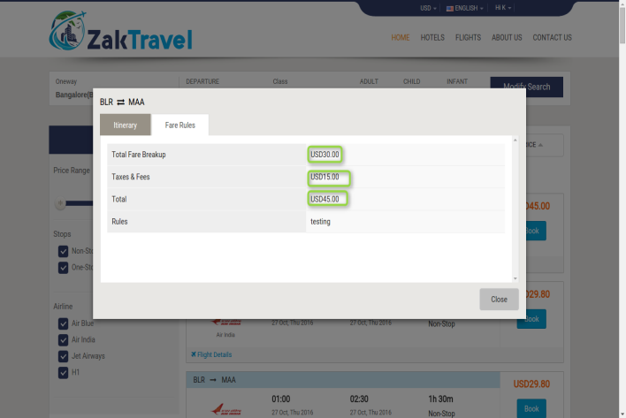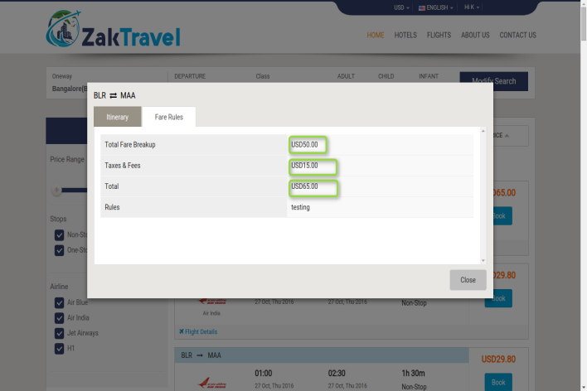

**4.4.1. Change the password in agent dashboard:** Here agent can change their account password and can login with the current (Changed) password.

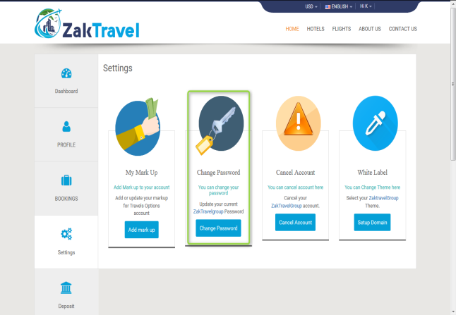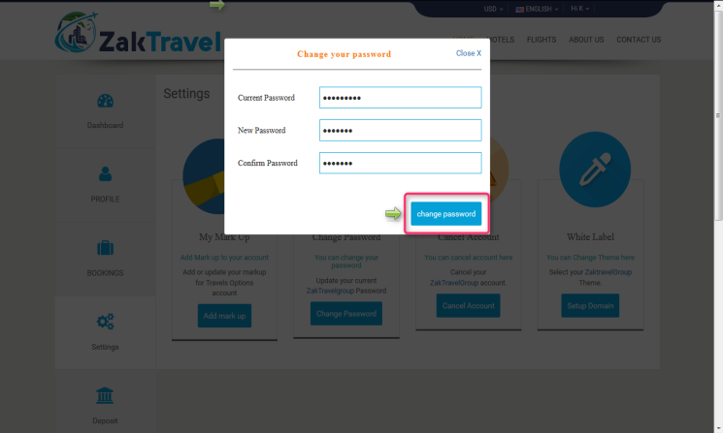

### 4.4.2. Cancel Account: Agent can cancel their account and after cancelling the account agent can’t be able to login again.

### 42.png43.png

**5. Deposit:** Agent can add the deposit, once they have added the deposit here, it will be in pending status so that agent can't use the amount until the admin approves and admin has to change the status as accept or approve .after booking the total amount will be deducted from this deposit.

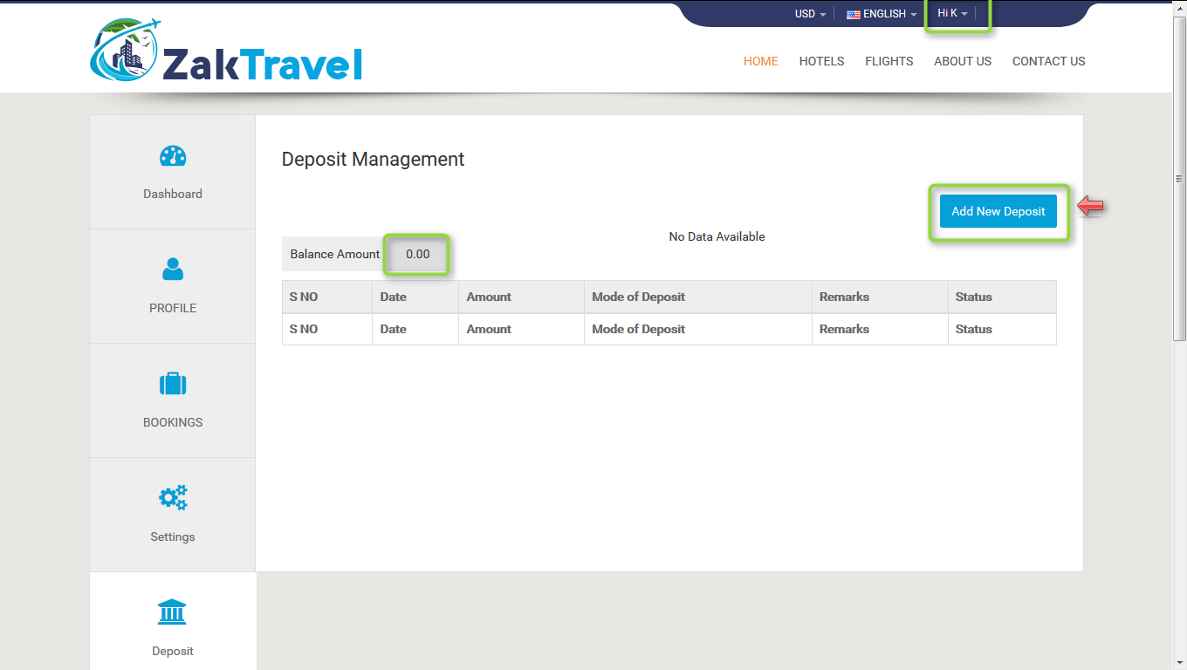

**5.1. Steps to add the deposit:** Click on add new deposit enter deposit amount, choose the date, mode of deposit and click on add amount now conformation popup will be displayed and click ok.

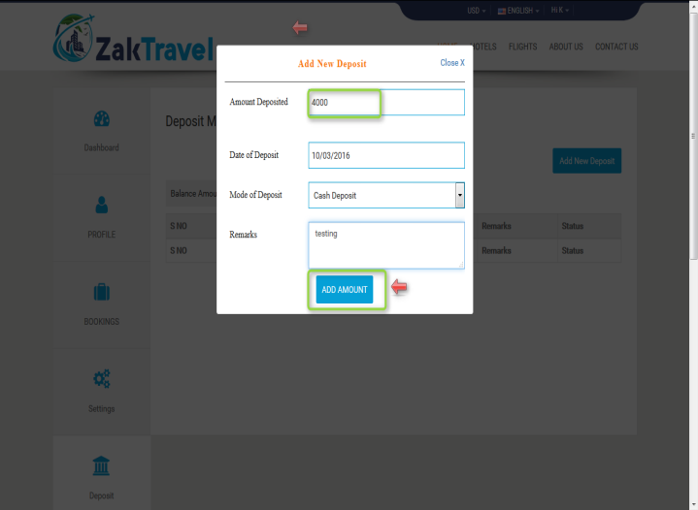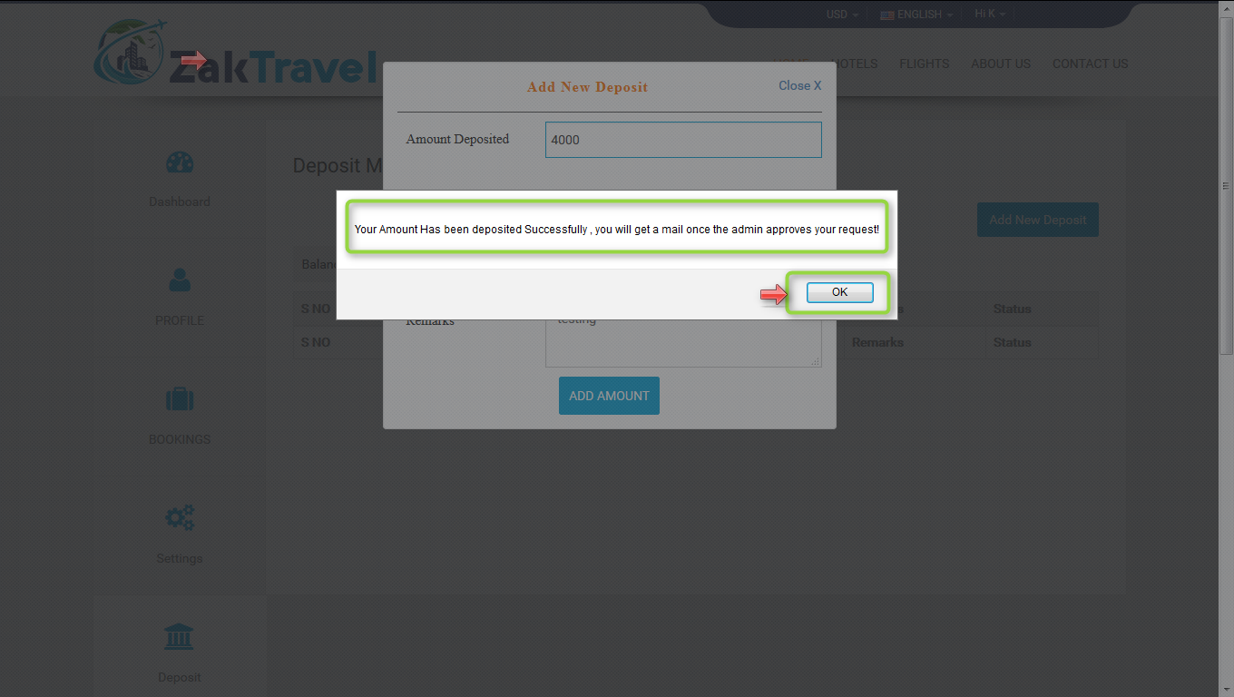

**5.2. Approve deposit amount from admin panel:** Go to the admin panel click on B2B user list and click on deposit in that click on the approve action.

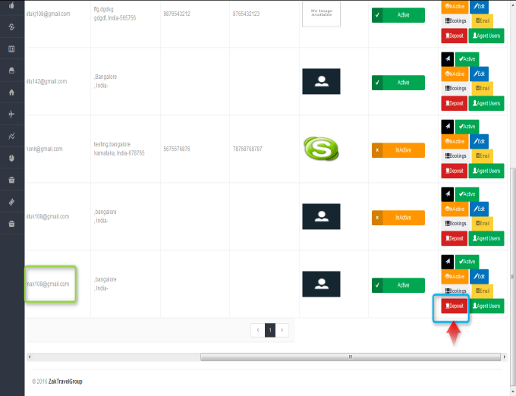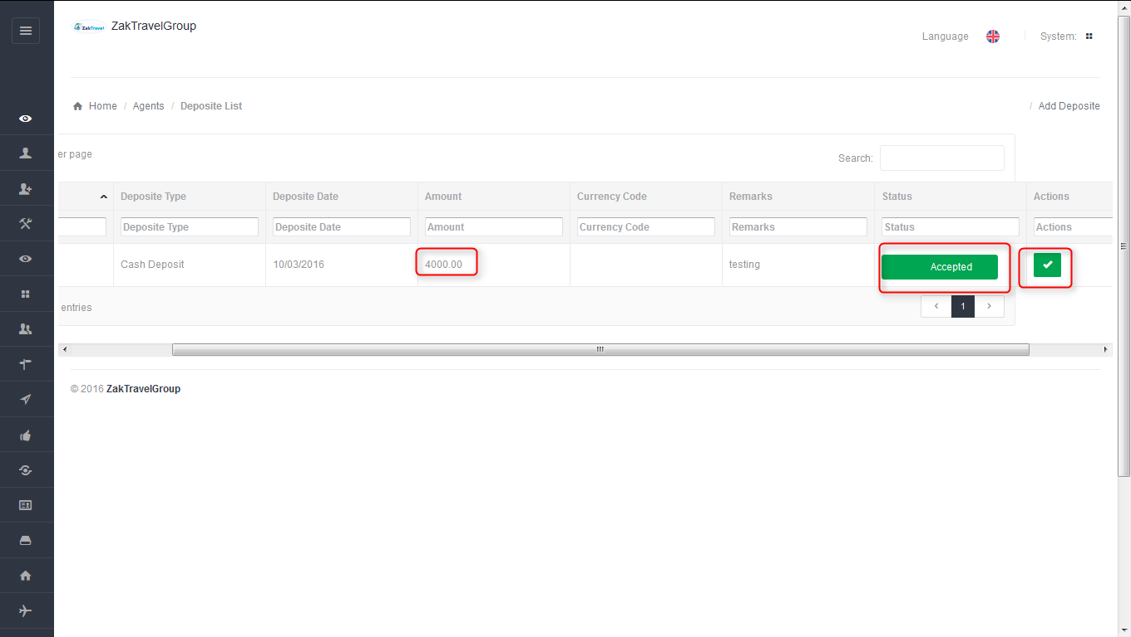

Before and after changing the agent status from admin panel.

**Before After**

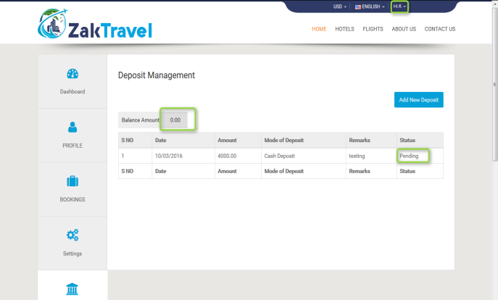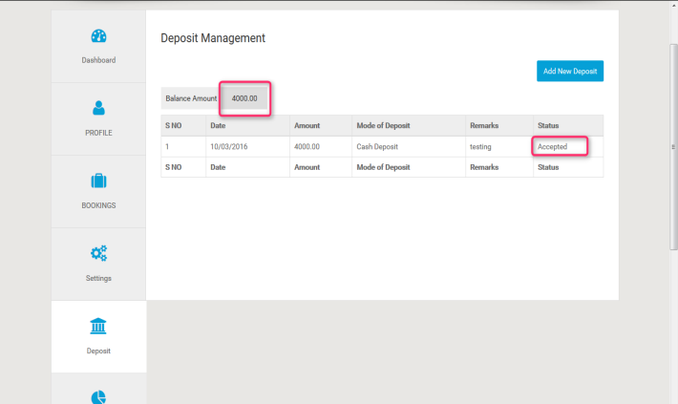

**6. Control panel:**

From control panel agent can manage all the white label things, for that they should have to create his domain in here Settings-> setup domain, Temporary update gives the option to the agent to view the changes made by them clicking the preview. Permanent update will make the site live.

Once the Domain is setup it will run under the host website (parent website)

**6.1. B2B, B2C user:** Here agent can see how many B2B, B2C user has been added and that user will be display after creating the account.

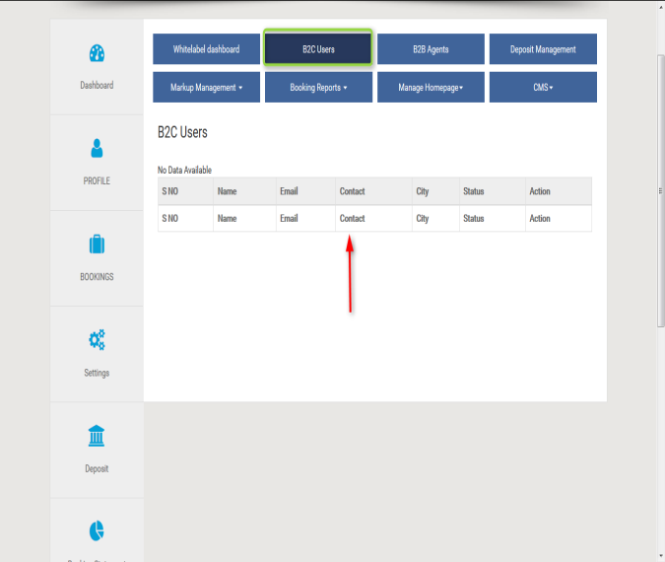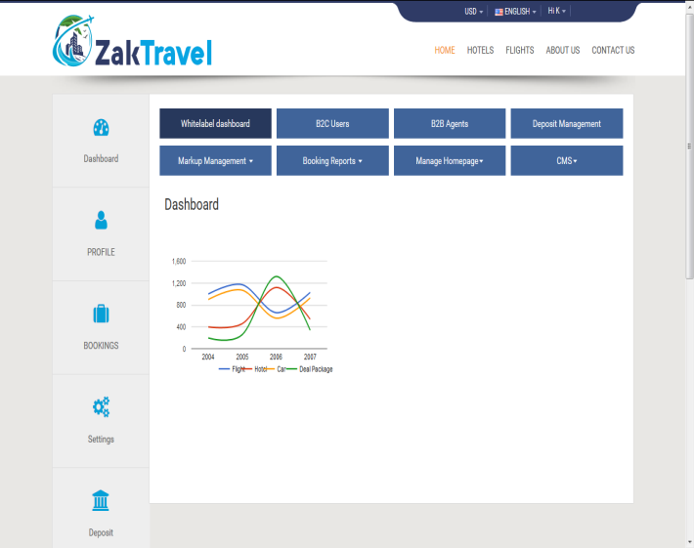

**6.2. Markup Management:** Here agent can add the markup for B2B2B, B2B2C and that added markup will be added with the total fare and will be displayed in the list in agent panel.

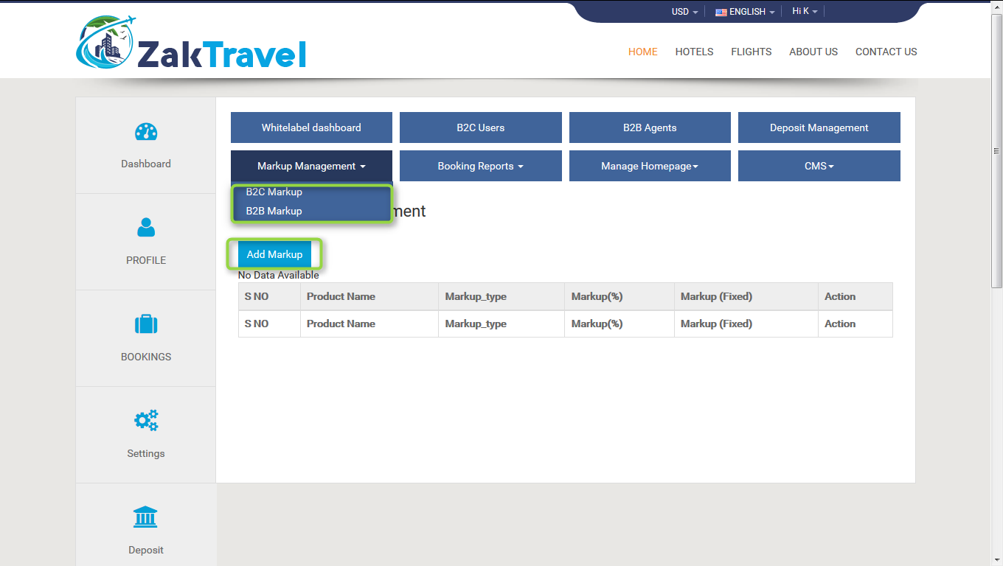

**6.3. Booking report:** Here agent can see how many bookings have been done for flight, car, hotel, and bundle and over all booking.

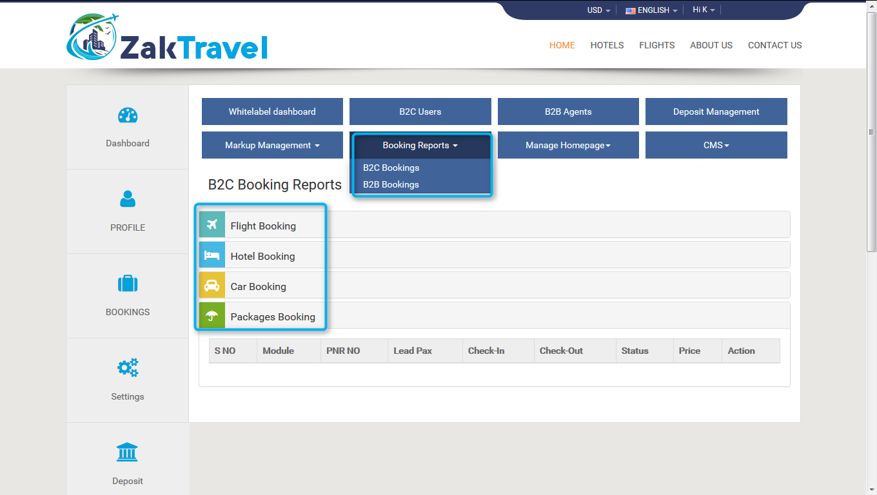

**6.4. Manage Home page:** From here agent can manage the home page like logo, Image banner, Featured hotel, Manage hotel deal, and Manage flight details for B2B2B, B2B2C.

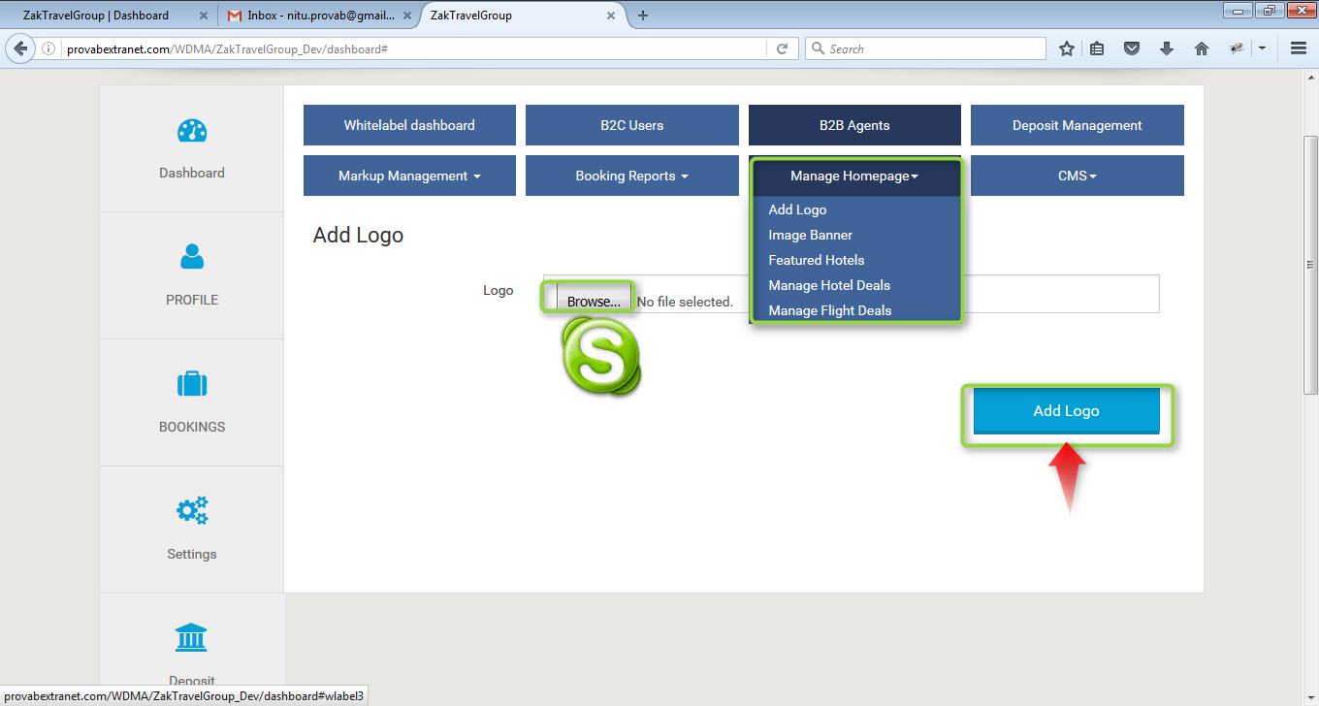

**6.5. CMS (social link):** Agent can add the social link.

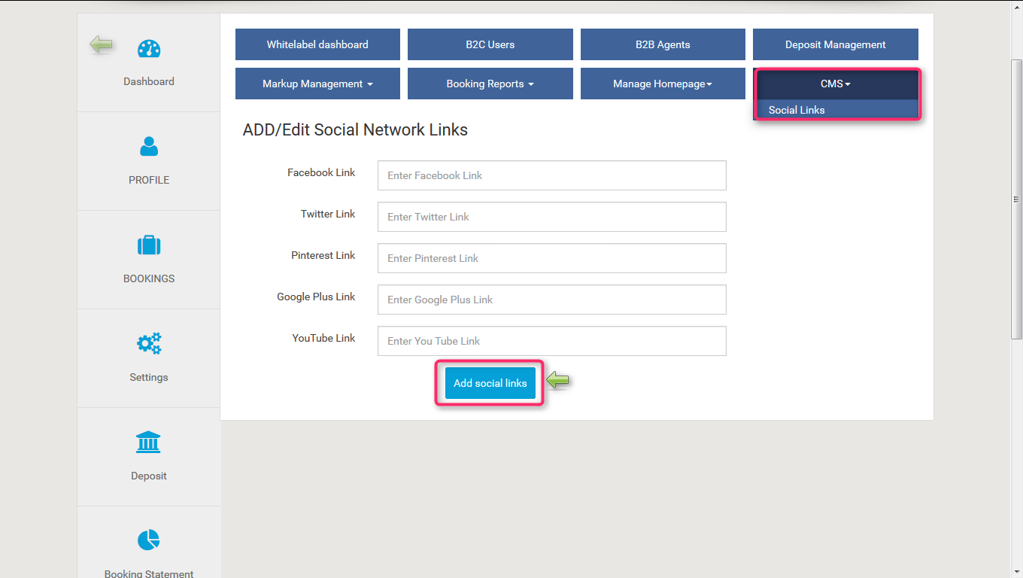

**7. Flight**

**7.1. Search flight:** Enter the flying from and flying to, select the departure time and click on search flight.

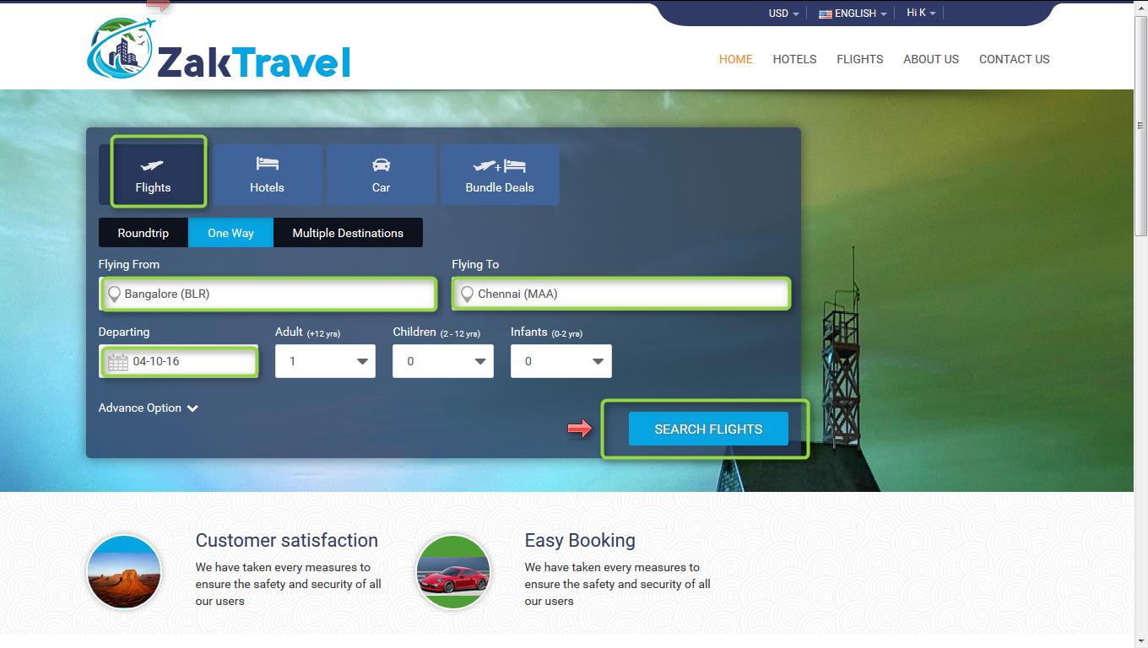

Search result display on front end.

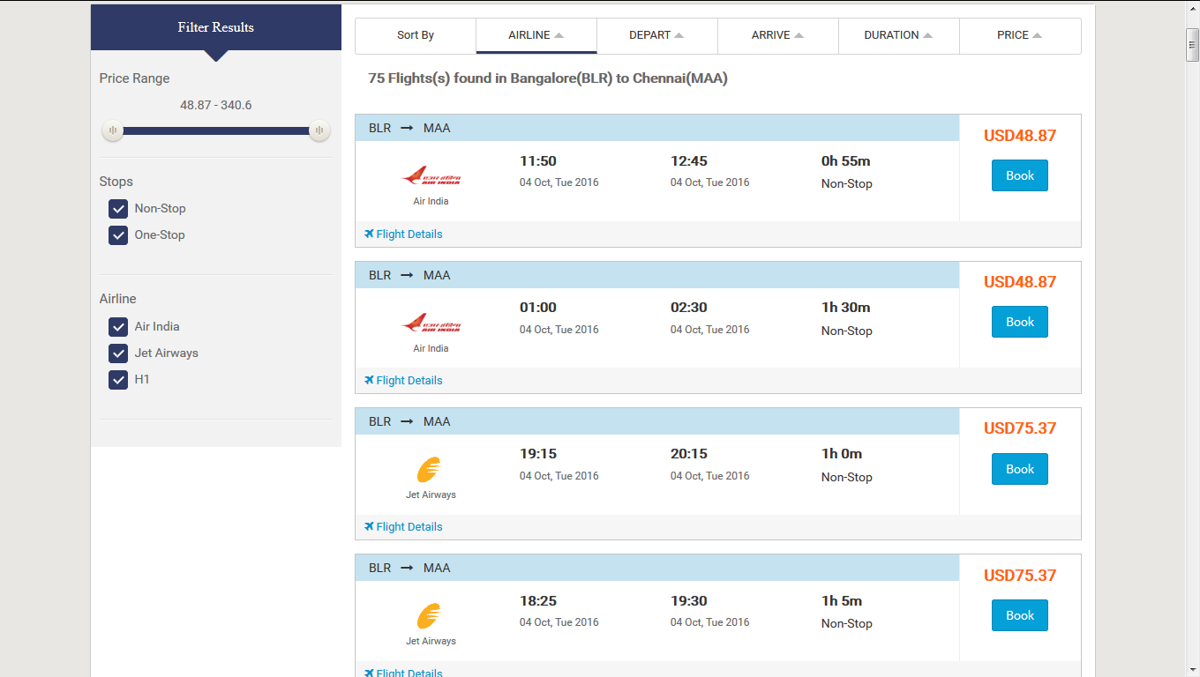

**7.2. Markup:** Markup is added by the Admin, after adding the markup from admin panel the markup will be added with total fare and display on front end.

**7.3. Markup for B2B Flight:**

**7.4. Before adding the Markup for flight Admin panel (B2B):** Markup will not display in the list before adding.

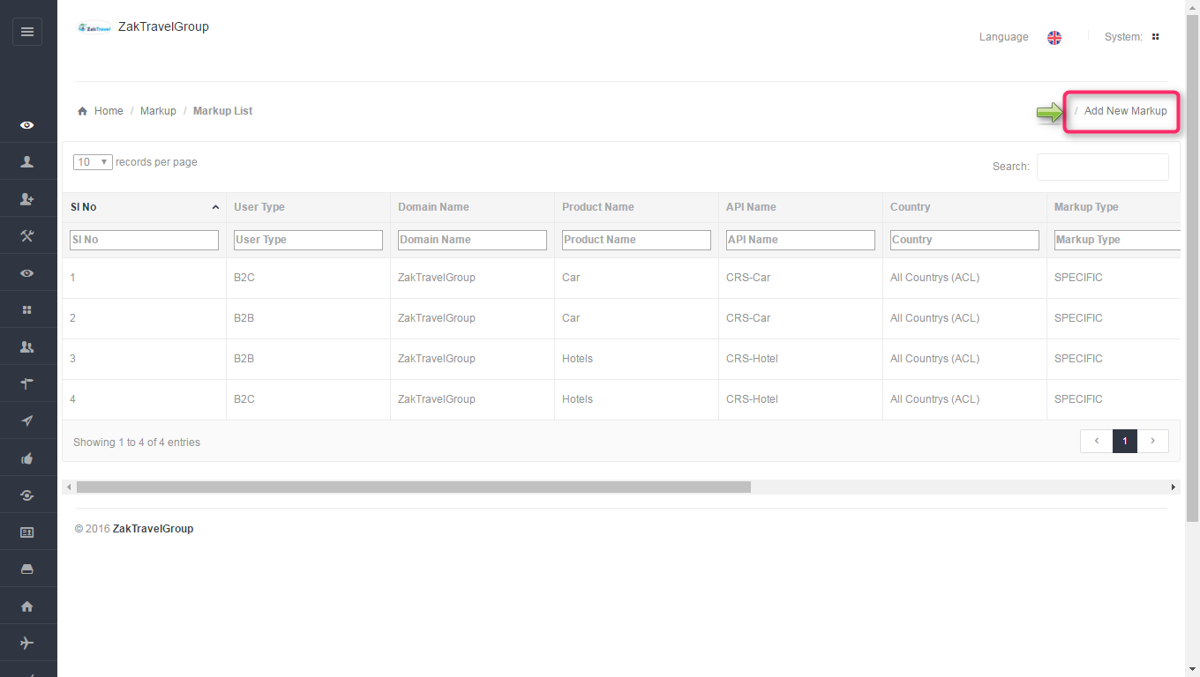

**7.5. Front End Without adding markup (B2B):** For a particular agentthe markup is not added with total fare so whatever the amount is added at the time of rate management that amount will be display only and total fare will display without markup.

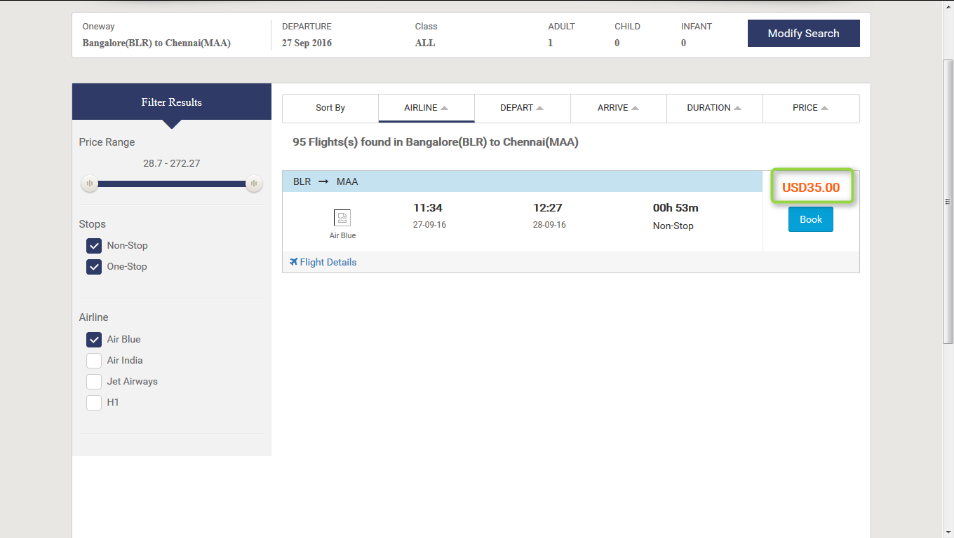

**7.6. Steps to add markup for Flight (B2B) Admin panel:** After click on add markup one form will be displayed and enter all the required information like user type, product, API, and markup value type, etc.

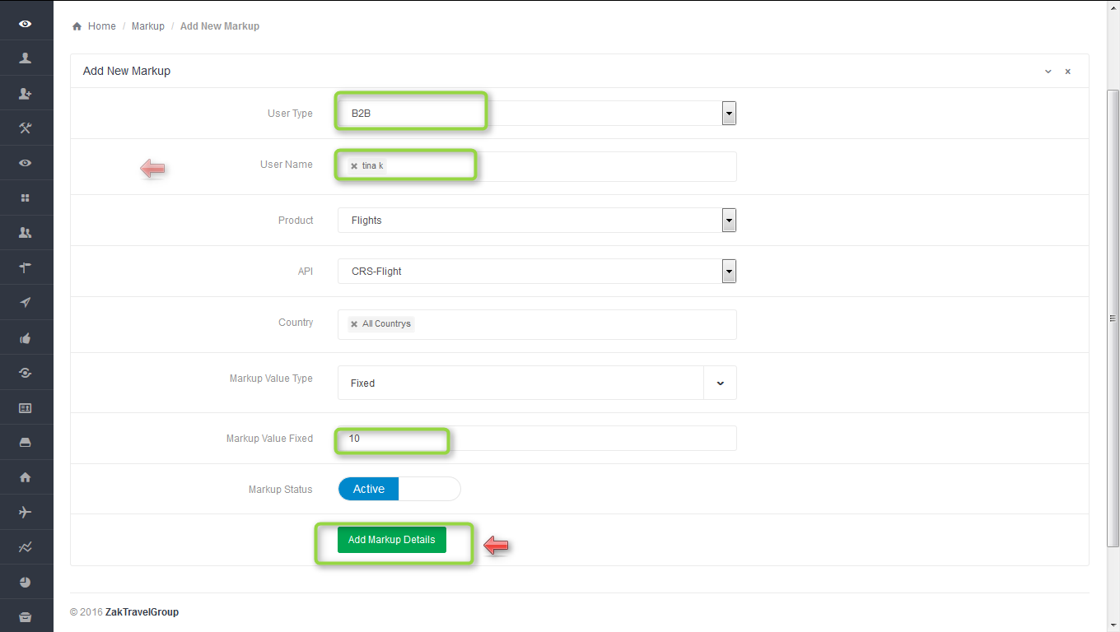

**7.7. Markup list admin panel for B2B**: Here admin add the markup for particular agent , select the user type as B2B , user name means for which agent admin add the markup, product as a Flight, API CRS Flight, country and markup type. After adding the markup will display in the list.

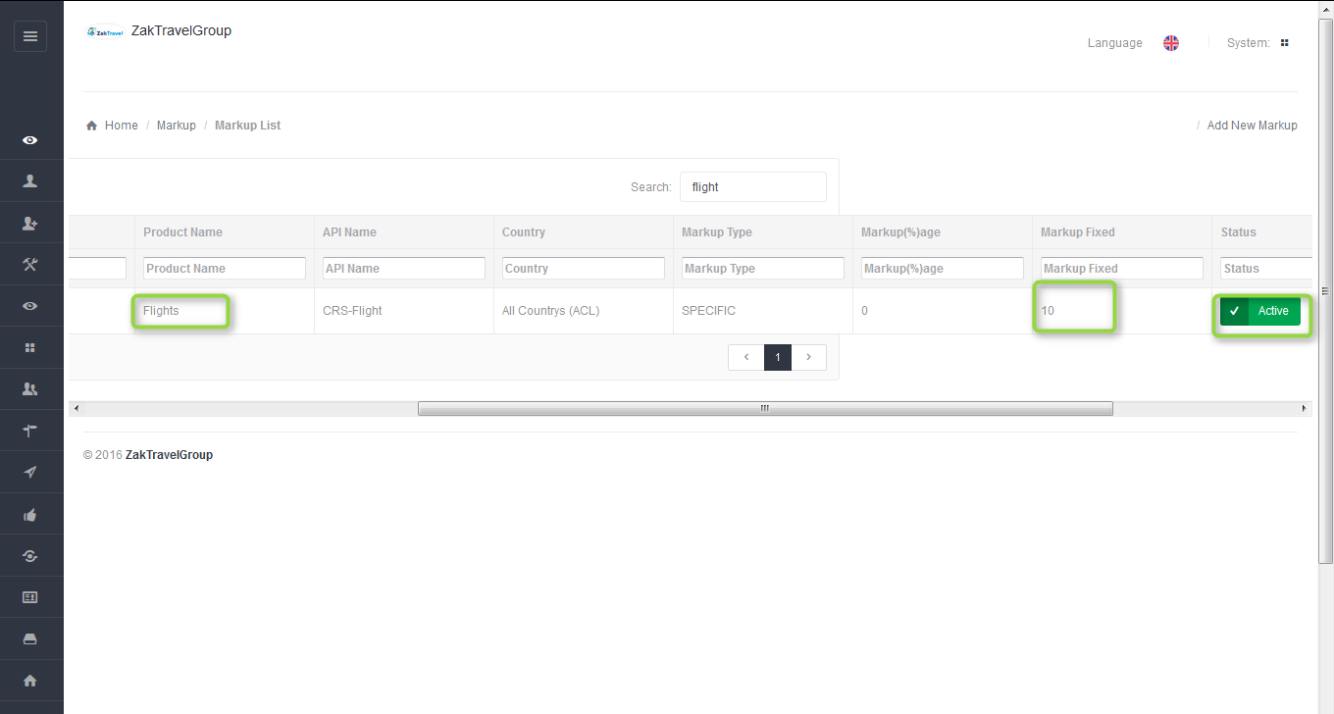

**7.8.** **Front end with Markup (B2B):** Now the added markup will be display with the total fare, for one day the markup added is 10 rupees now and markup will be added according to number of days.

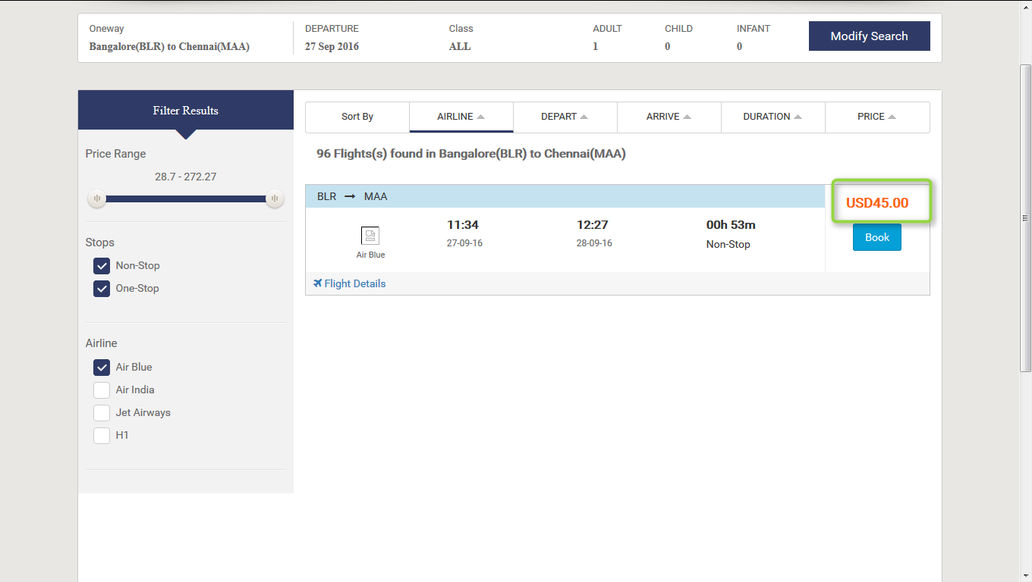

**7.9. Activation and Inactivation for markup:** After click on inactive the markup will not add with the total fare for adding the markup the status should be in active state.

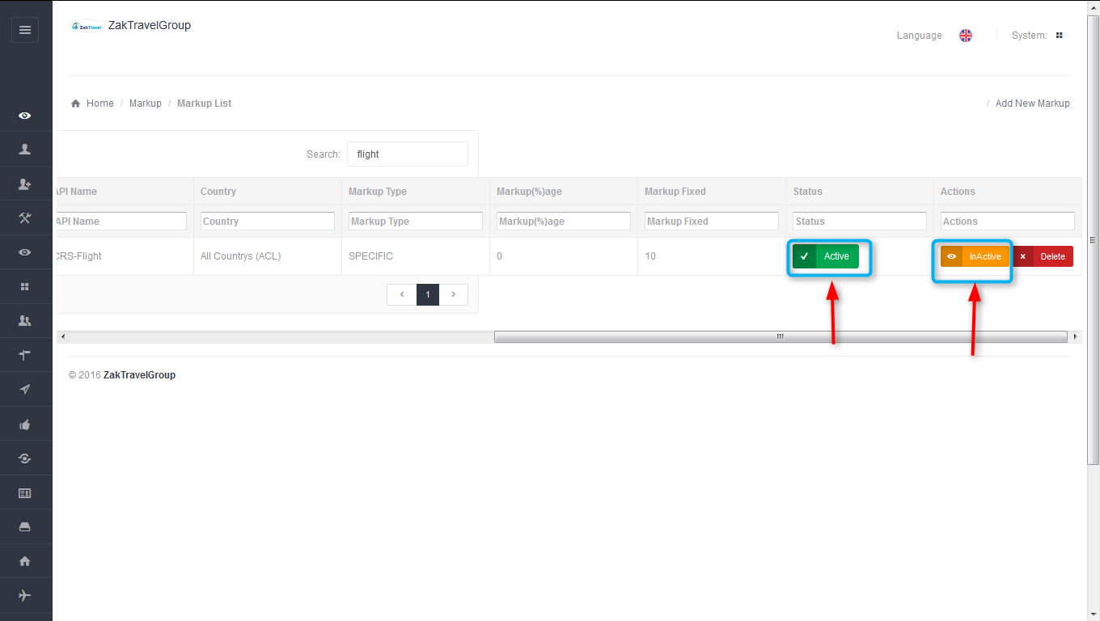

**Active Inactive**

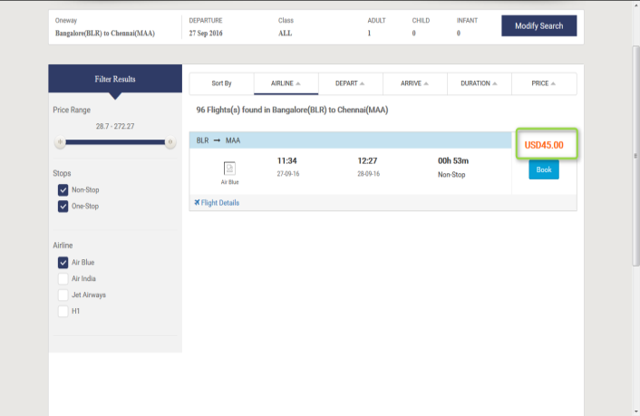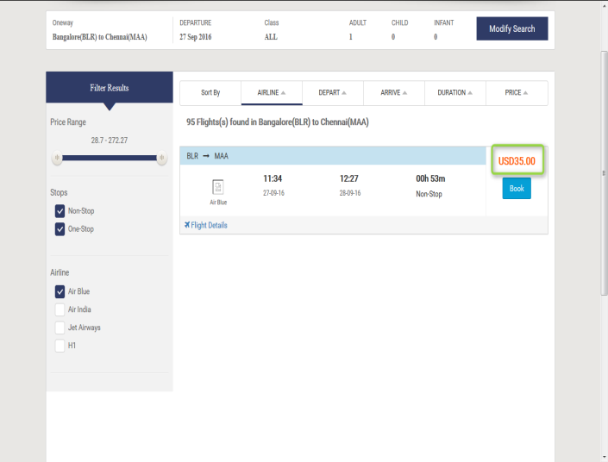

**7.9.1. Booking for Flight (B2B):**

Users can book the particular Flight by providing their personal details. And they will get confirmation letter. Now click on flight tab and provide all the valid detail and search for the Flight.

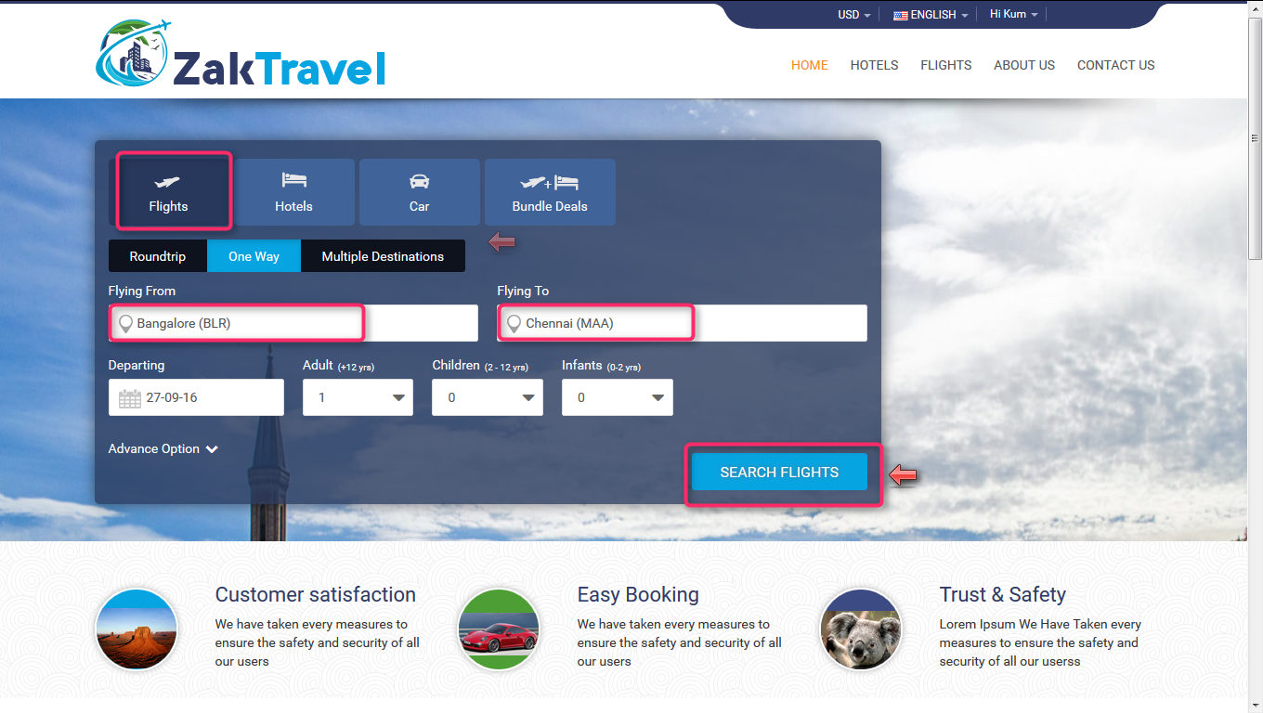

After click on search, the Flight search result will display. So click on Book button for booking the Flight.

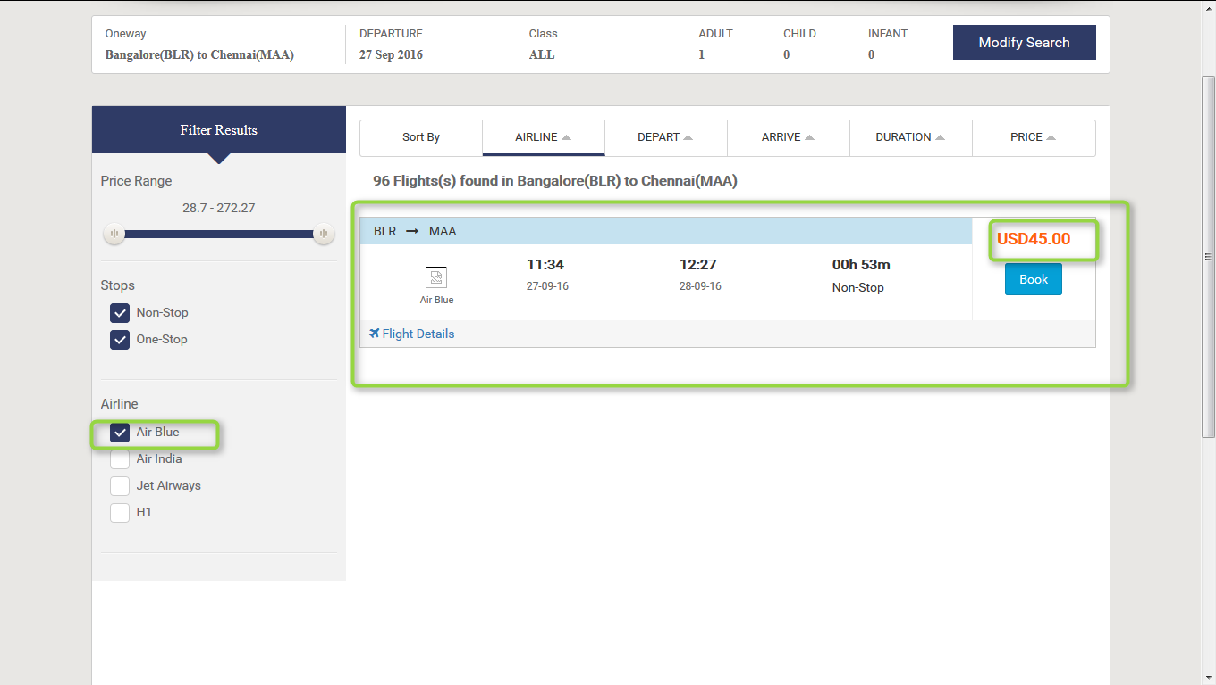

Now after click on book button it will open review, travelers and payment information and click on continue tab it will open the form to enter the personal information. Provide all the valid information and click on continue button and check the check box for terms and conditions.

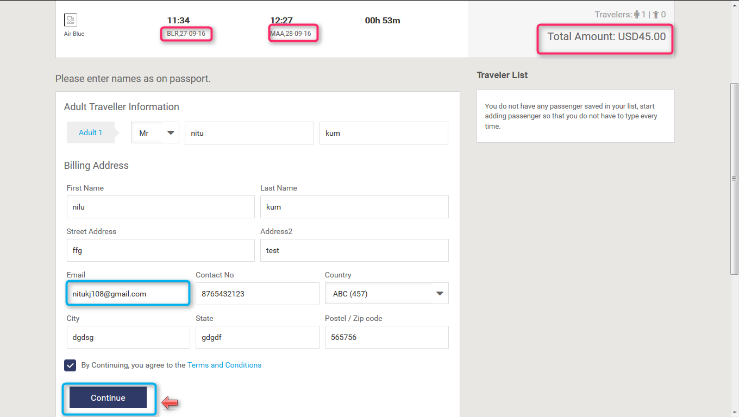

**7.9.2. Voucher page for Flight (B2B)**: Voucher page display after providing all the information and click on continue button and everything will be present on the voucher page like booking status, reservation number, Traveler, date, amount etc.

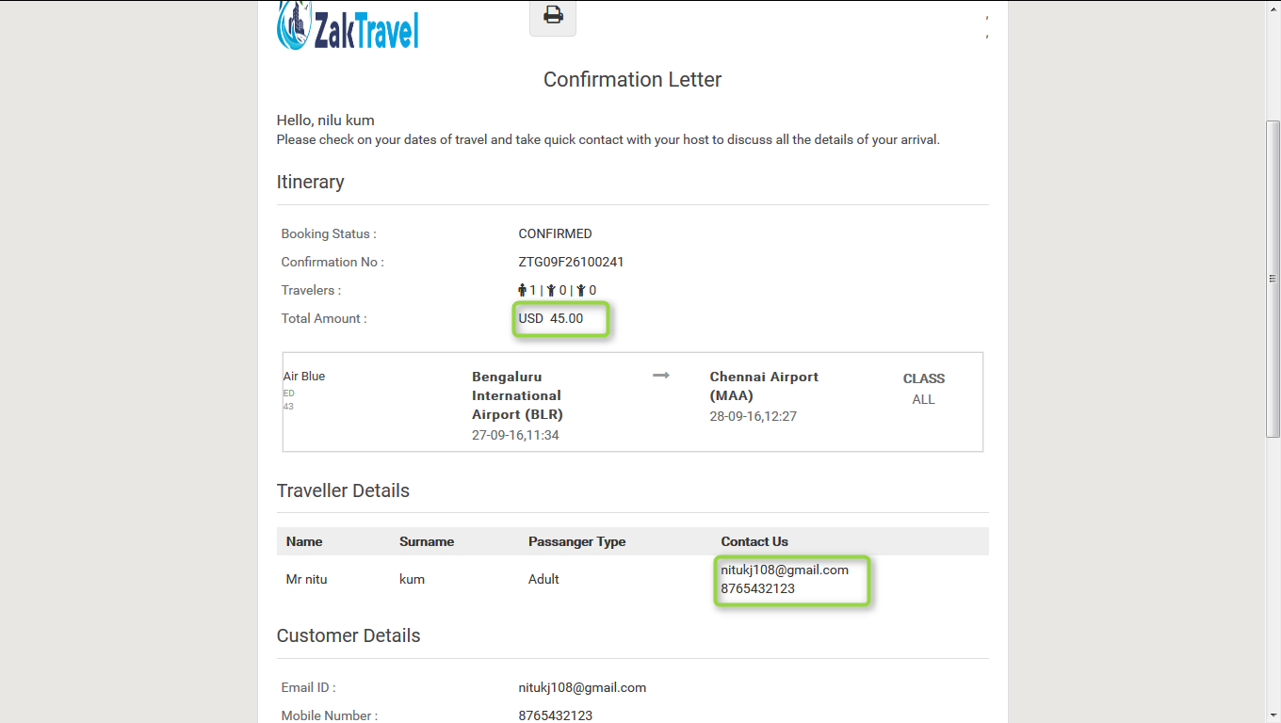

**8. HOTEL**

**8.1. Search hotel:**

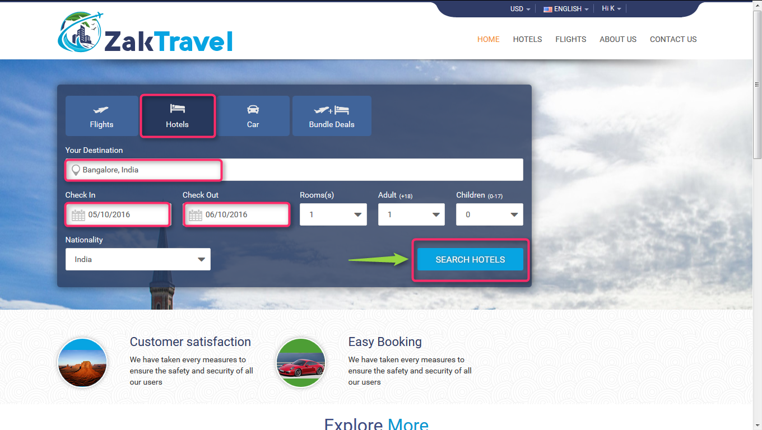

**8.2. Hotel displayed on front end:**  After search the hotel will be displayed on the front end and from where user can book.

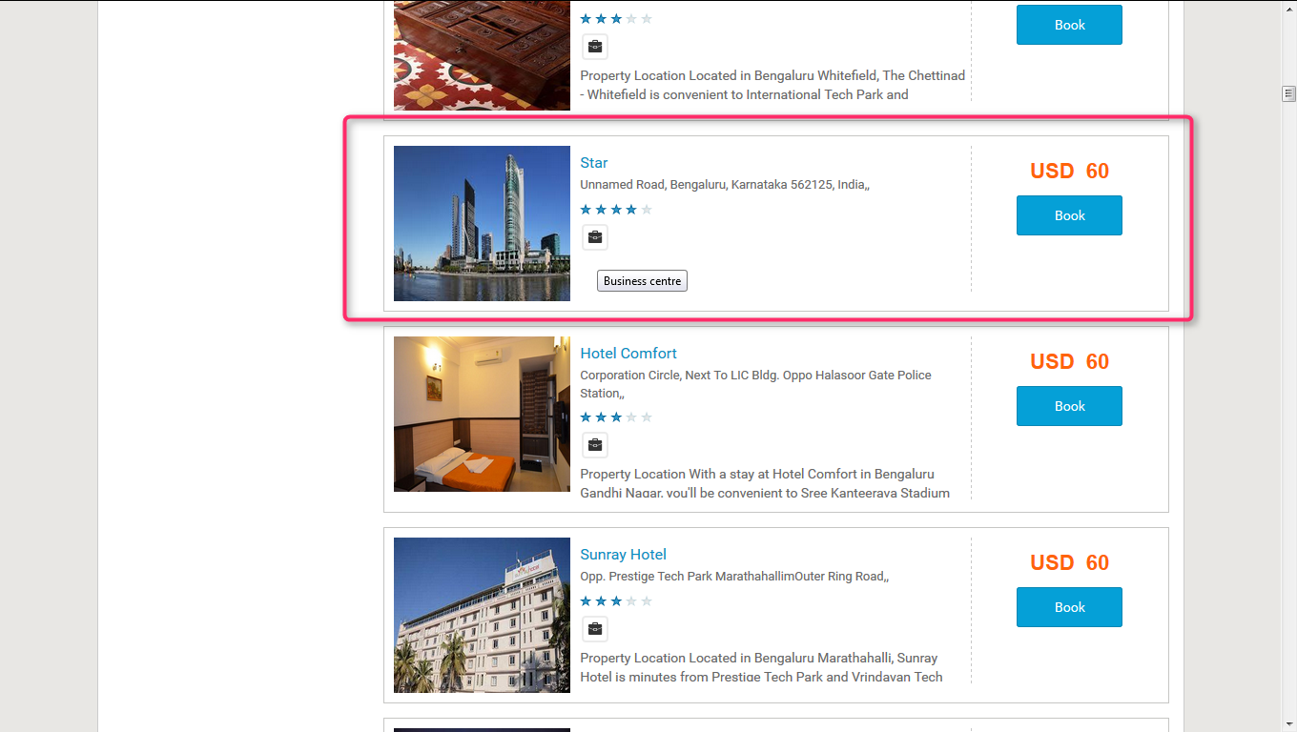

**8.3. MARKUP for Hotel (B2B)**: Markup is added by the Admin, after adding the markup from admin panel the markup will be added with total fare and display on front end.

**8.4. Before adding the Markup for Hotel Admin panel (B2B):** Markup will not display in the list before adding.

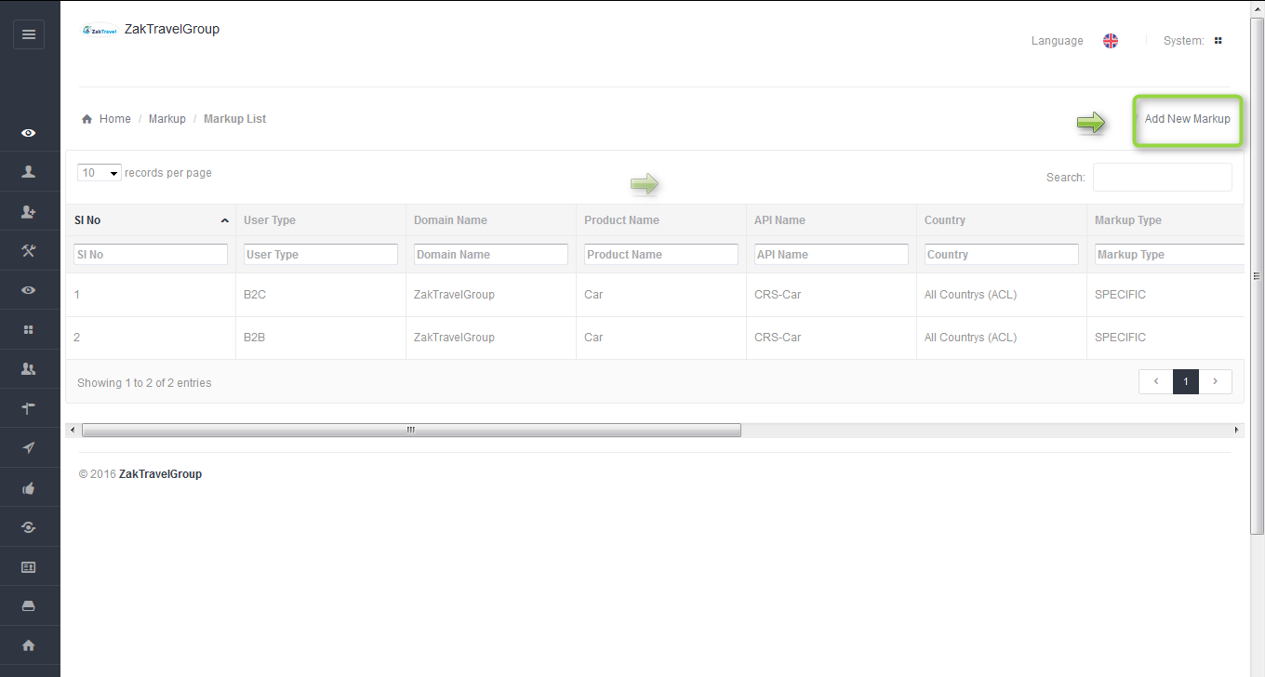

**8.5. Front End Without adding markup (B2B):** For a particular agentthe markup is not added with total fare so whatever the amount is added at the time of transfer creation that amount will be display only and total fare will display without markup.

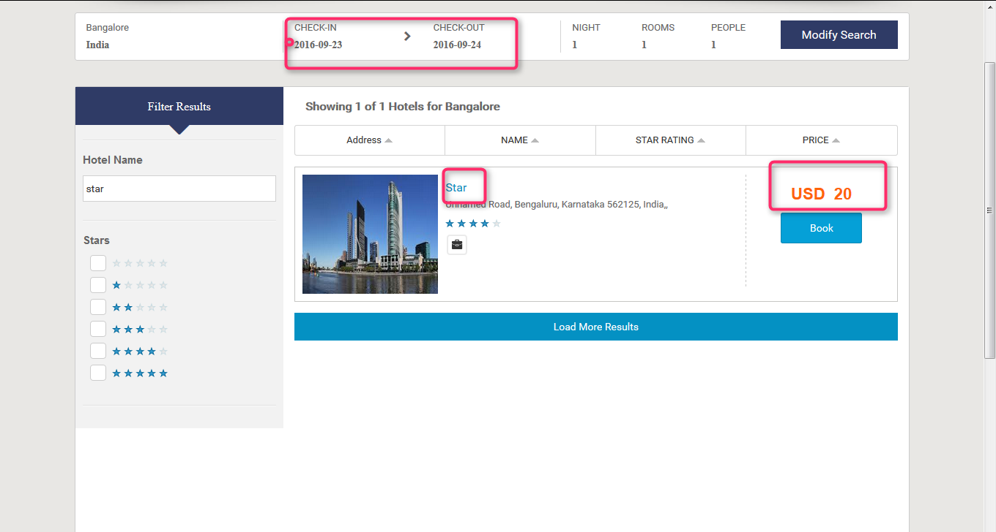

**8.6. Steps to add markup for hotel (Admin panel):** After click on add markup one form will be displayed and enter all the required information like user type, product, API, and markup value type, etc.

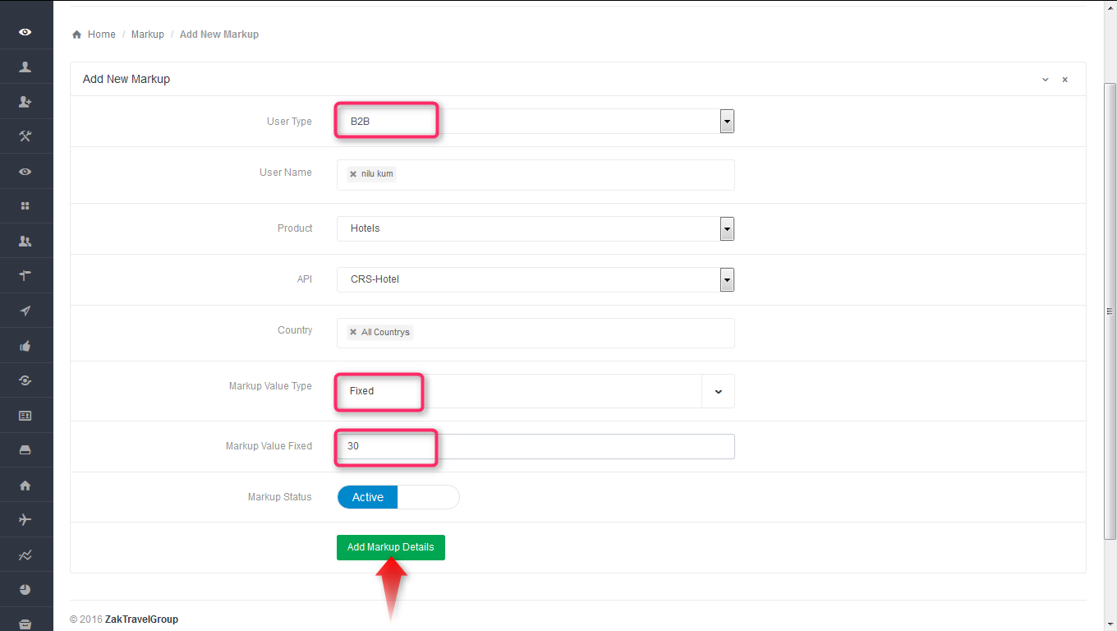

**8.7.Markup list admin panel for B2B**: Here admin add the markup for particular agent , select the user type as B2B , user name means for which agent admin add the markup, product as a Hotel , API CRS Hotel , country and markup type. After adding the markup will display in the list.

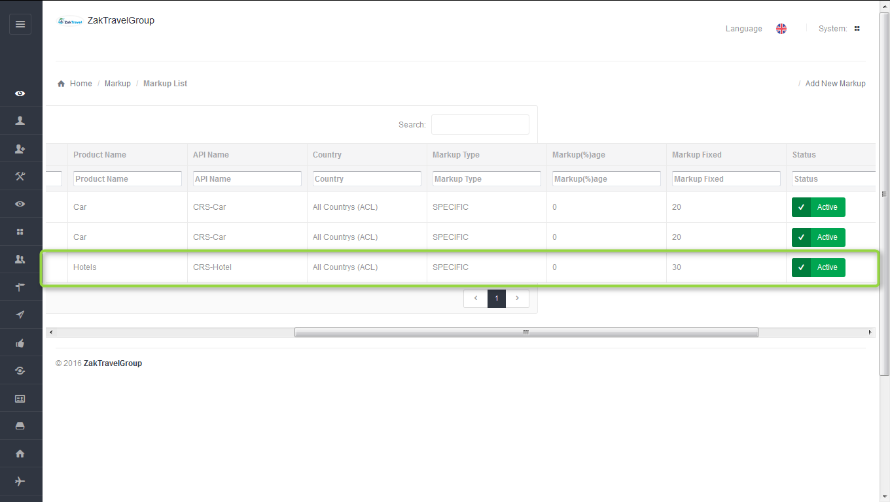

**8.8. Front end with Markup (B2B):** Now the added markup will be display with the total fare, for one day the markup added is 30 rupees now and markup will be added according to number of days.

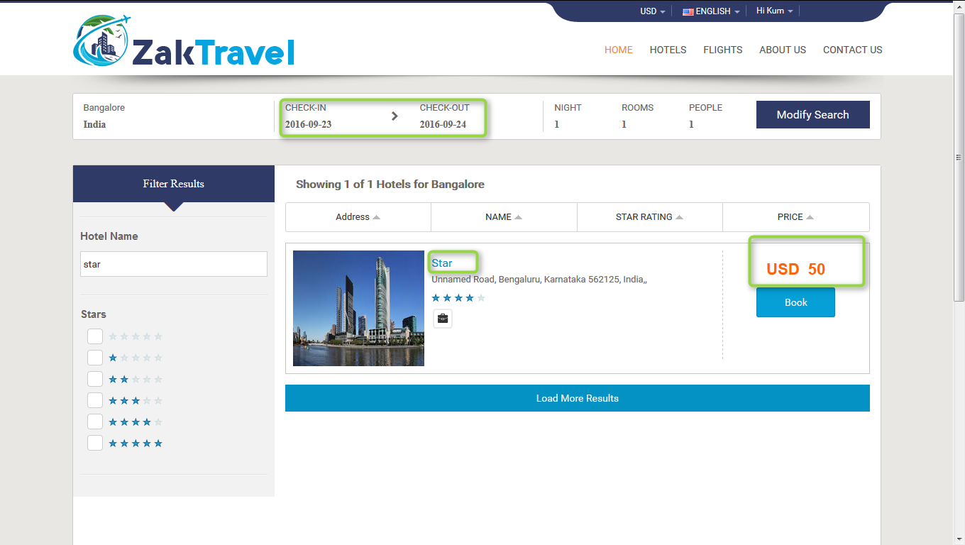

**8.9. Activation and Inactivation for markup:** After click on inactive the markup will not add with the total fare for adding the markup the status should be in active state.

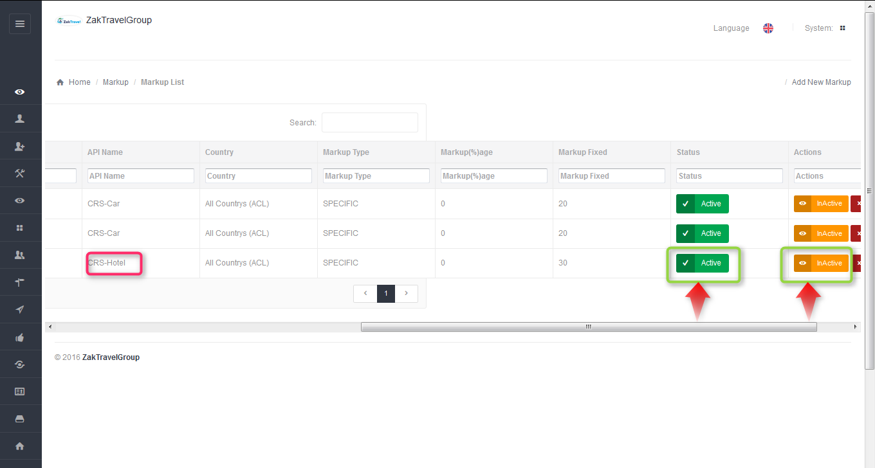

**Active Inactive**

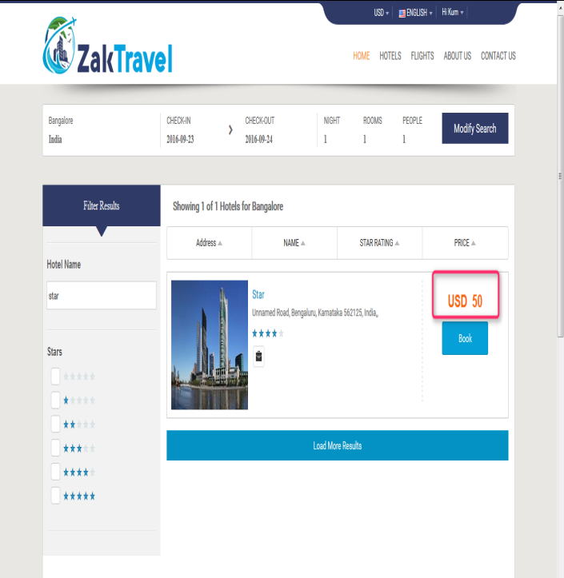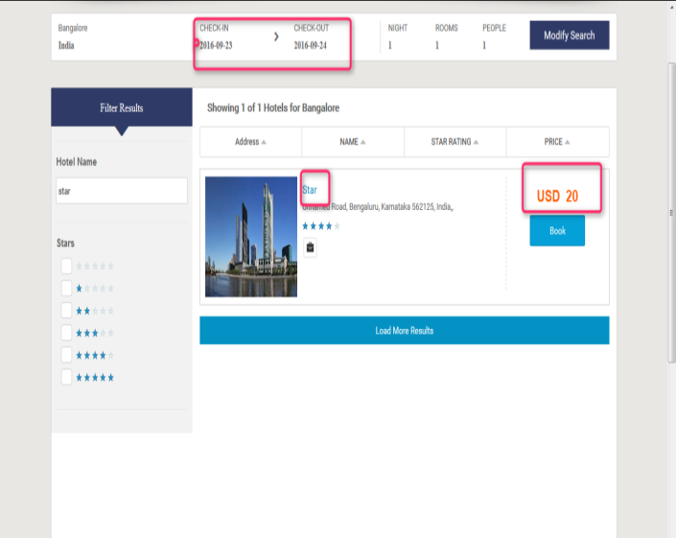

**8.9.1. Booking for Hotel (B2B):**

Users can book the particular hotel by providing their personal details. And they will get confirmation letter. Now click on hotel tab and provide all the valid detail and search for the hotel.

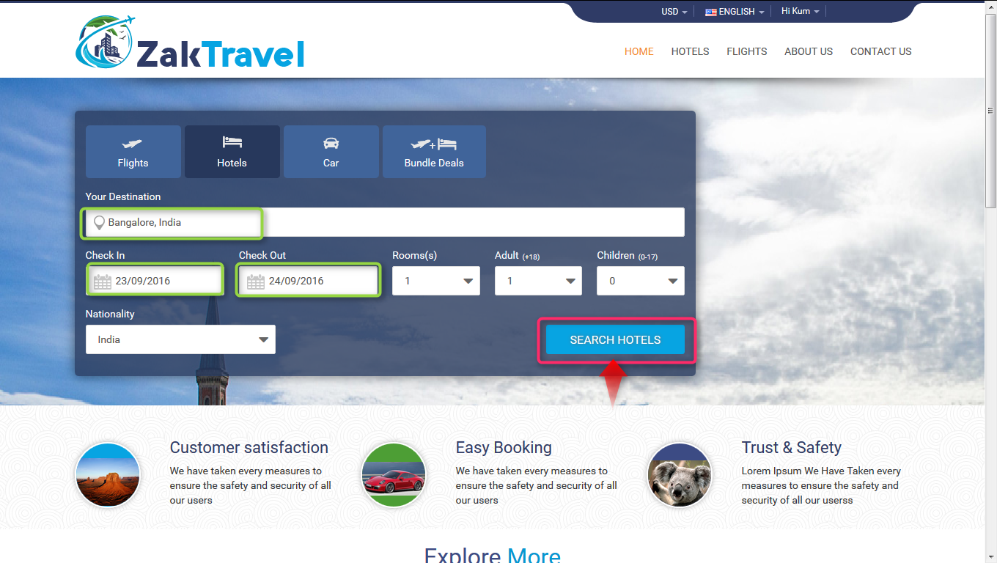

After click on search, the hotel search result will displayed. So click on Book button for booking the Hotel.

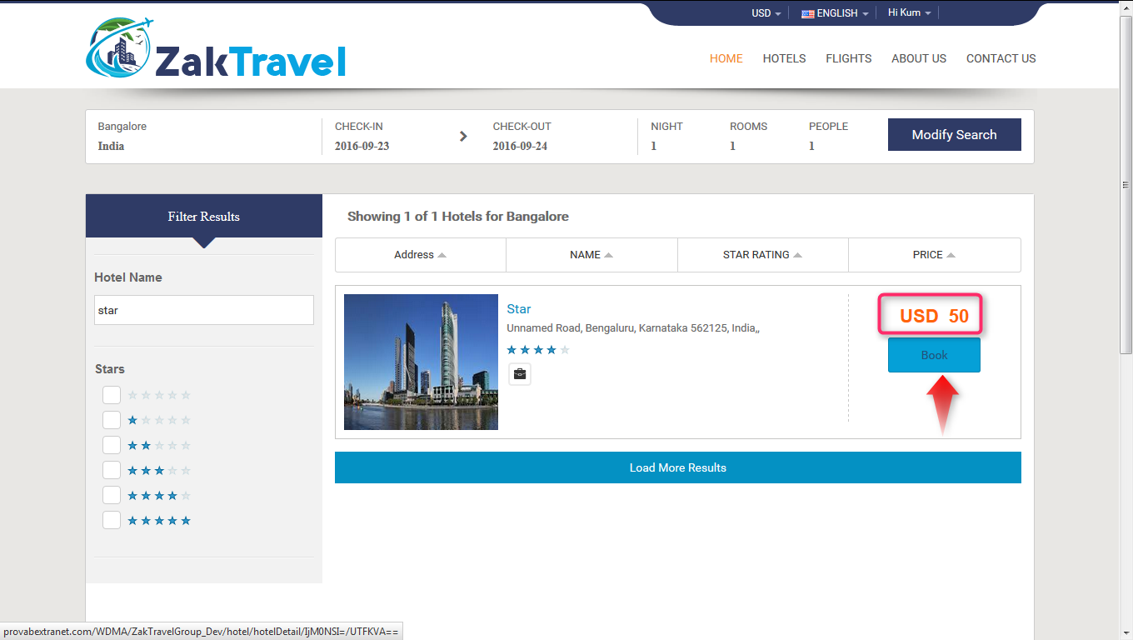

Now after click on book button it will open review, travelers and payment information and click on continue tab it will open the form to enter the personal information.

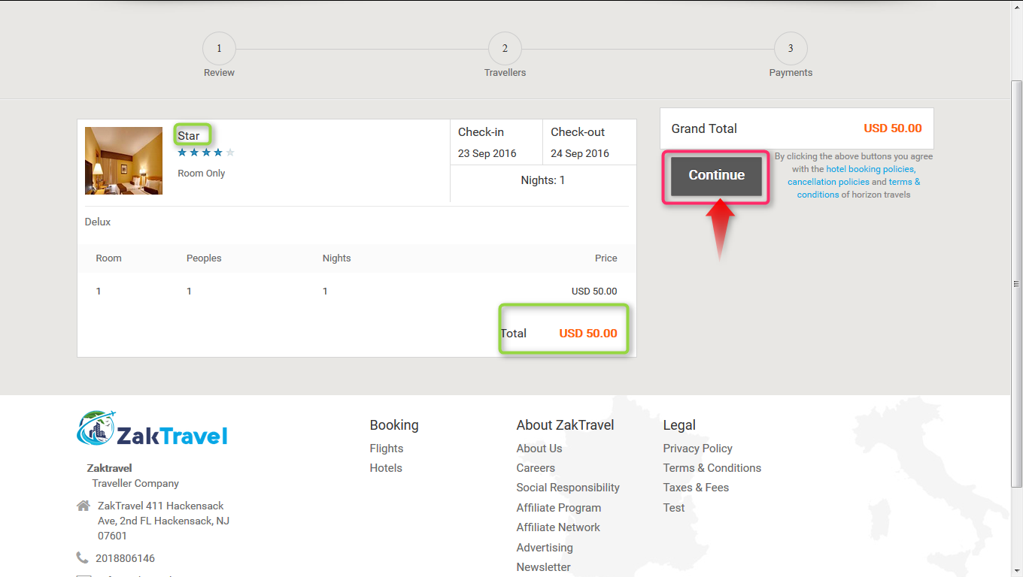

Provide all the valid information and click on continue button and check the check box for terms and conditions.

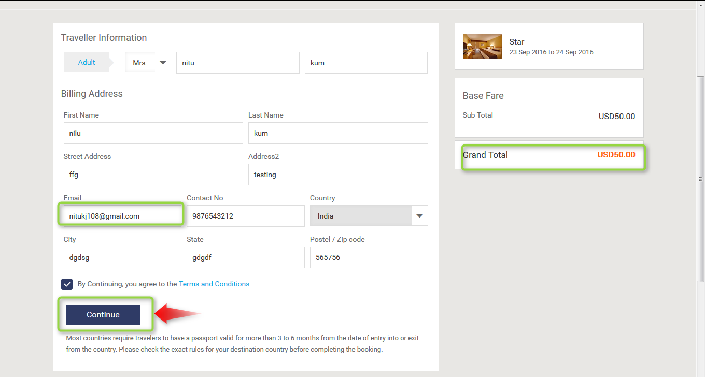

**8.9.2.Voucher page for Hotel (B2B)**: Voucher page display after providing all the information and click on continue button and everything will be present on the voucher page like booking status, reservation number, Traveler, date, amount etc.

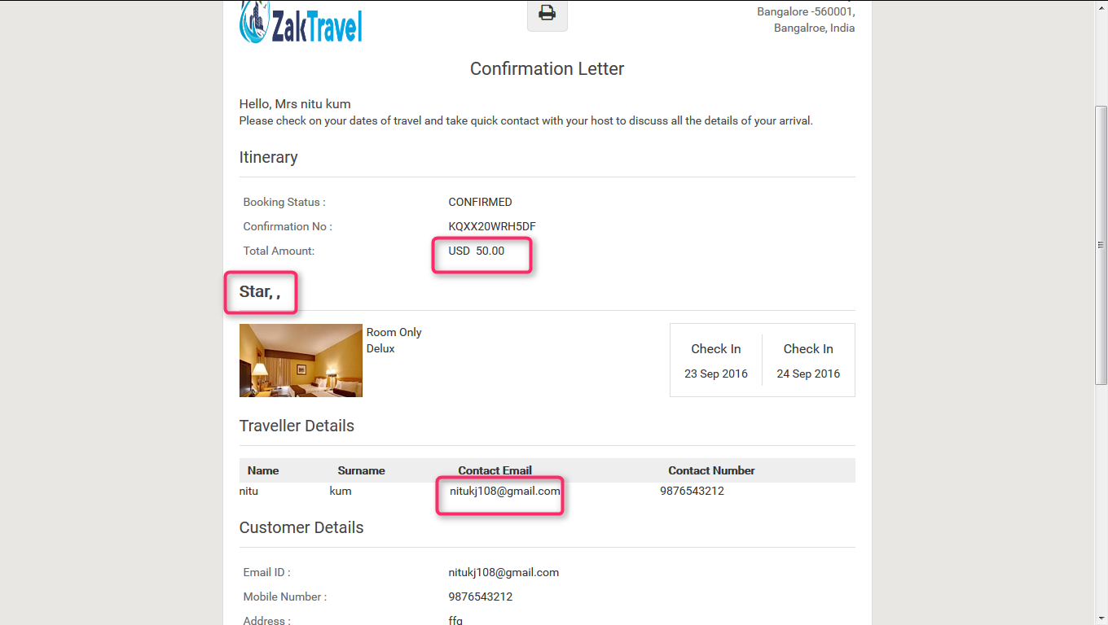

**9. CAR**

**9.1. search car:**

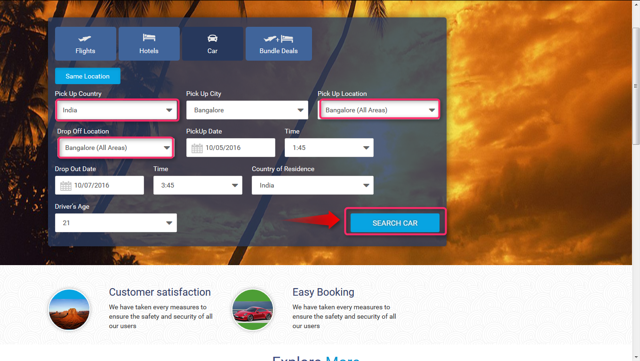

**9.2. Car displayed on Front End:** After search the transfer will be displayed on the front end and from where user can book the car.

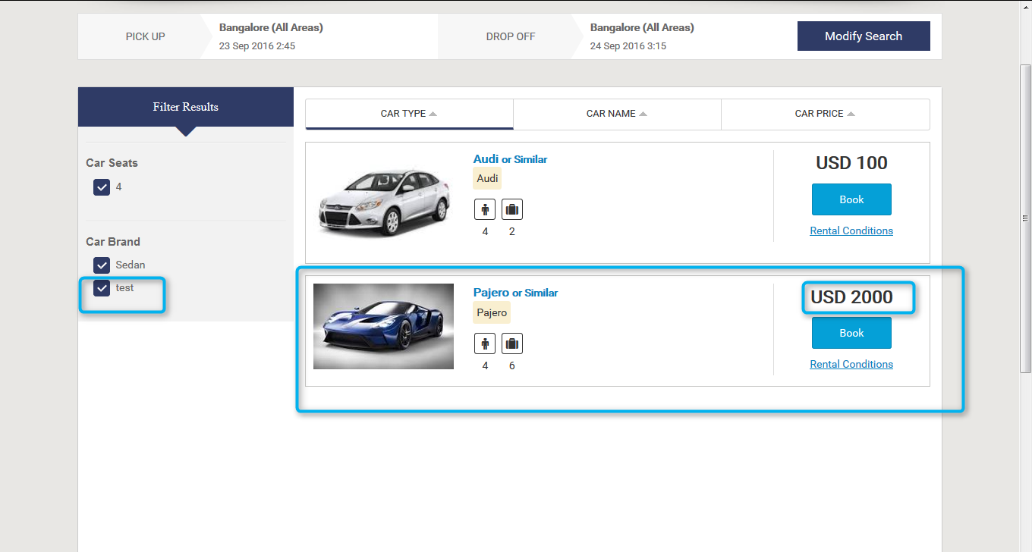

**9.3. Active and Inactive for car:** After change the status as inactive from the admin panel where car is added, the car will not be display on the front end for displaying need to change the status as active.

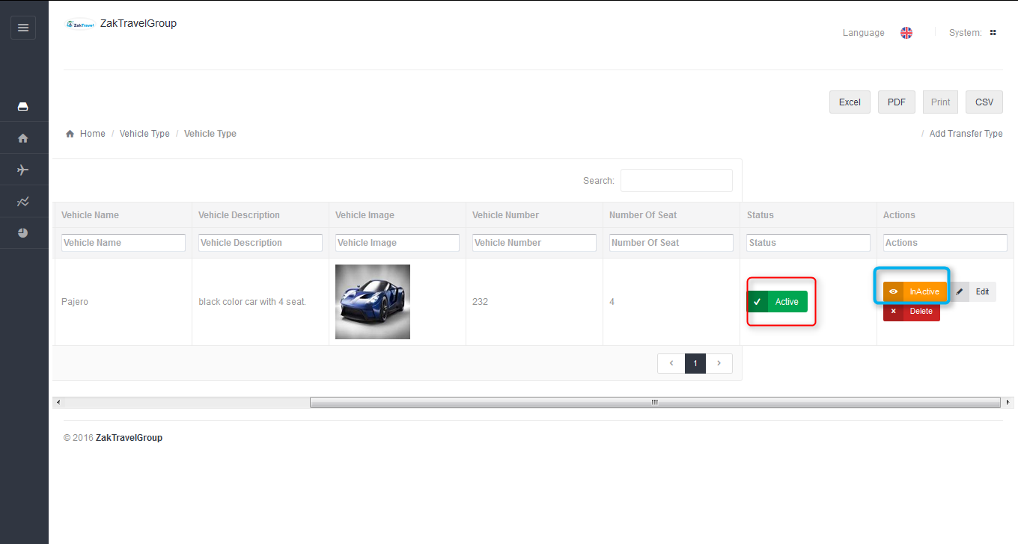

Active Inactive

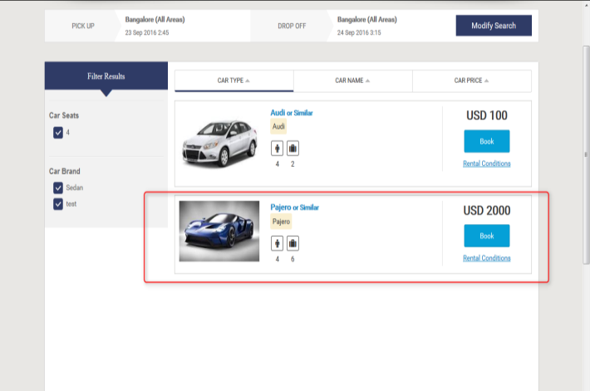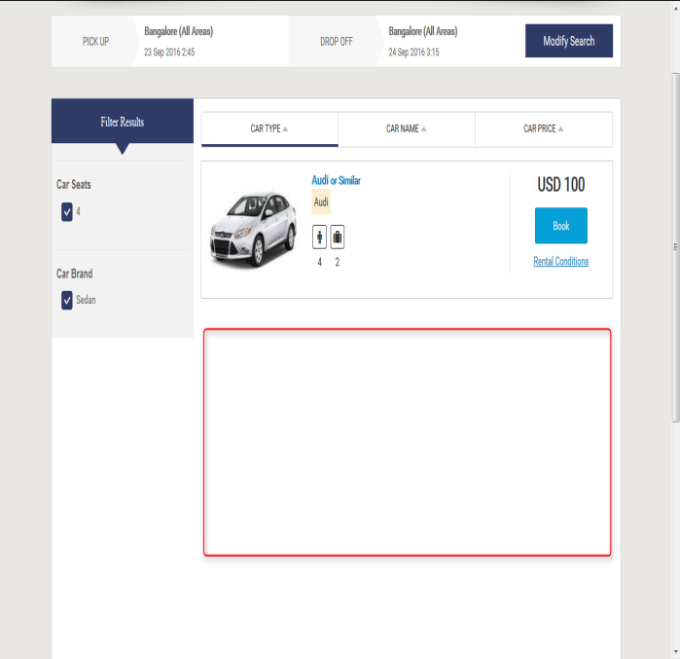

**9.4. MARKUP for Car**: Markup is added by the Admin, after adding the markup from admin panel the markup will be added with total fare and display on front end.

**9.5. Before adding the Markup for car:**

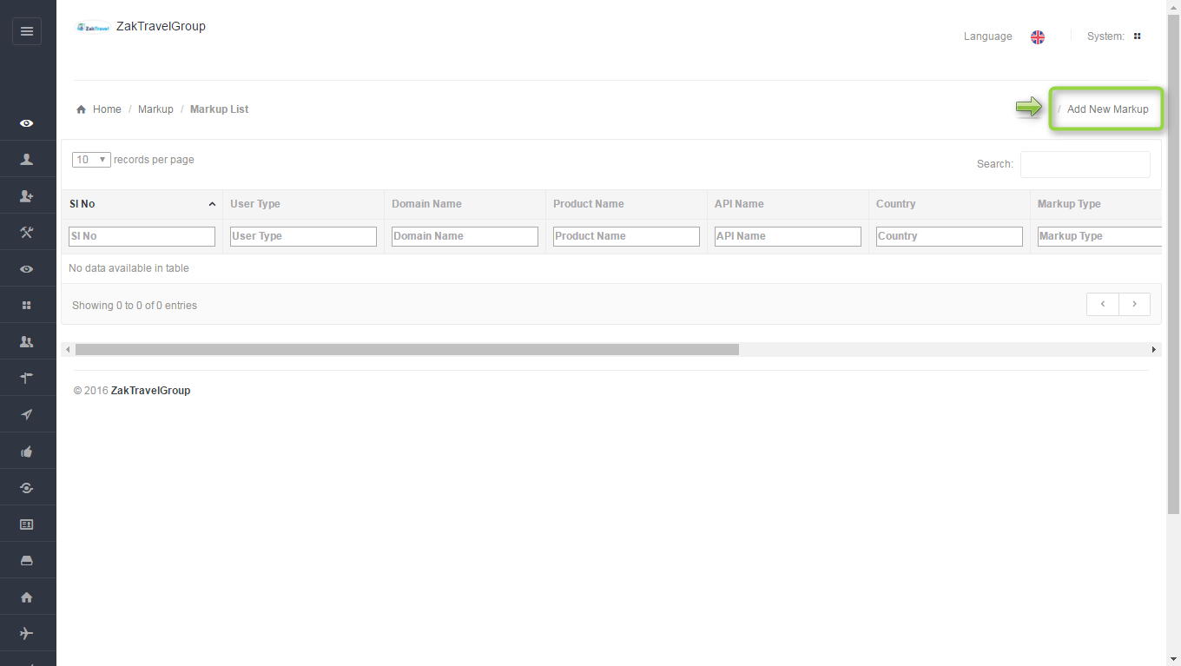

**9.6. Add markup step by step:** After click on add markup one form will be displayed and enter all the required information like user type, product, API, and markup value type, etc.

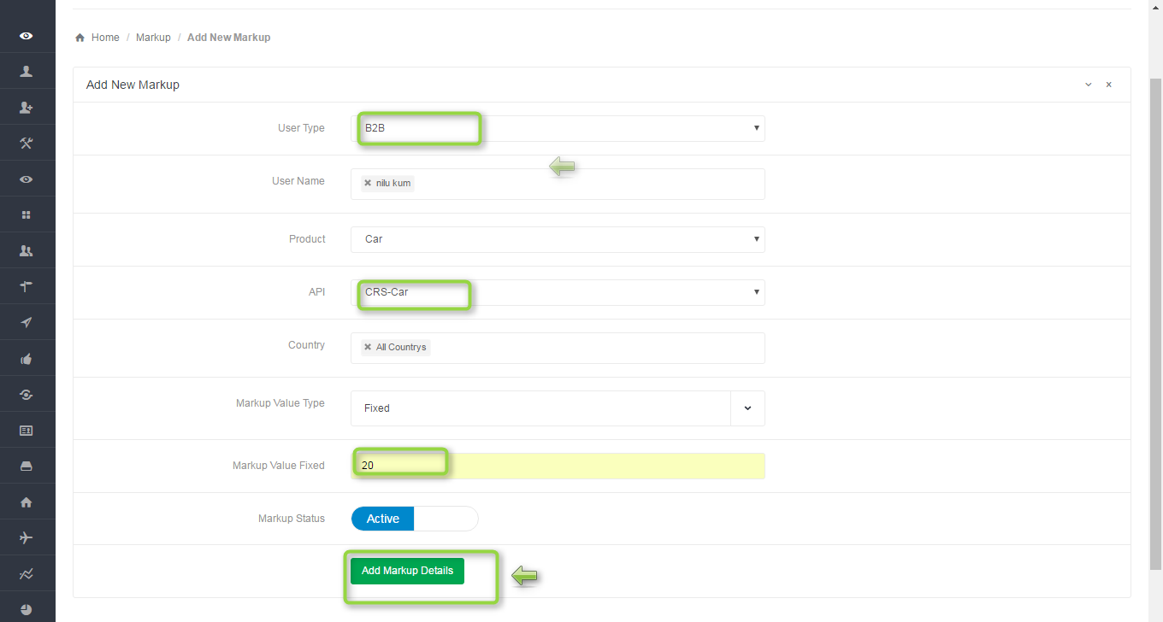

**9.7. There are two types of markup value:**

1) Percentage – The markup will add in percent (Example – Total fare =1000 and add 10% of total fare, now the total amount = 1100)

2) Fixed – Markup will be add in the fixed amount (Example – Total fare =100 and add 20 Rupees fixed amount with total fare, now the total amount = 120)

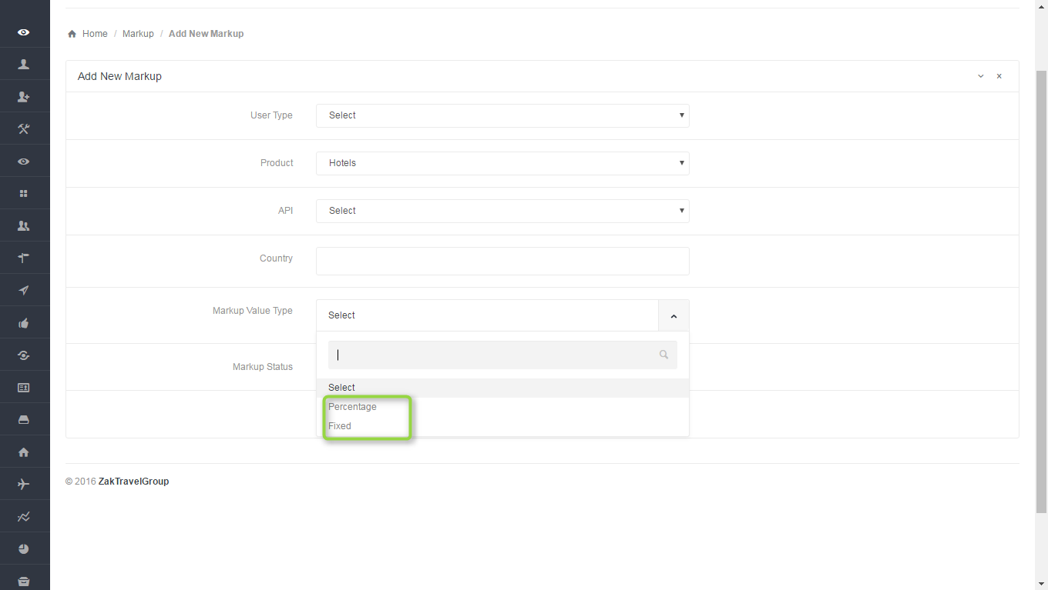

**9.8. Front End Without adding markup (B2B):** For a particular agentthe markup is not added with total fare so whatever the amount is added at the time of transfer creation that amount will be display only and total fare will display without markup.

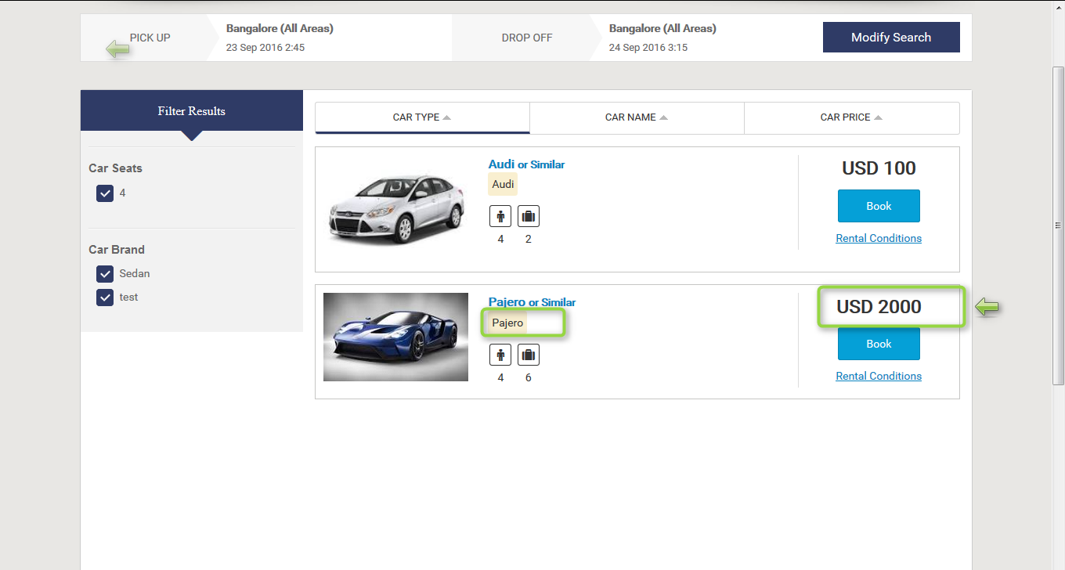

**9.9. Markup list in admin panel for B2B**: Here admin add the markup for particular agent , select the user type as B2B , user name means for which agent admin add the markup, product as a Hotel , API CRS Hotel , country and markup type. After adding the markup will display in the list.

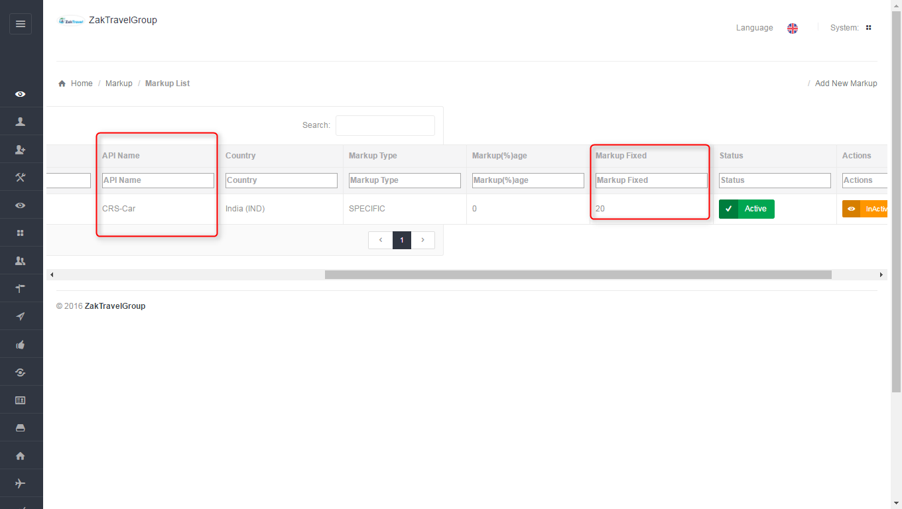

**9.9.1. Front end with Markup (B2B):** Now the added markup will be display with the total fare, for one day the markup added is 20 rupees now and markup will be added according to number of days.

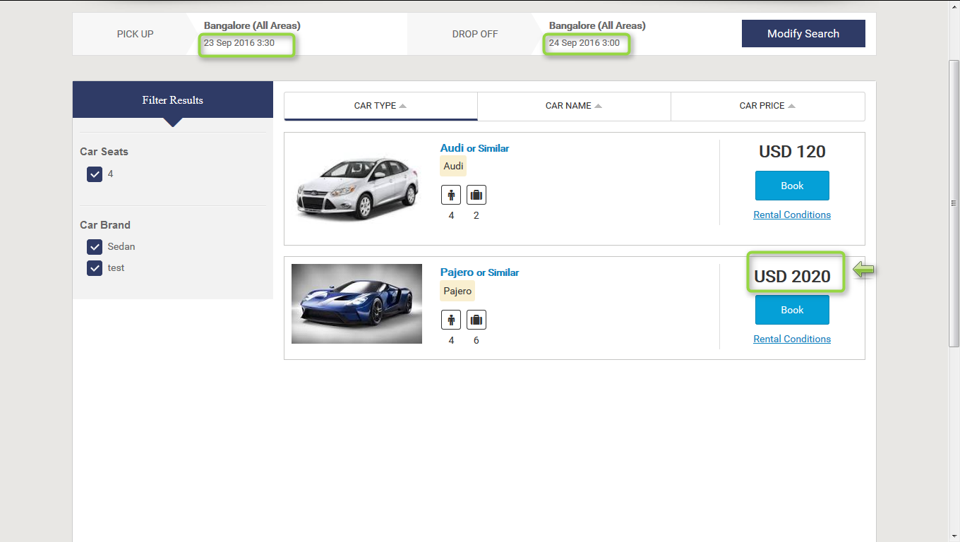

**9.9.2. Activation and Inactivation for markup:** After click on inactive the markup will not add with the total fare for adding the markup the status should be in active state.

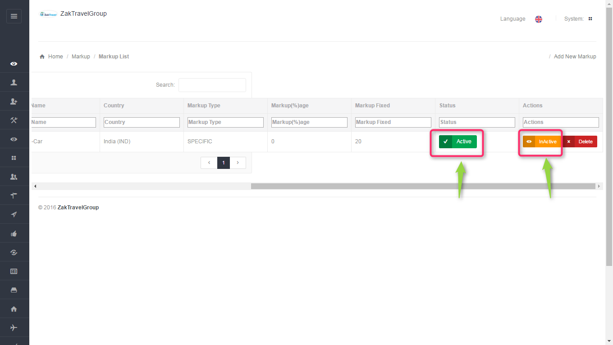

**Active Inactive**

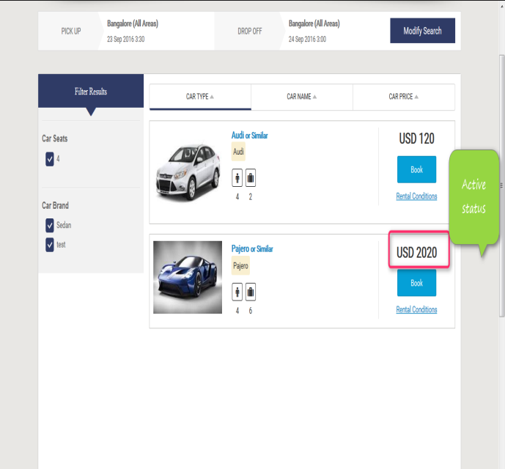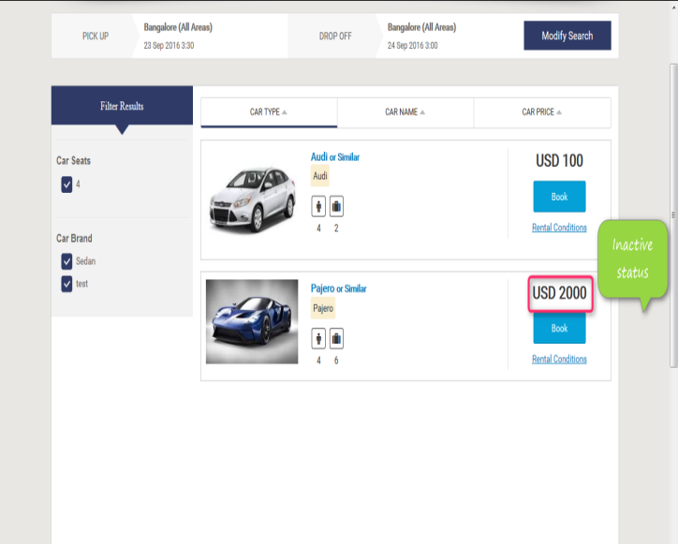

**9.9.3. Booking for Car:**

Users can book the particular car by providing their personal details. And they will get confirmation letter. Now click on car tab and provide all the valid detail and search for the car.

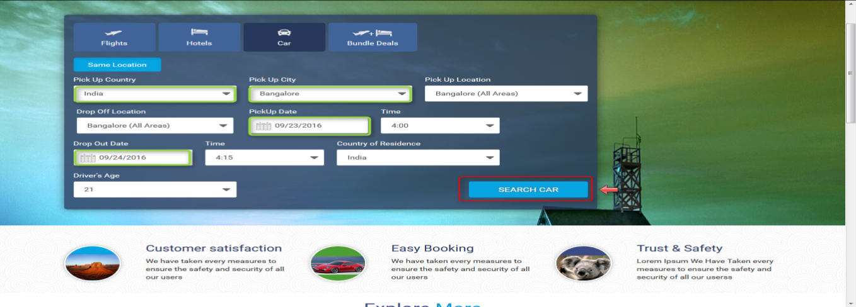

After Click on search button now car search result will displayed. So click on Book button for booking the car.

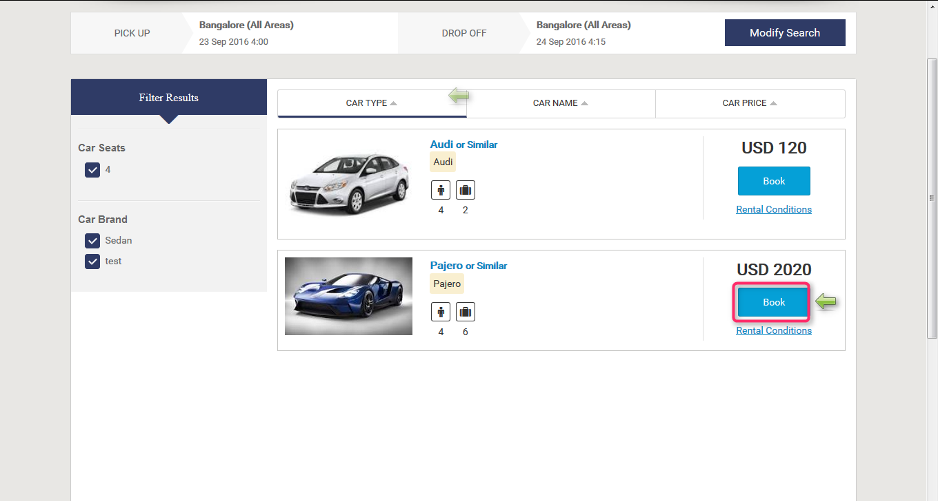

Now after click on book button it will open review, travelers and payment information and click on continue tab it will open the form to enter the personal information.

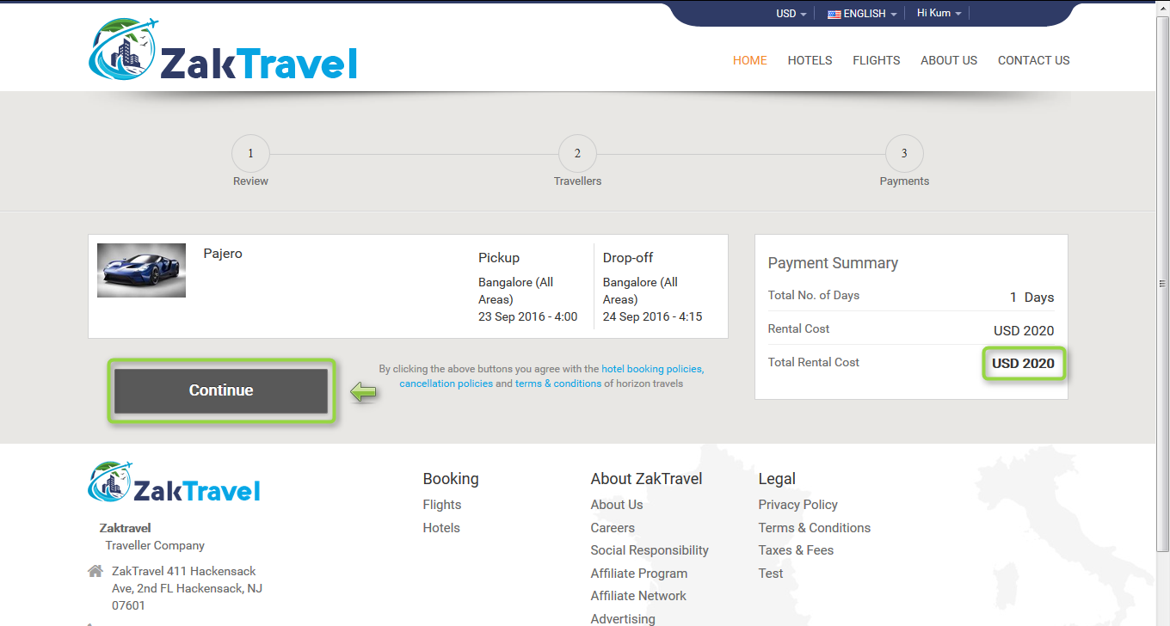

Provide all the valid information and click on continue button and check the check box for terms and conditions.

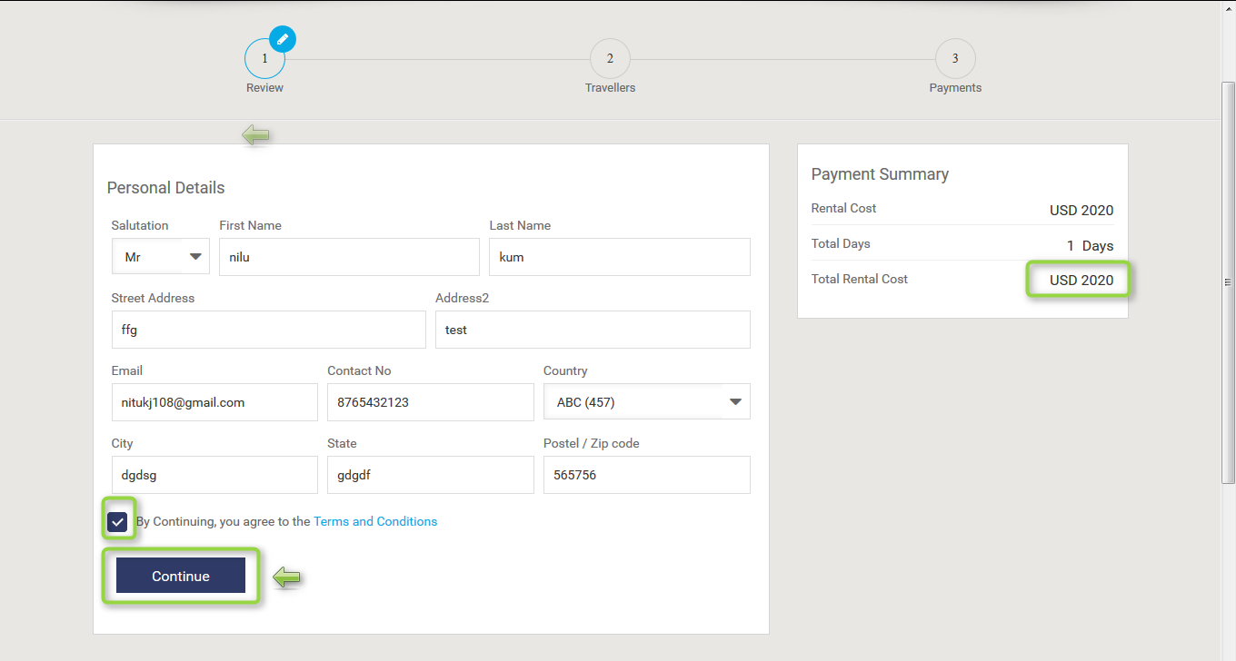

**9.9.4. Voucher page :** Voucher page display after providing all the information and click on continue button and everything will be present on the voucher page like booking status, reservation number, Traveler, date, amount etc.

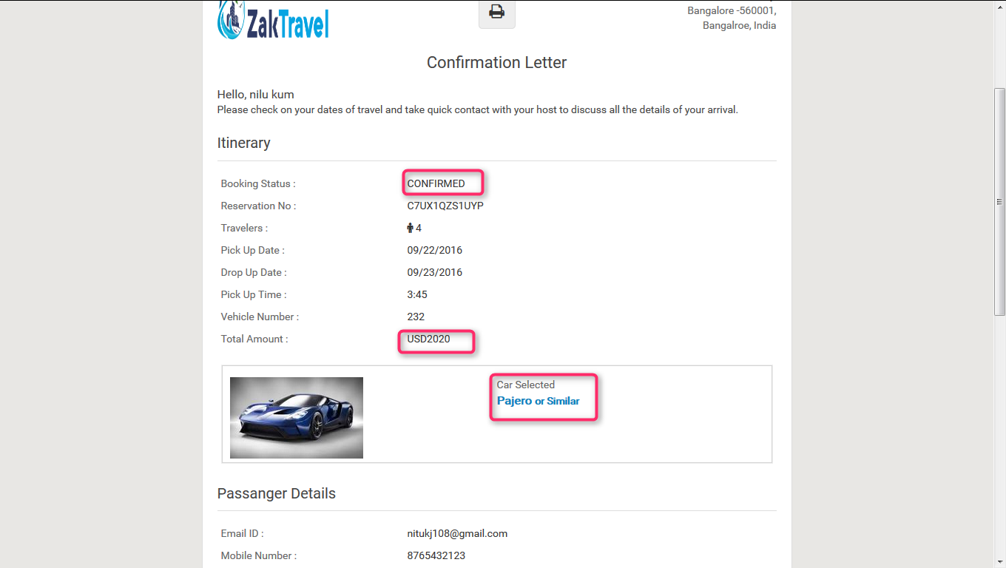

**10. BUNDLE DEALS:**

**10.1. Before adding bundle deals:** Admin needs to add the Bundle and can edit and delete also.

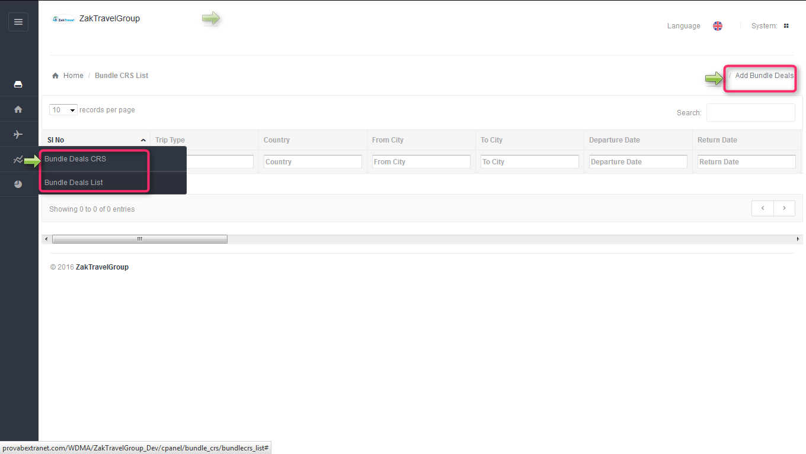

**10.2. Steps to add bundle deals (Flight, Hotel, Car):** Admin can  add bundles they need to provide all the information  like city name, departure and return date , trip type, and all the details about bundle (Car, Flight, Hotel) , need to Activate the bundle and the added bundles will display on front end. After deactivating the deals it will not be display on the front end.

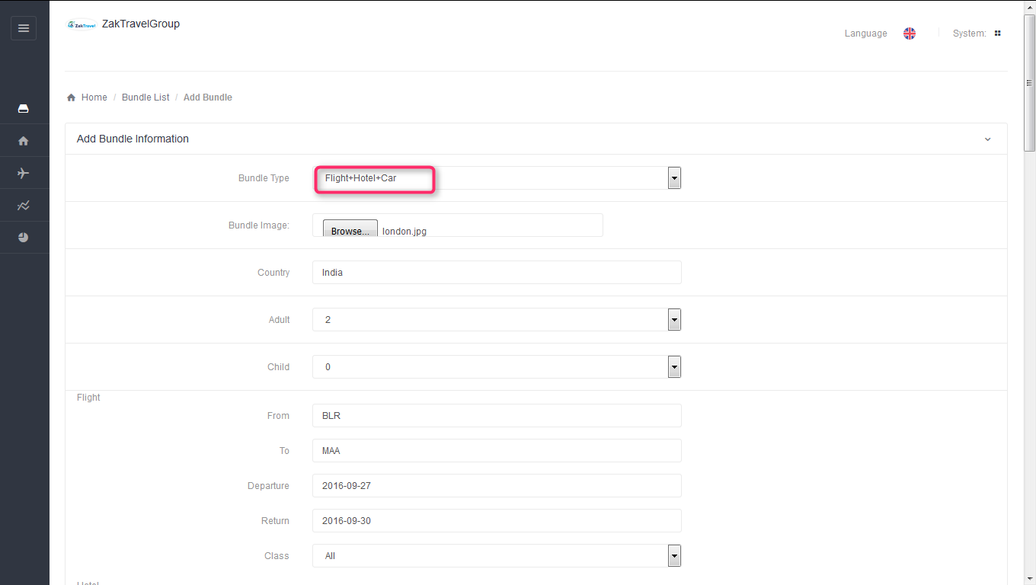

**10.3. Flight segment Management:**

**10.4. Before adding segment:** Admin needs to add the flight segment.

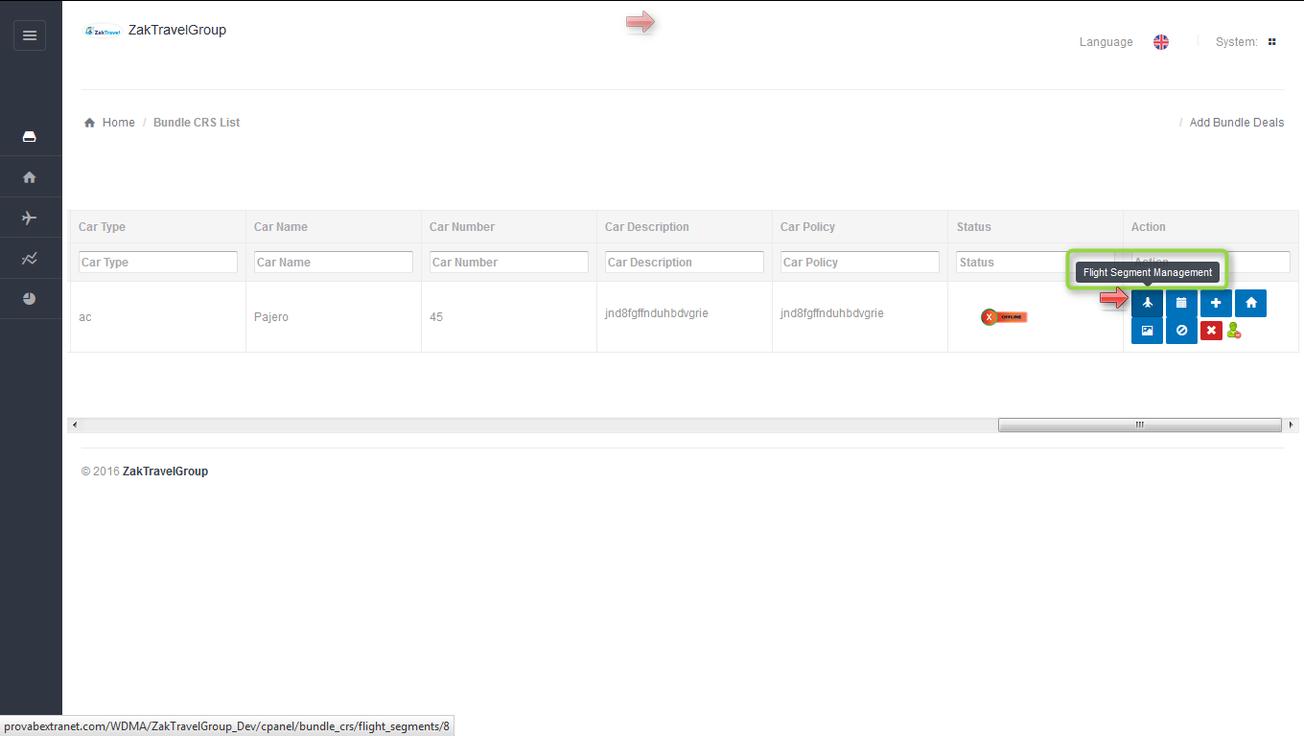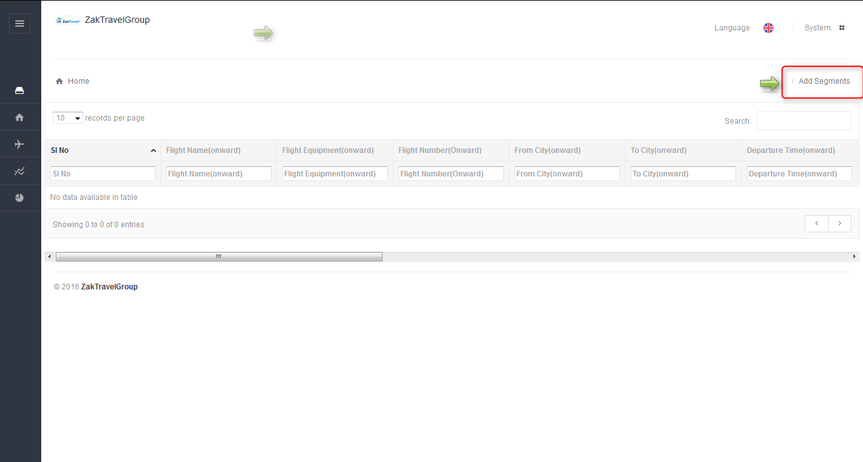

**10.5. Steps to add flight segment:** Click on flight segment symbol and click on add segment, Enter flight name, and Equipment, Departure and arrival time for both onward and return.

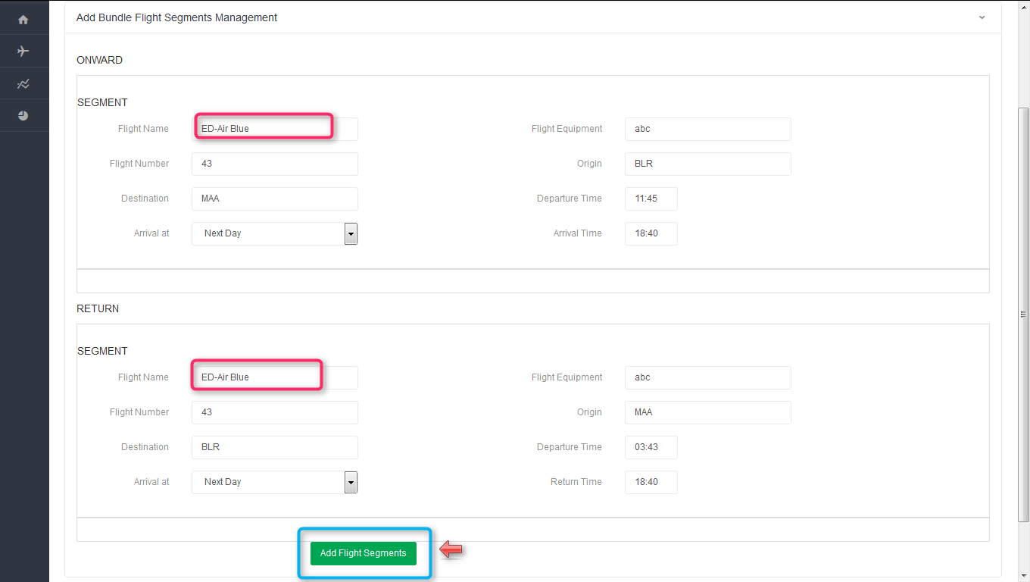

**10.6. After adding segment:** Added segment will be displayed in the list.

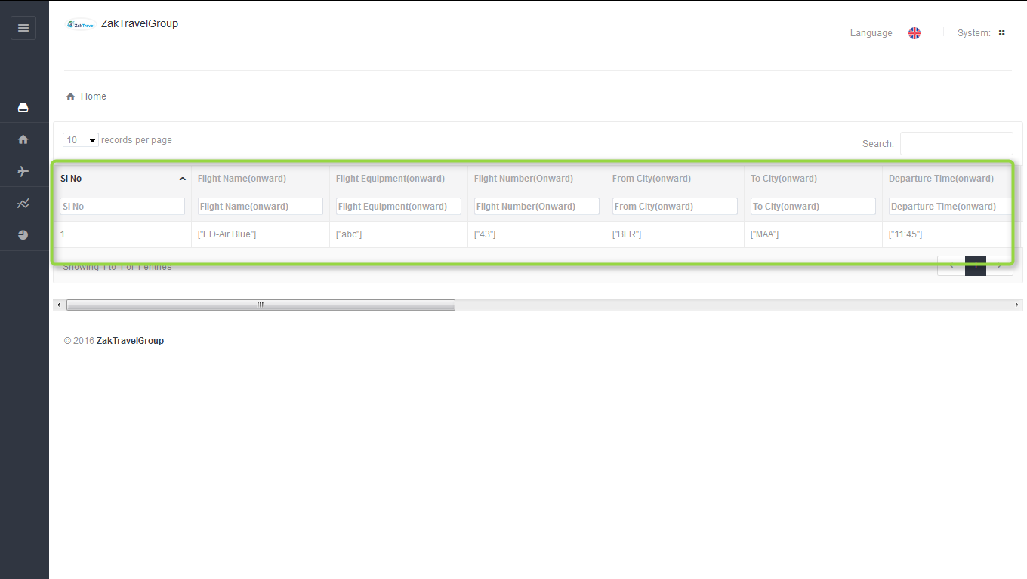

**10.7. Add Bundle Flight Pricing Management:** In price management need to add the price for adult, Child, infant with tax.

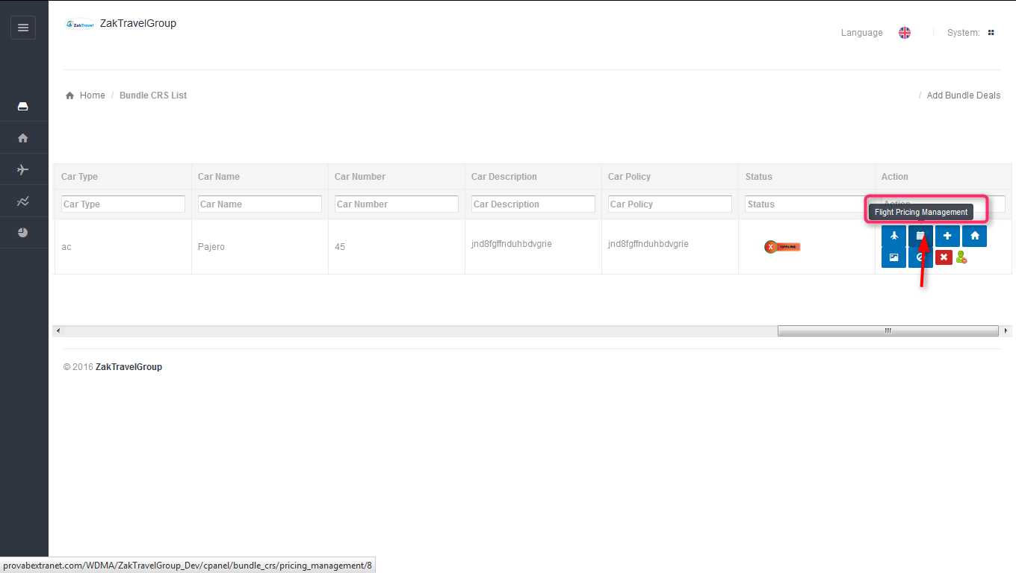

**10.8. Before adding the price:** Supplier needs to add the price of the flight.

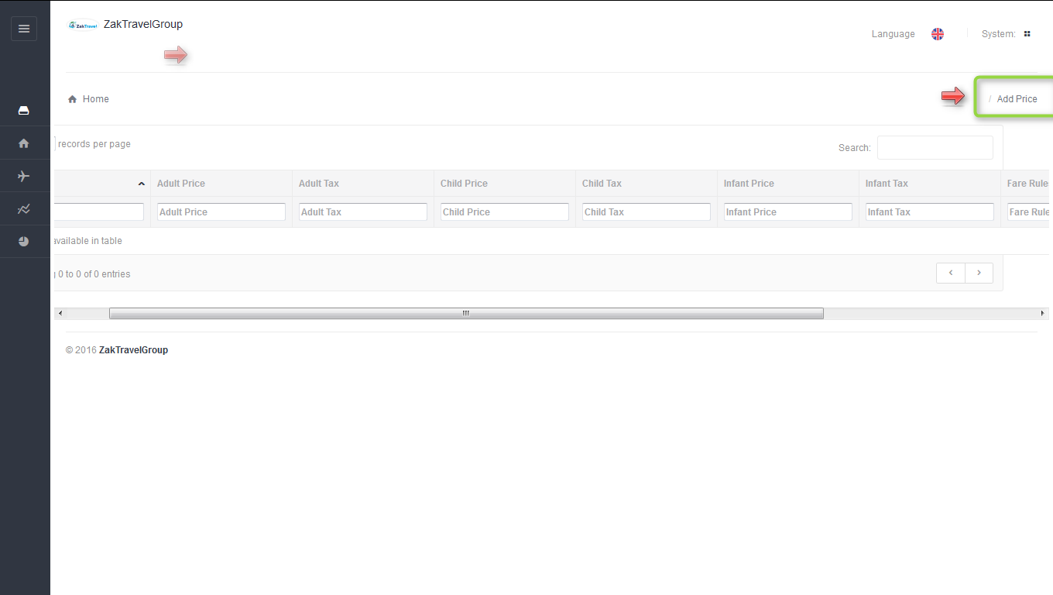

**10.9. Steps to add the price:** Click on add price Enter adult, child, infant price with tax and click on add.

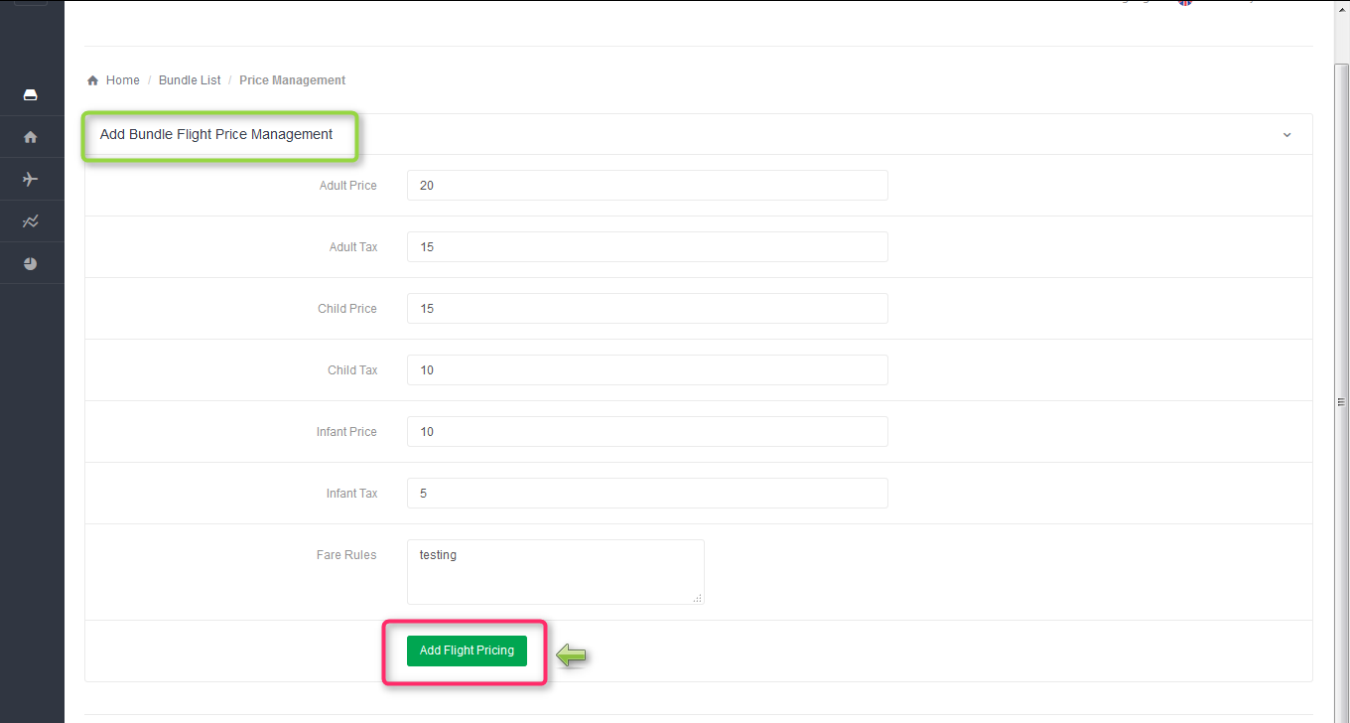

**10.9.1. Add/View Room type:** Need to add the room type and number of customers.

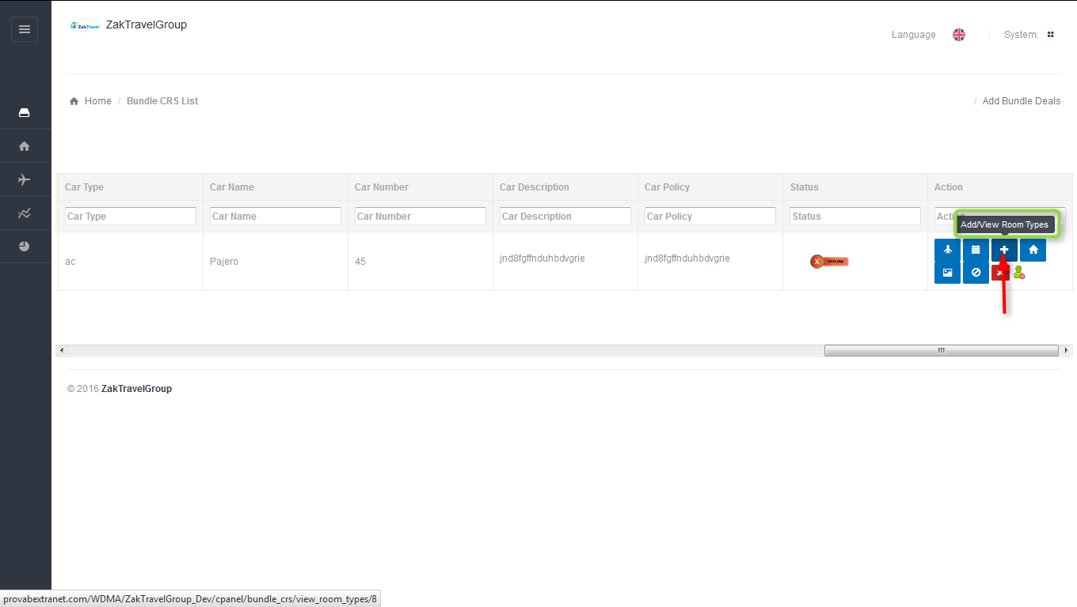

**10.9.2. Before adding room type :** Supplier needs to add the room type.

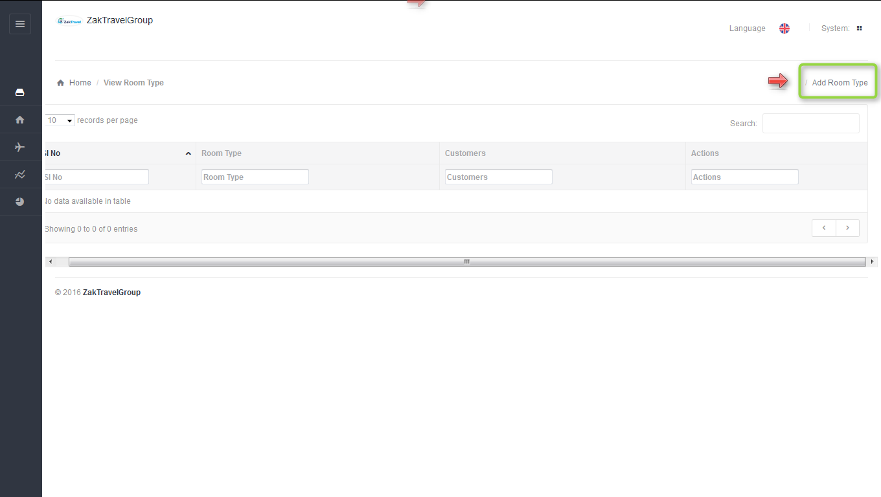

**10.9.3. Steps to add the room type:** Click on add room type and enter the type and select the customer.

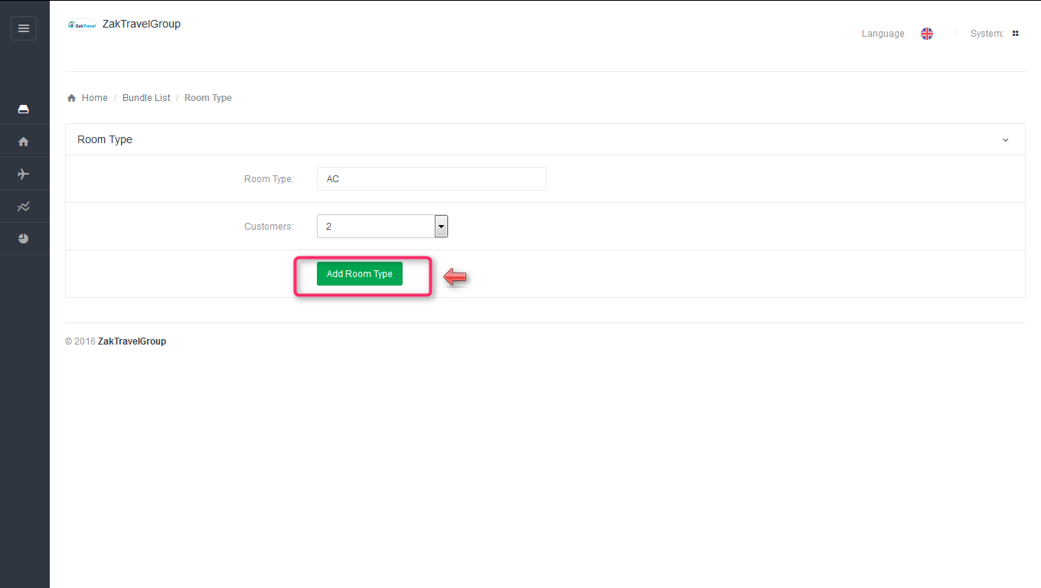

**10.9.4. After adding room type:** The added room type will display in the list.

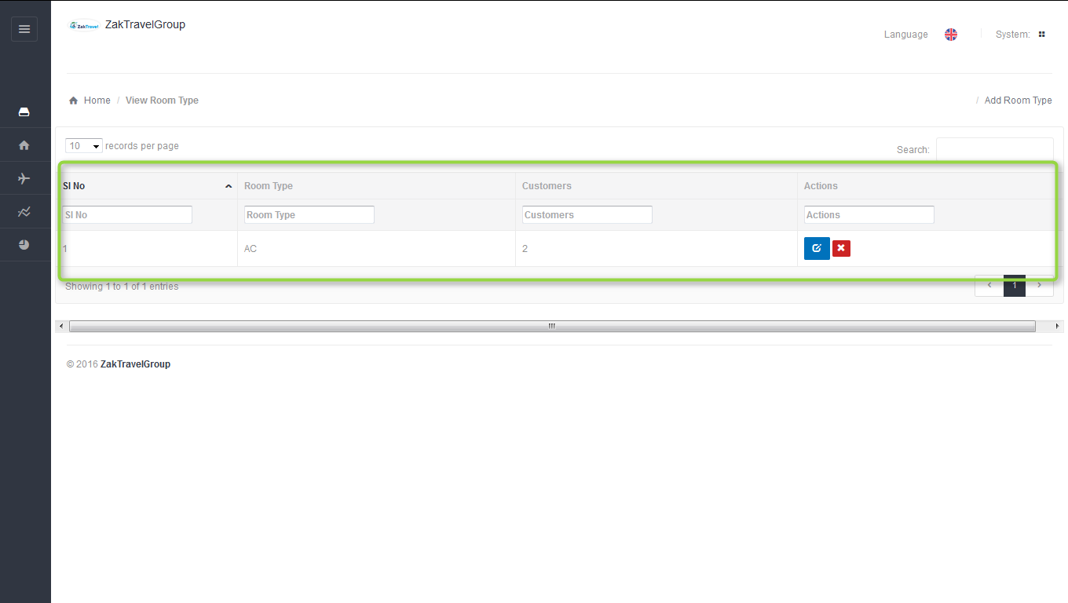

**10.9.5. Room Management (Add new room):** In room management add new rooms and hotel price and hotel name will be pre populated because the hotel name is already provided while adding bundle information.

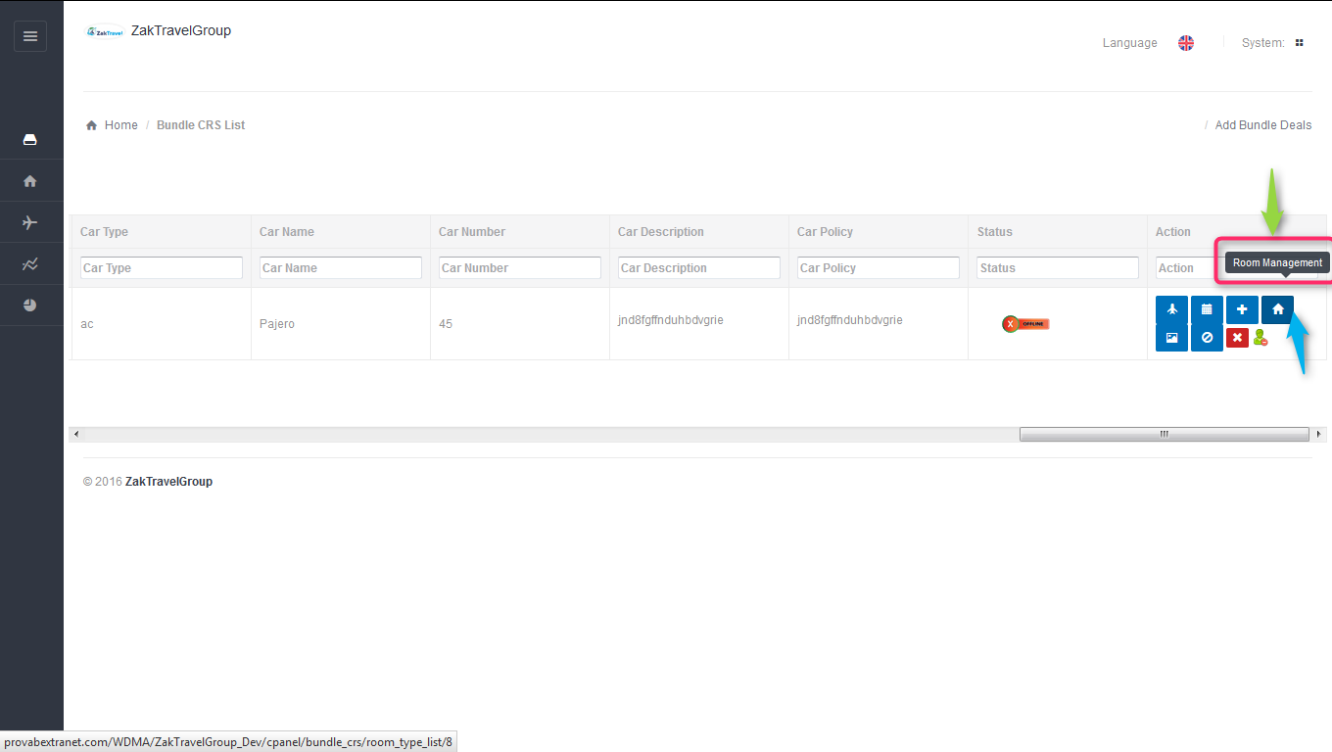

**10.9.6. Before adding room:** Admin needs to add the room.

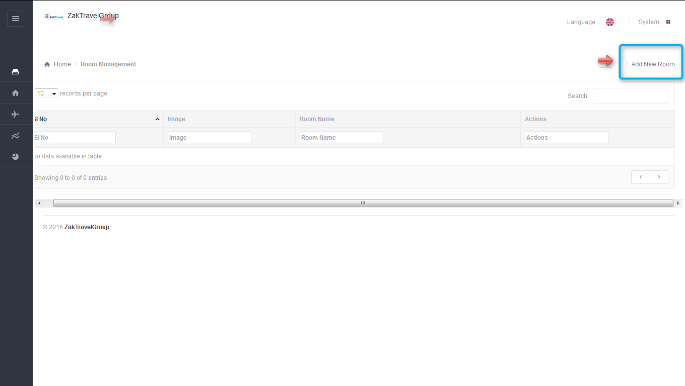

**10.9.7**. **Steps to add the new room:** Now Click on Add new room and hotel name would be pre selected and select the room name, hotel price, Cancellation Charges and click on add.

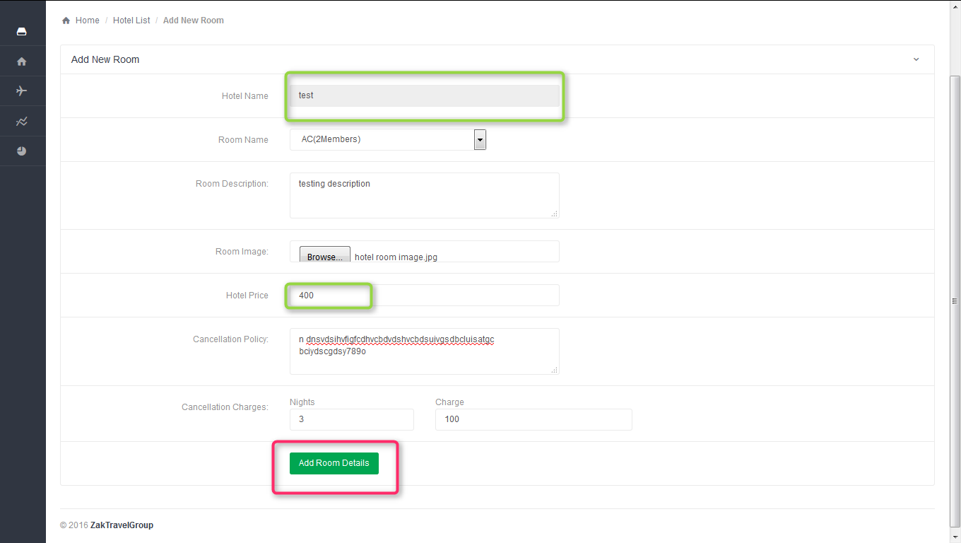

**10.9.8. After adding the new room:** The added room will display in the list.

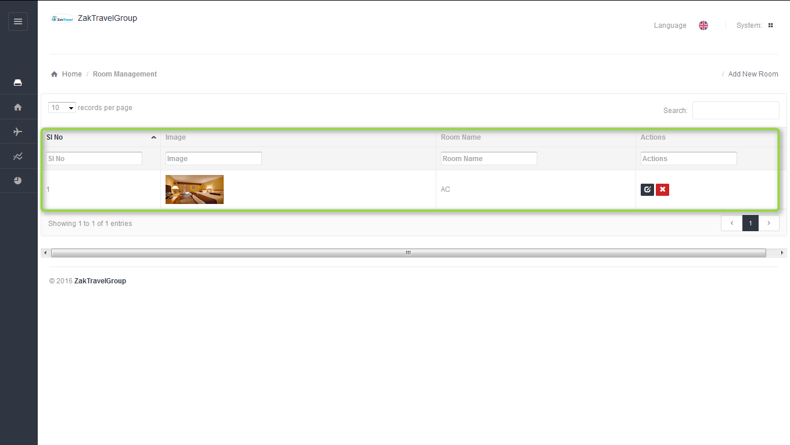

**10.9.9. Gallery management:** In the gallery management add hotel image and need to upload the same image.

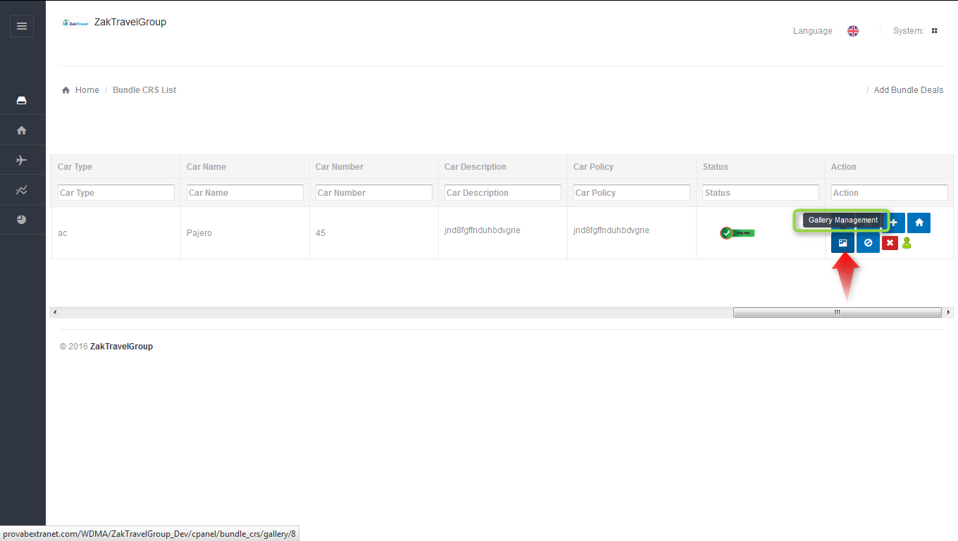

**11. Before adding gallery:** Admin needs to add the gallery.

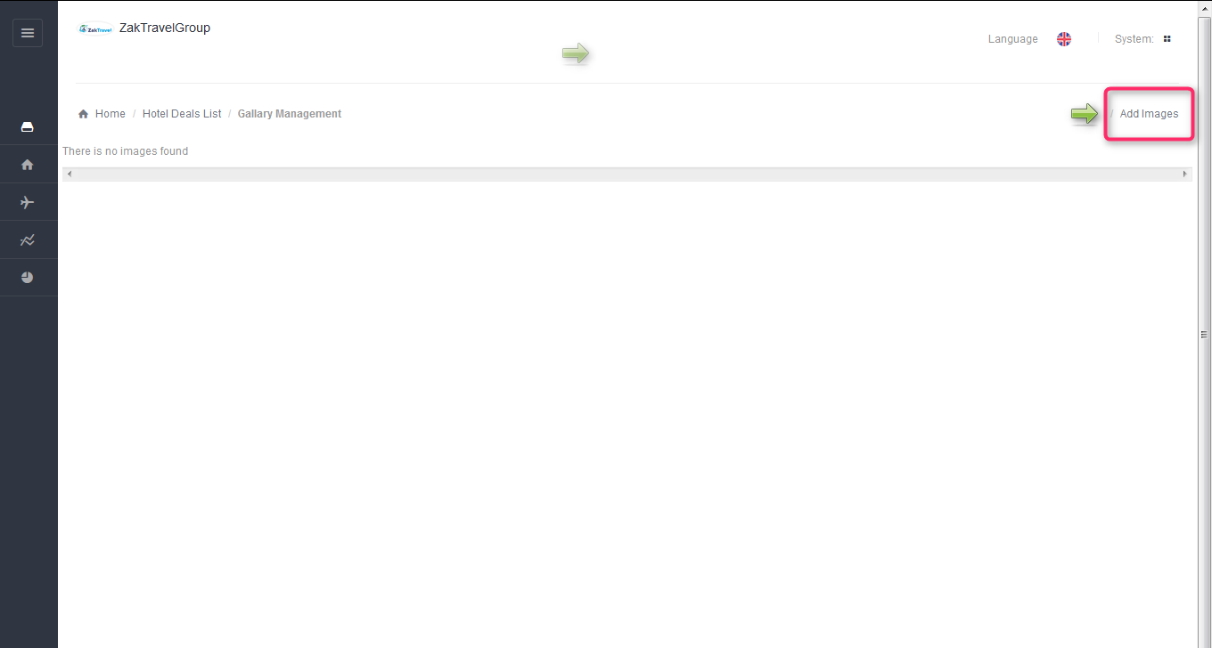

**11.1. Steps to add the gallery:** Click on add image and click on add file and select the image and click open start uploading and upload the image successfully.

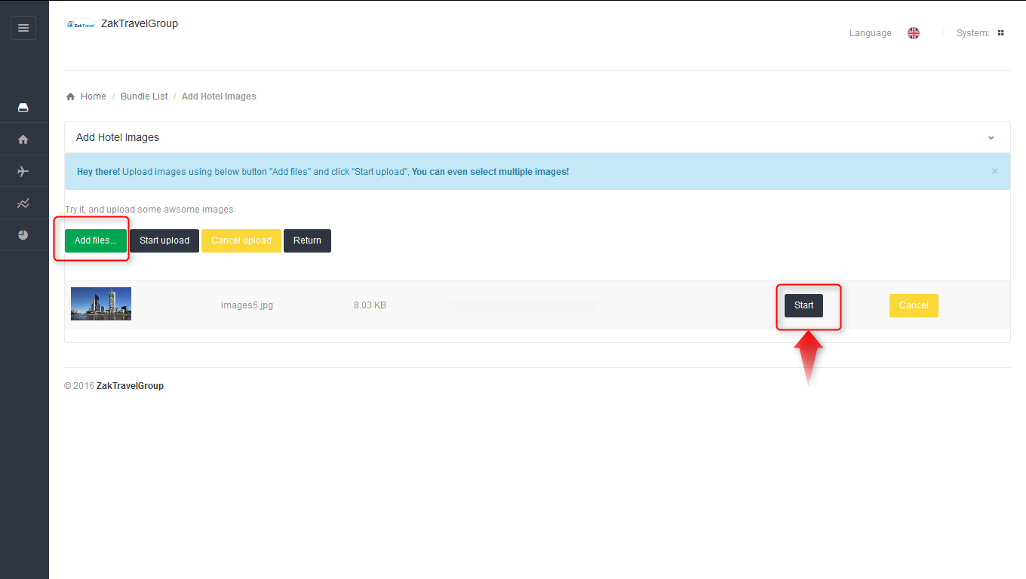

**11.2**. **After uploading:** After uploading the picture of hotel will display in the list.

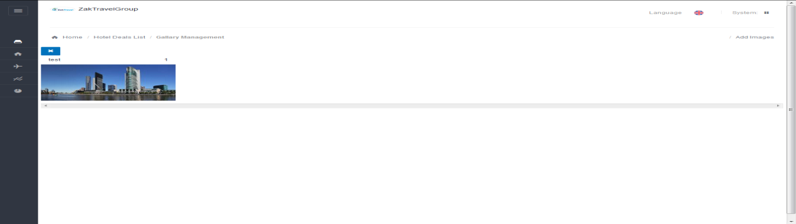

**11.3. Car Pricing:** Here need to add the adult price for the car with Baggage Allowance in kg and how many Suitcases should be carried.

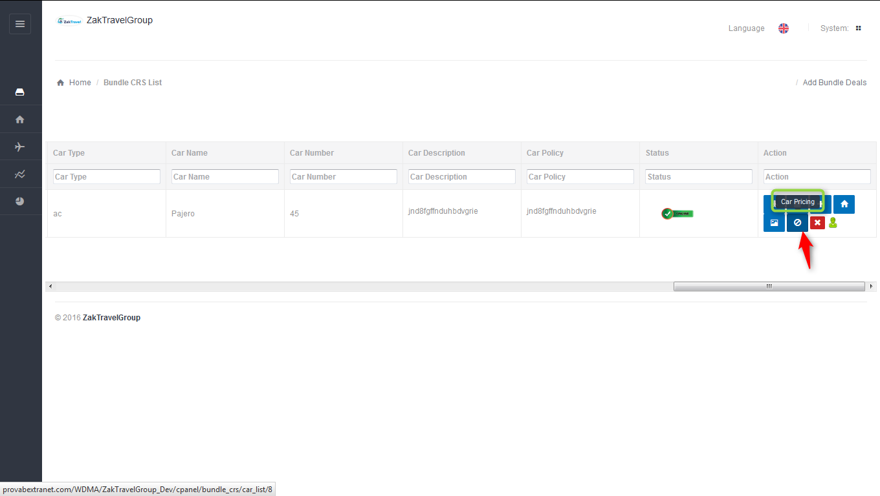

**11.4. Before adding car pricing:** Admin needs to add the car price.

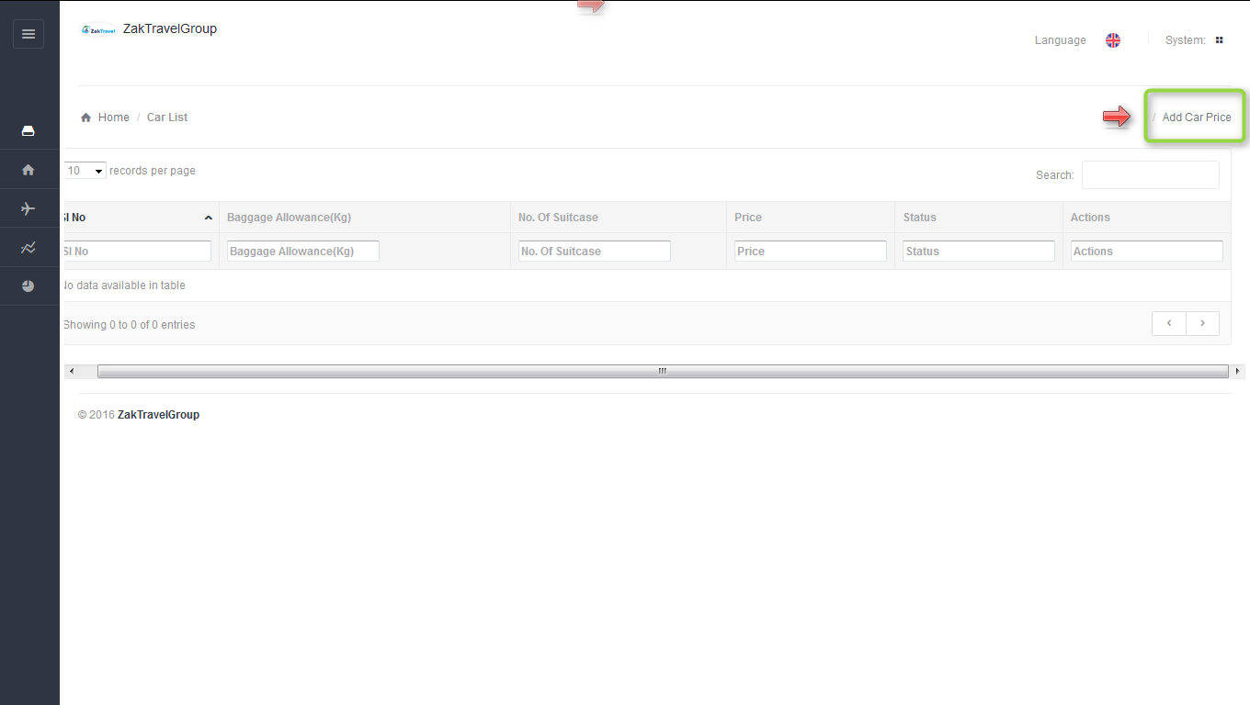

**11.5. Steps to add car price:** Click on car price and enter the adult price, number of suitcase to be carried out etc and click on add transfer detail.

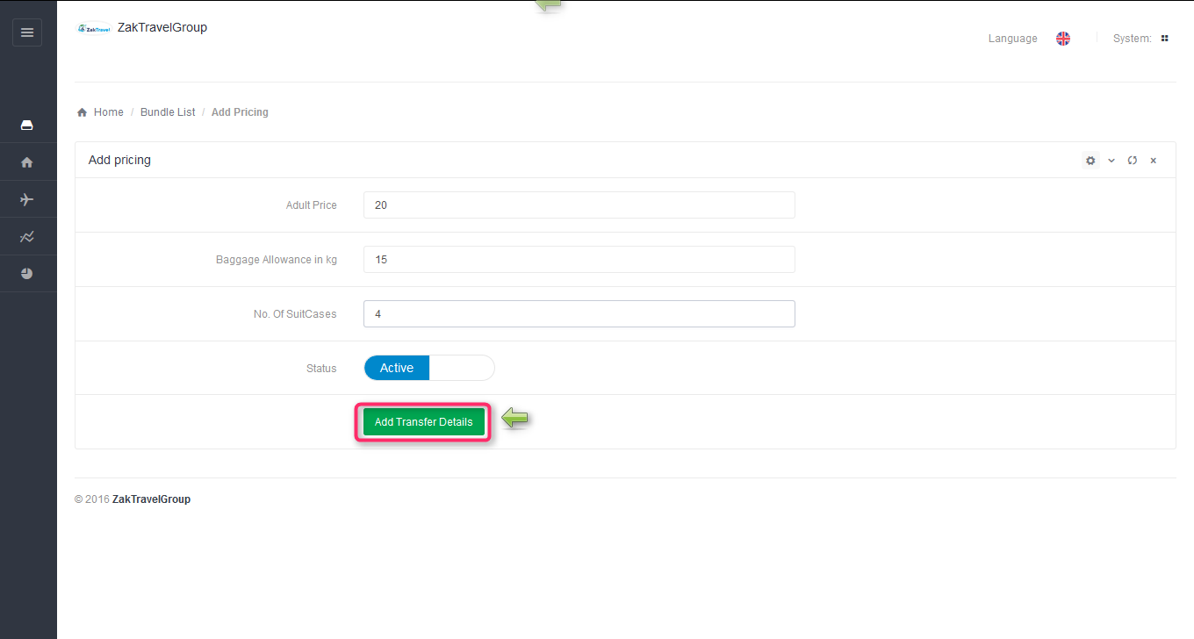

**11.6. Created bundle deal (B2B):** Now created bundle will display on the home page in best deals and click on bundle deals.

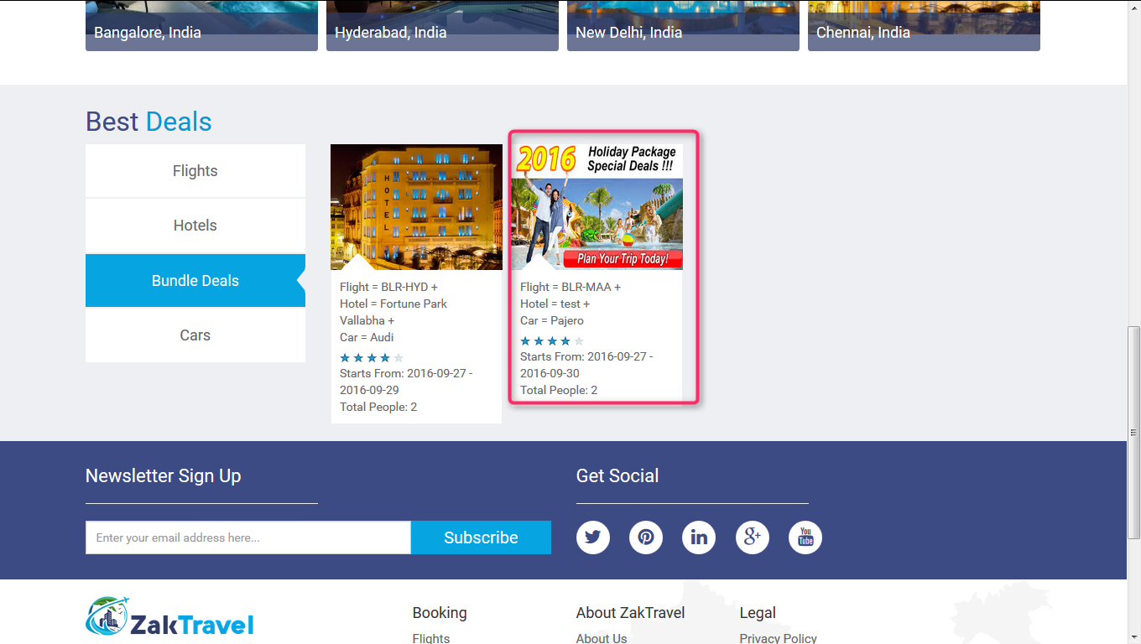

**11.7. Front End (B2B):** Created bundle will display on front end from where booking will be done.

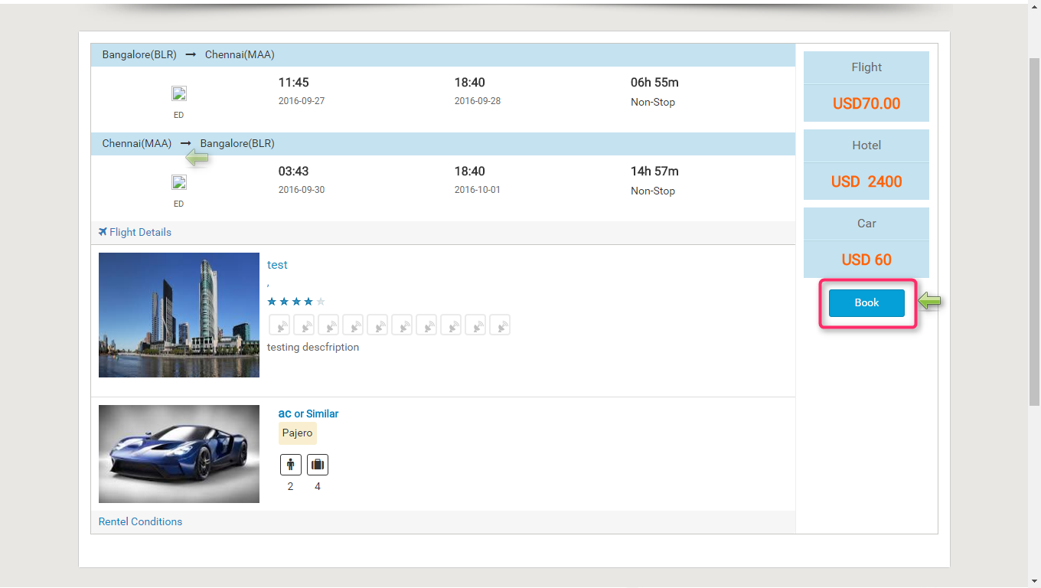

**11.8. Booking Page (B2B):** Click on bookand onthe booking page all the information which is given by the user and total amount will be present. Now click on continue voucher page will be displayed.

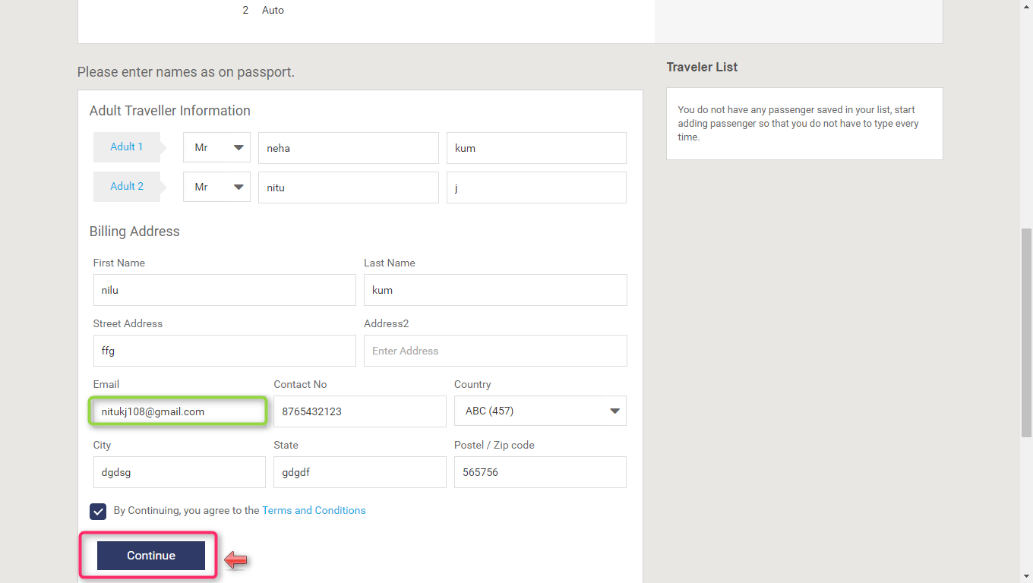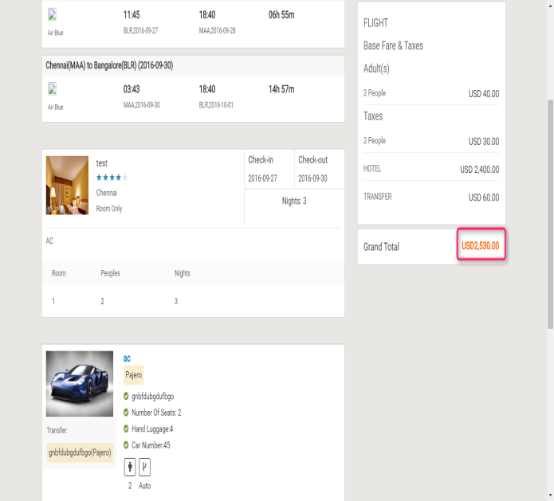

**11.9. Voucher Page (B2B):**After providing all the information and click on continue user will get confirmation letter.

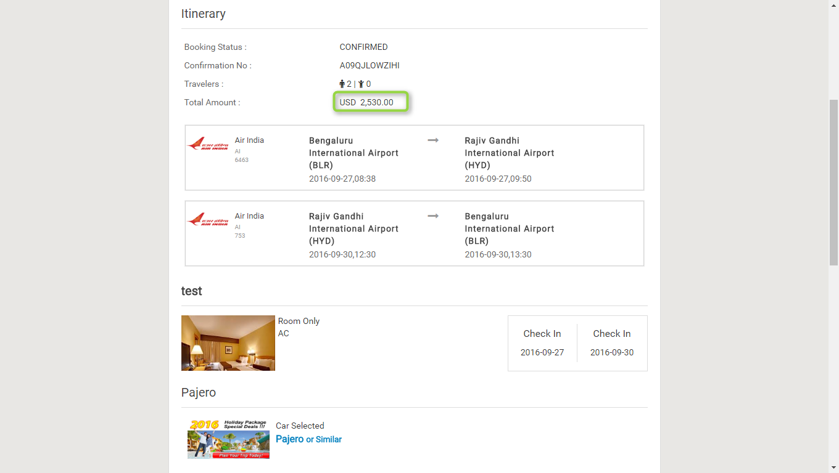

**11.9.1. MARKUP for Bundle deals (B2B)**: Markup is added by the Admin, after adding the markup from admin panel the markup will be added with total fare and display on front end.

**11.9.2. Markup for B2B Bundle deal:**

**11.9.3. Before adding the Markup for bundle Admin panel (B2B):** Markup will not display in the list before adding.

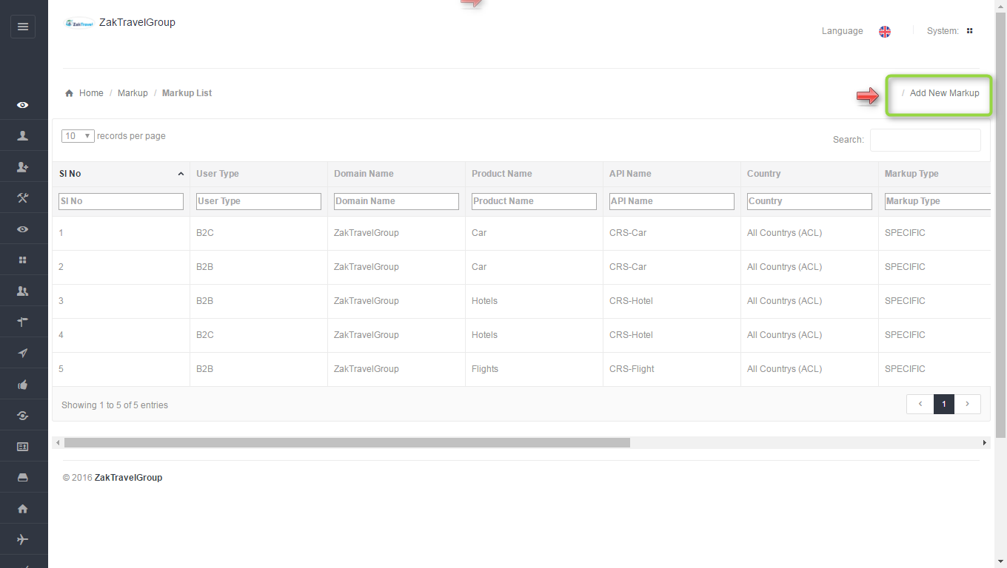

**11.9.4. Front End Without adding markup (B2B):** For a particular agentthe markup is not added with total fare so whatever the amount is added at the time of rate management that amount will be display only and total fare will display without markup.

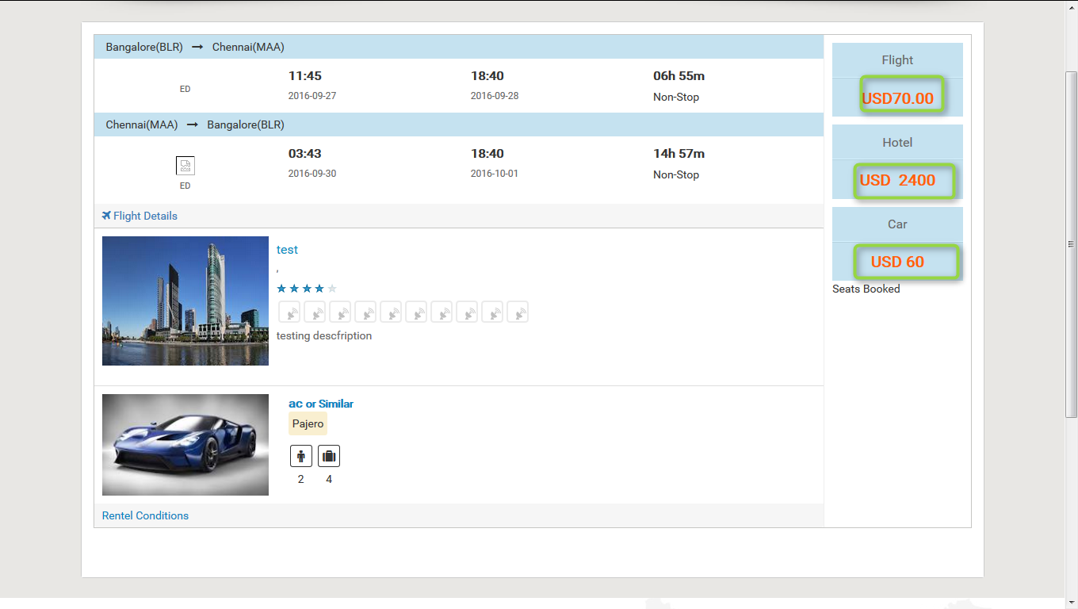

**11.9.5. Steps to add markup for bundle (B2B) Admin panel:** After click on add markup one form will be displayed and enter all the required information like user type, product, API, and markup value type, etc.

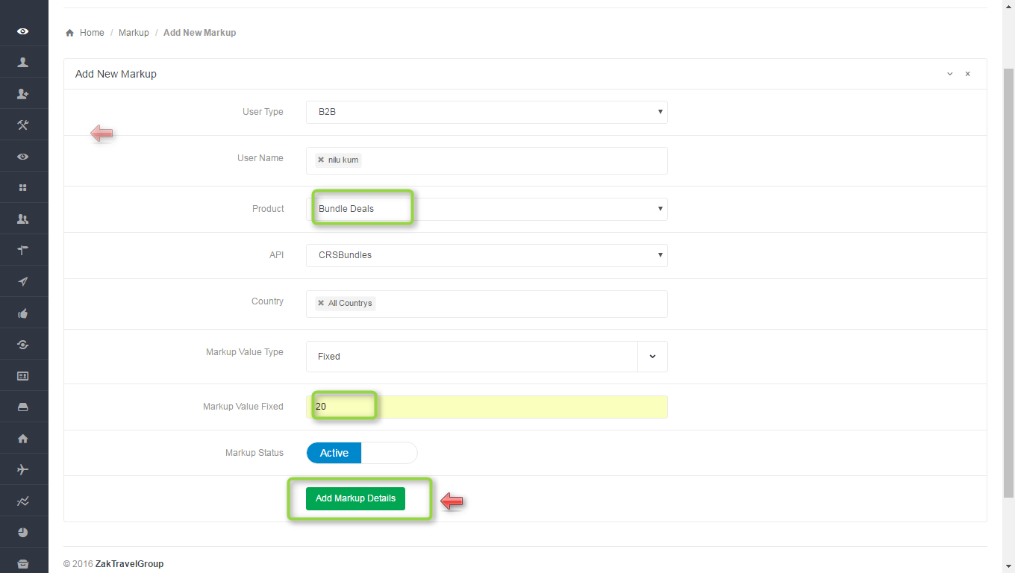

**11.9.6. Markup list admin panel for B2B**: Here admin add the markup for particular agent , select the user type as B2B , user name means for which agent admin add the markup, product as a bundle, API CRS Bundle, country and markup type. After adding the markup will display in the list.

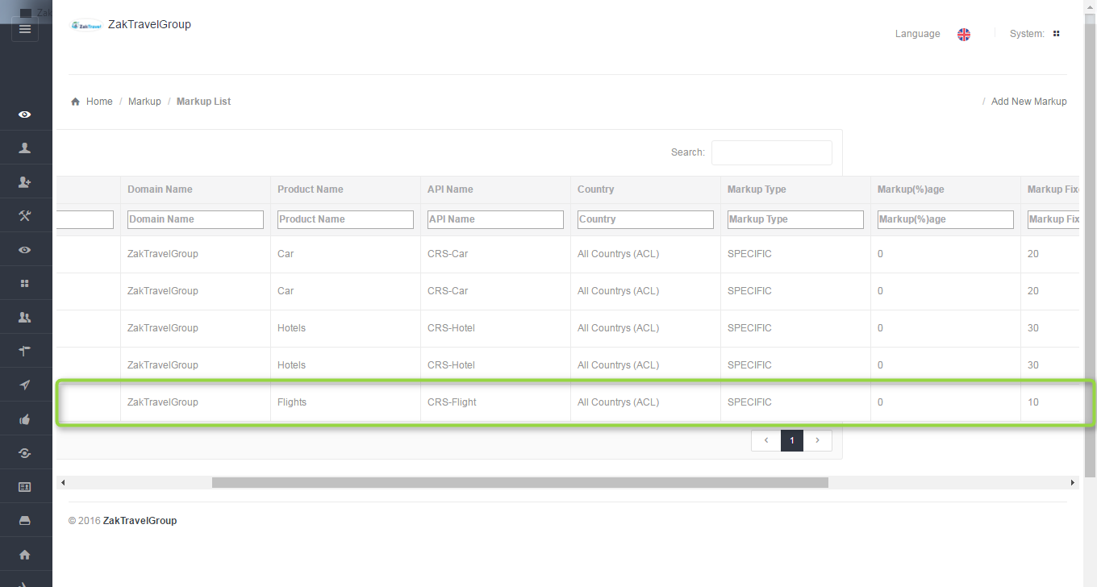

**11.9.7. Front end with Markup (B2B):** Now the added markup will be display with the total fare, for one day the markup added is 20 rupees now and markup will be added according to number of days.

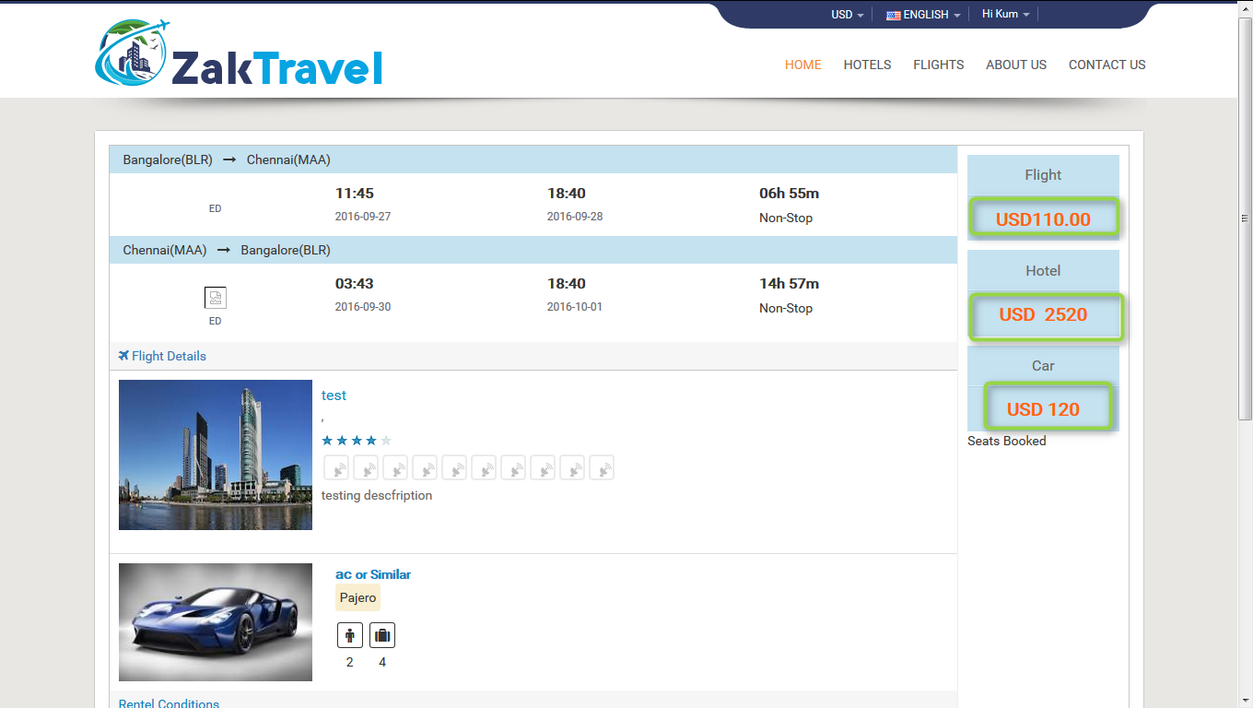

**11.9.8. Activation and Inactivation for markup (B2B):** After click on inactive the markup will not add with the total fare for adding the markup the status should be in active state.

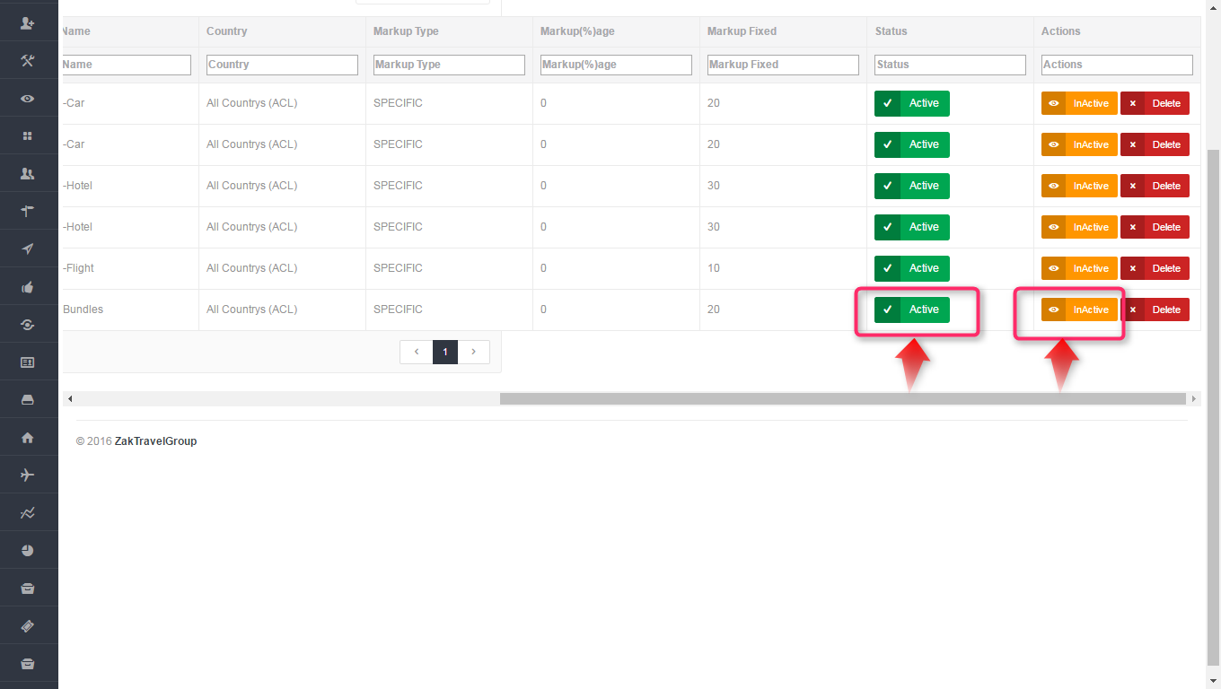

**Active Inactive**

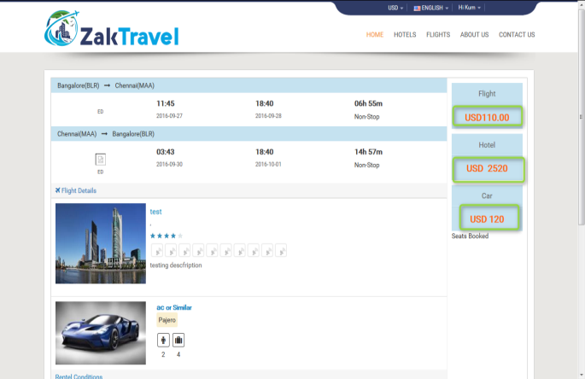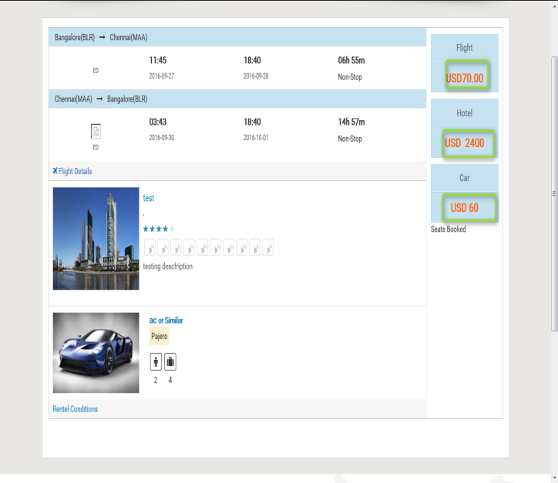

**12.(Flight Hotel) :** Admin can  add bundles they need to provide all the information  like city name, departure and return date , trip type, and all the details about bundle (Flight Hotel) , need to Activate the bundle and the added bundles will display on front end. After deactivating the deals it will not be display on the front end.

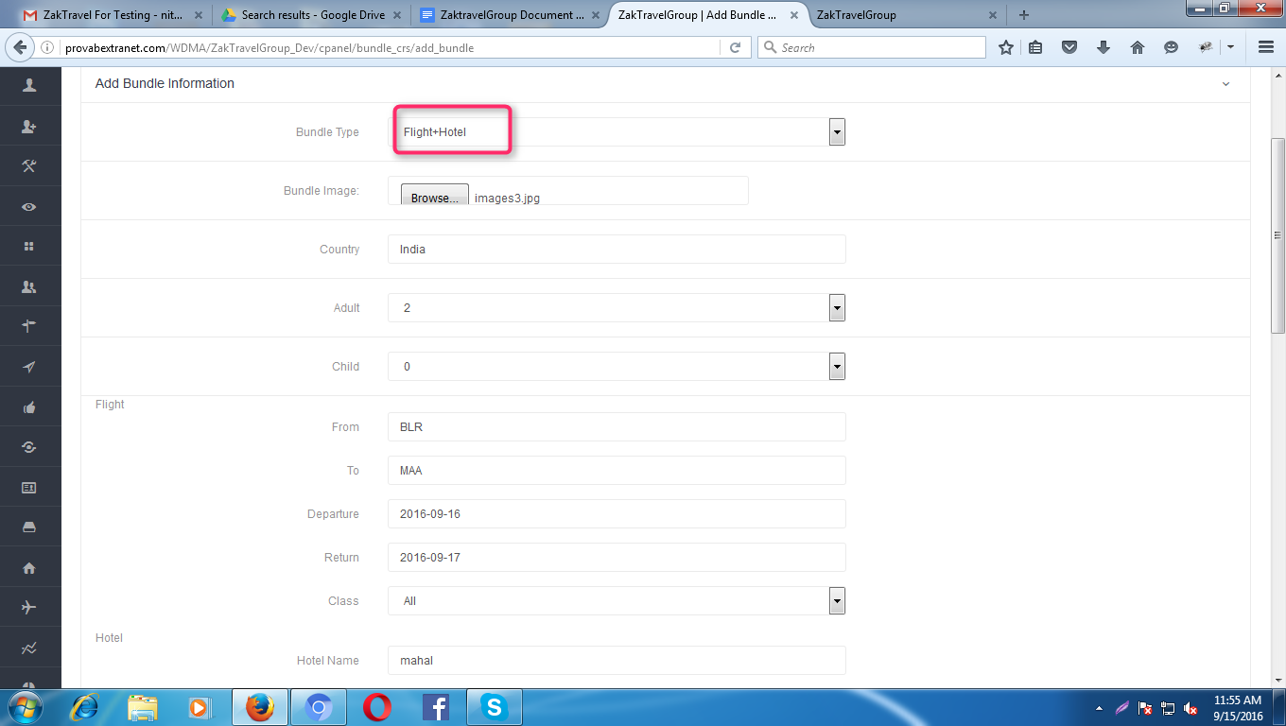

**12.1. Flight segment Management:**  Add the flight segment like flight name, city, and time etc for both onward and return.

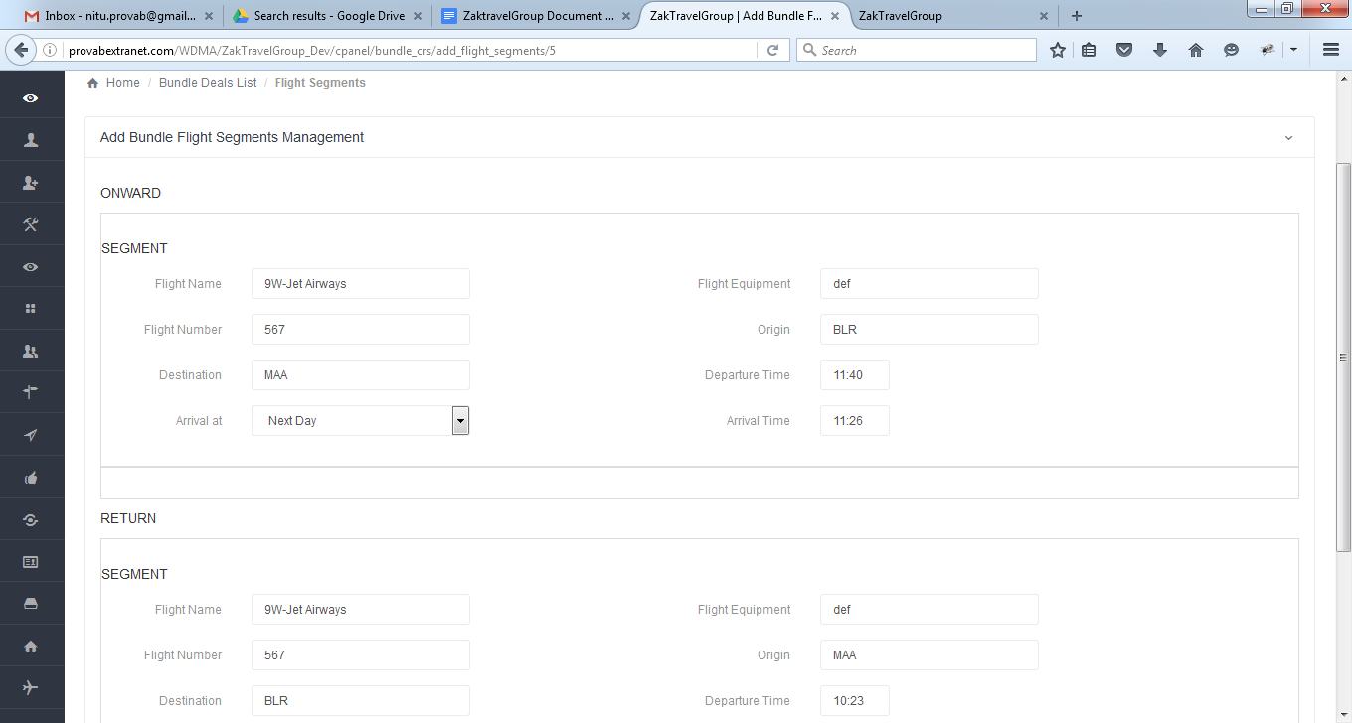

**12.2. Add Bundle Flight Price Management:** In price management need to add the price for adult, Child, infant with tax.

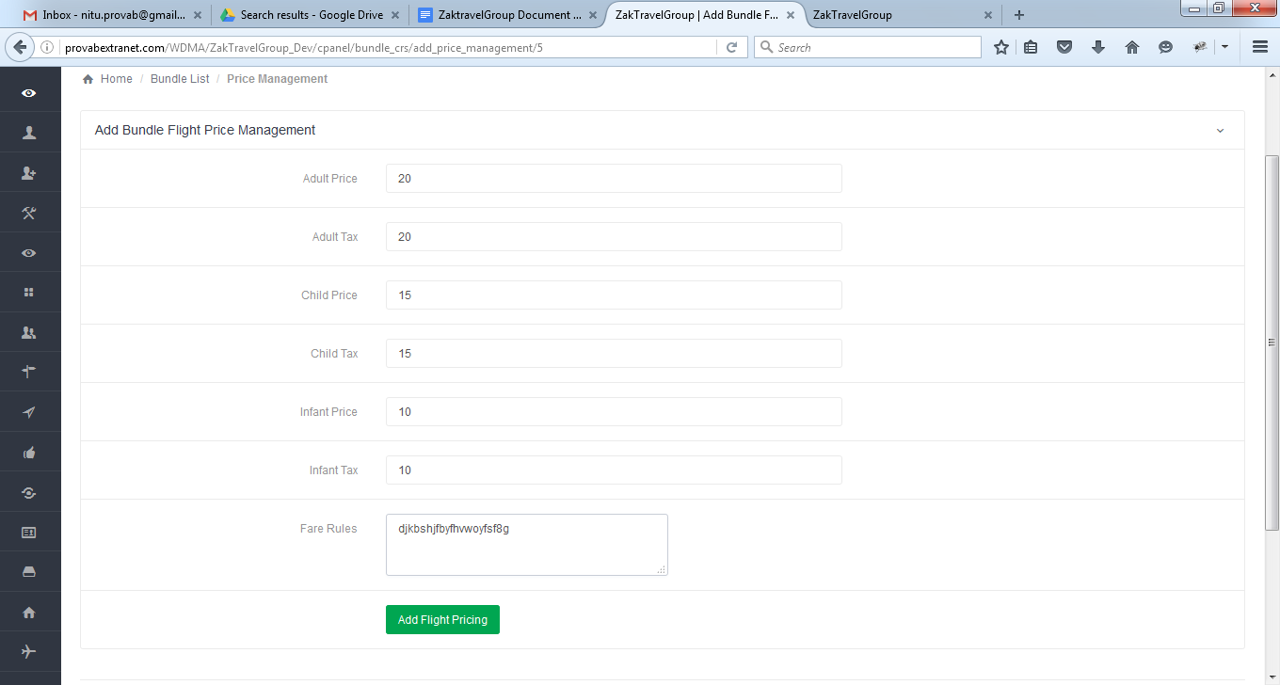

**12.3. Add/View Room type:** Need to add the room type and number of customers.

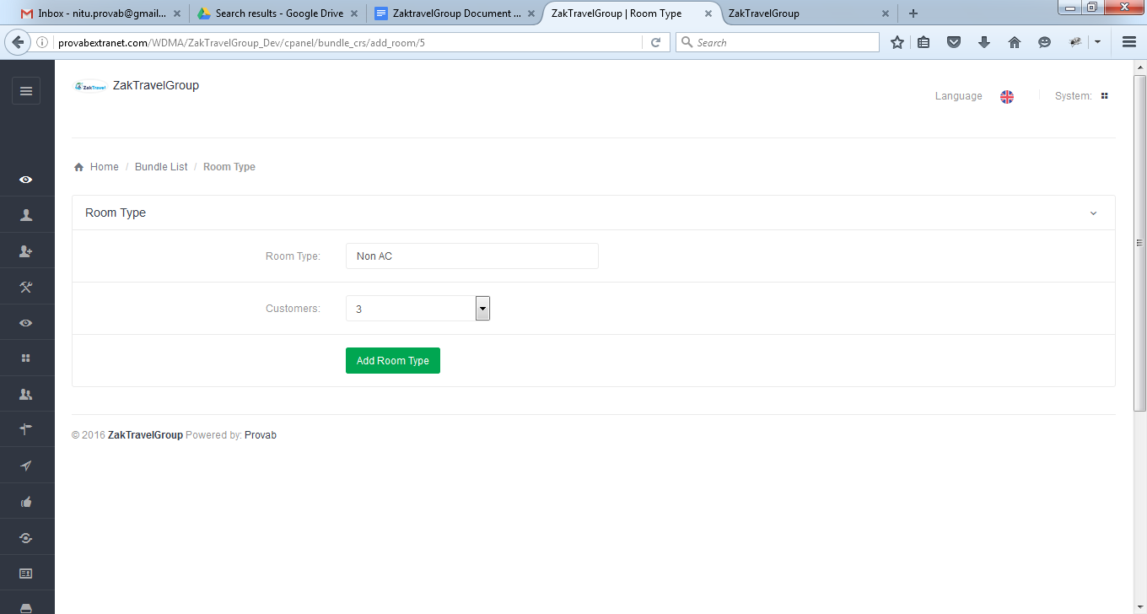

**12.4. Room Management (Add New Room):** In room management add new rooms and hotel price and hotel name will be pre populated because the hotel name is already provided while adding bundle information.

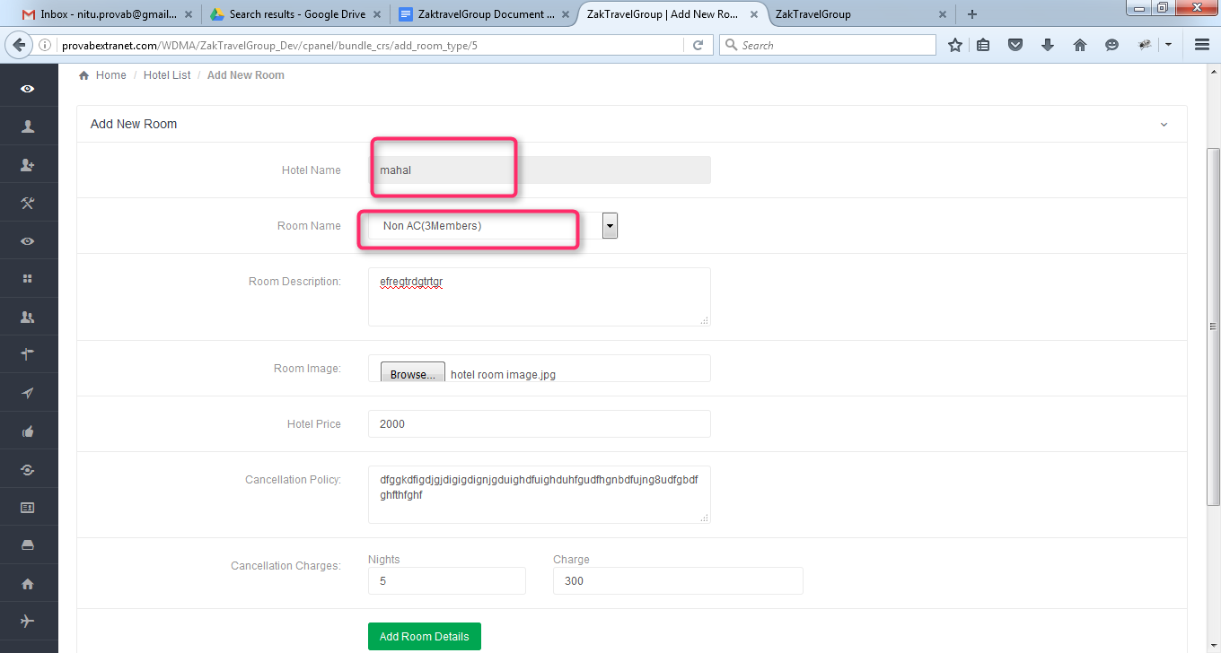

**12.5. Gallery management:** In the gallery management add hotel image and need to upload the same image.

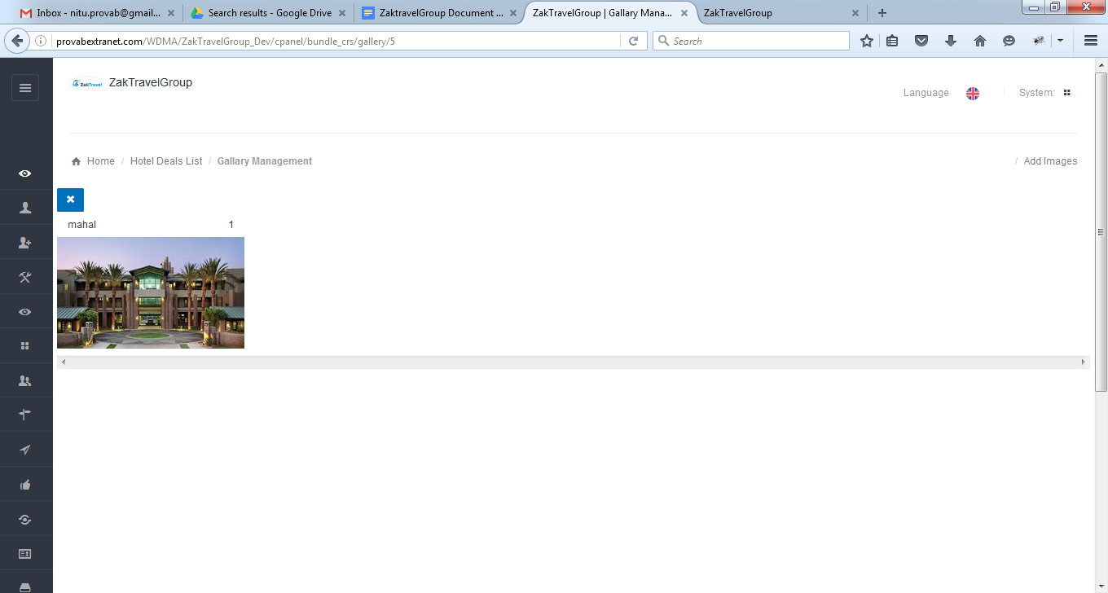

**12.6. Created bundle deals:**

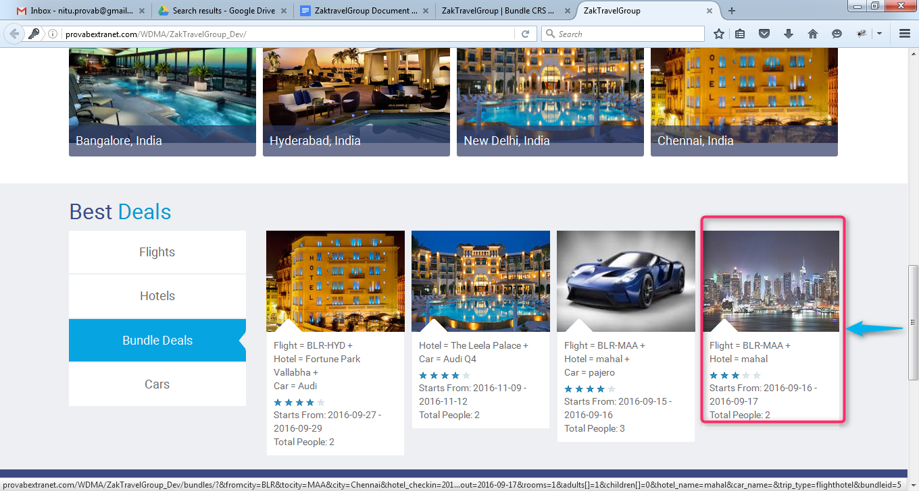

**12.7. Front End:** Created bundle will display on front end from where booking will be done.

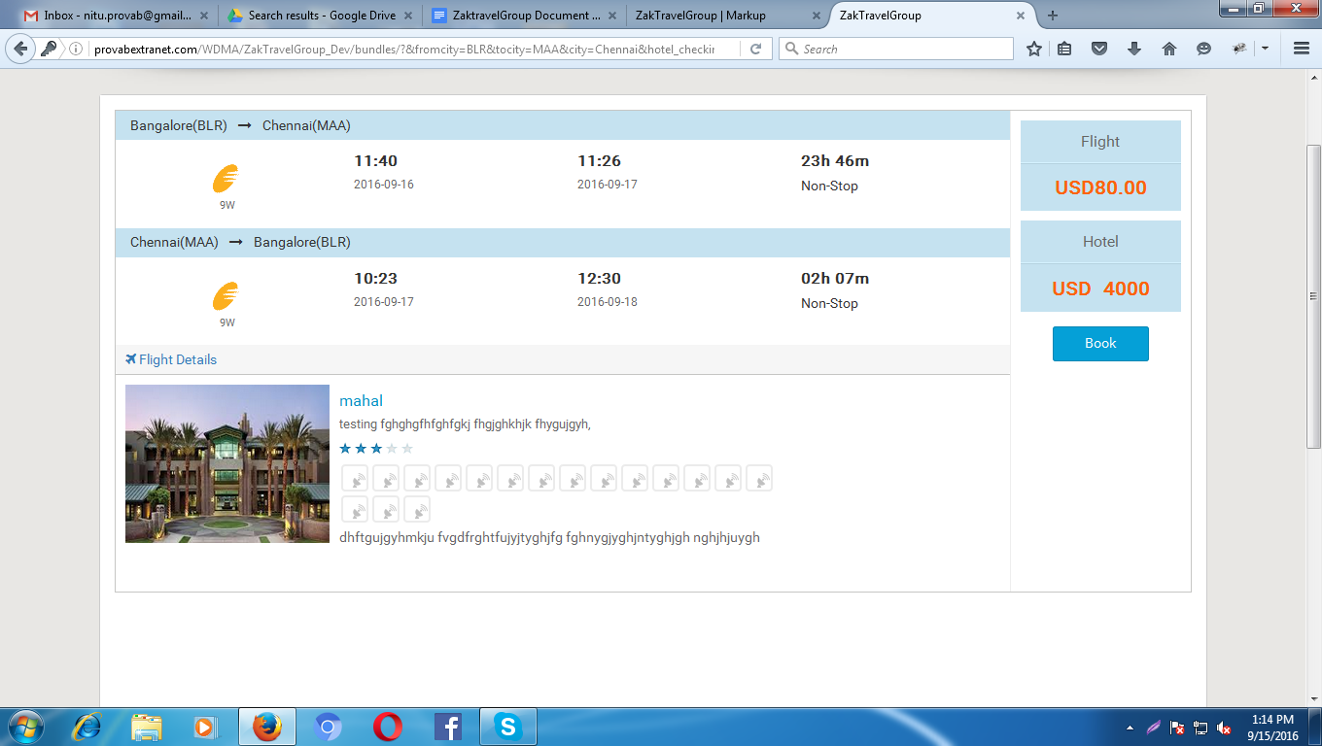

**12.8. Booking Page:** On the booking page all the information which is given by the user and total amount will be present.

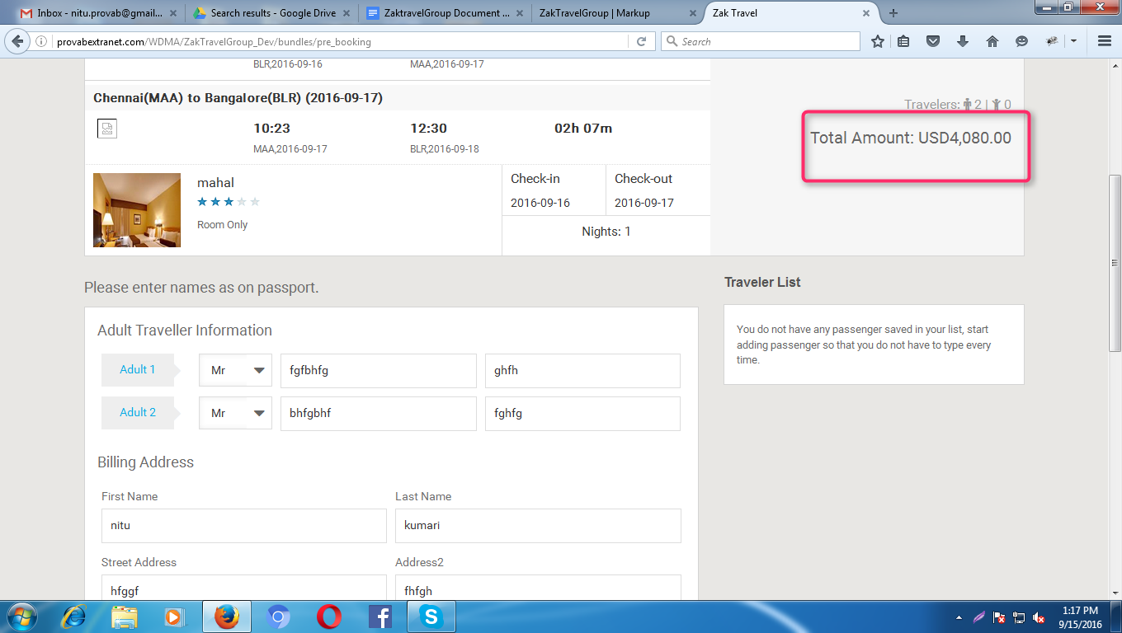

**12.9. Voucher Page:**After providing all the information and click on continue user will get confirmation letter.

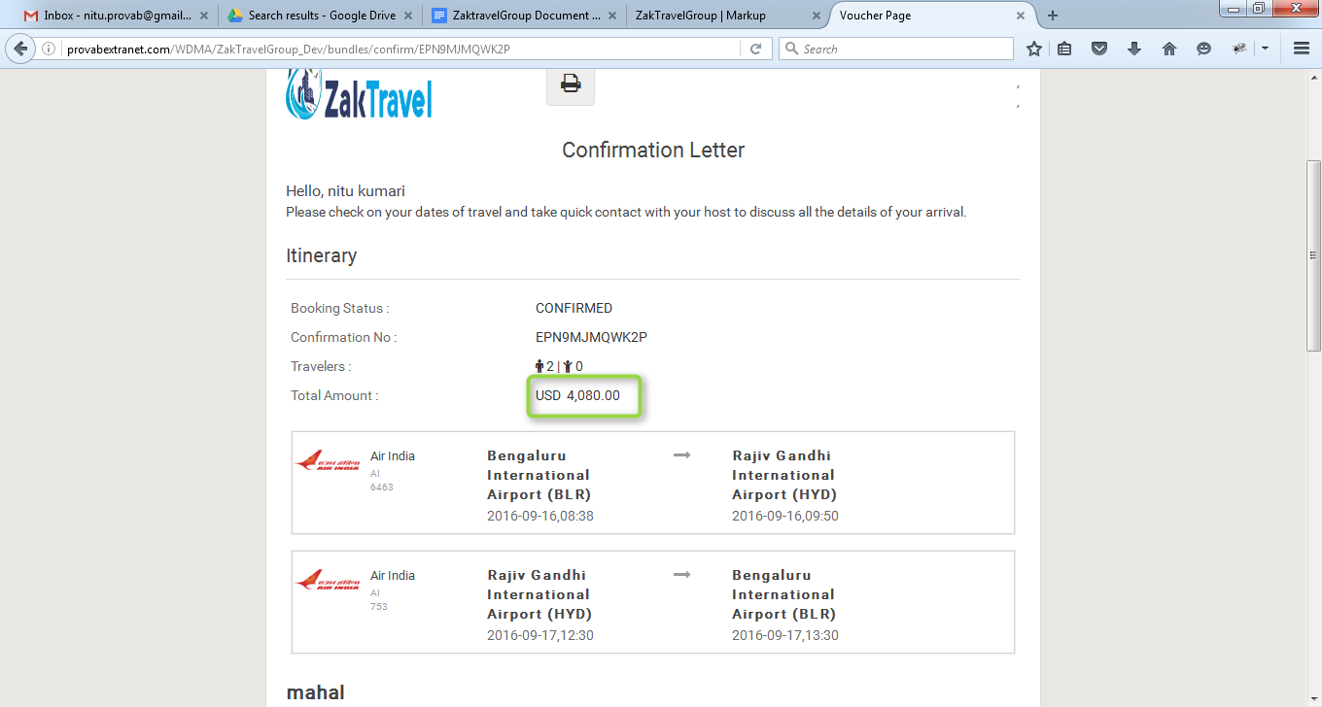

**12.9.1. Without Markup Bundle deals (B2B), (Hotel Flight):** Markup is not added with total fare so whatever the amount is added at the time of rate management that amount will be display only and total fare will display without markup.

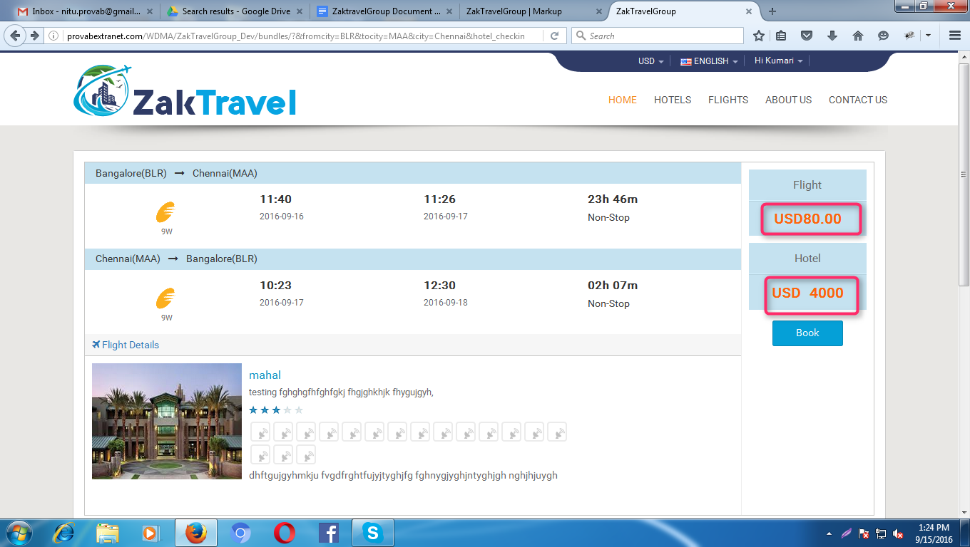

**12.9.2. Add Markup from Admin panel for bundle deals (B2B):** Add the markup from admin panel and the added markup will be displayed in the list.

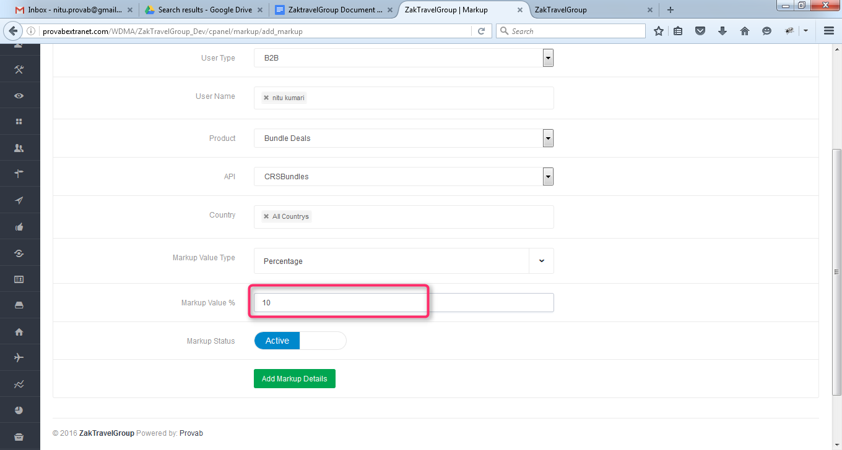

**12.9.3. With Markup Bundle deals (B2B), (Hotel Flight):** Now the added markup will be display with the total fare and markup will be added according to number of days.

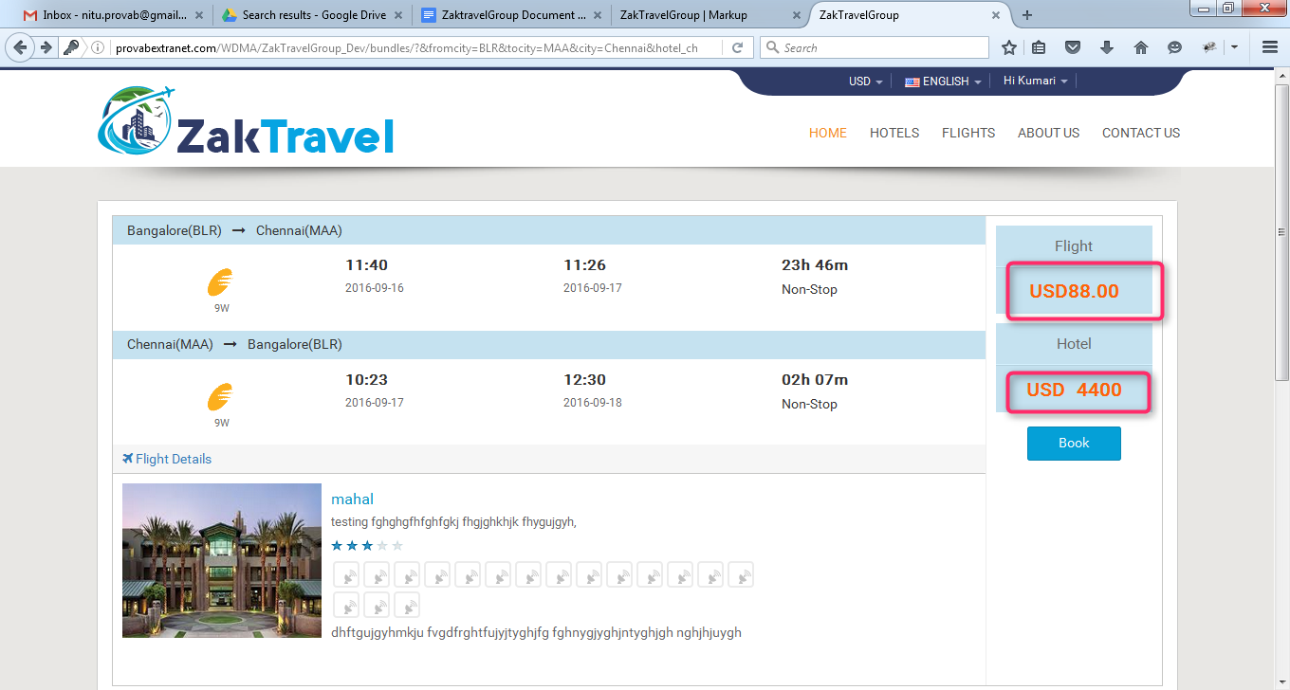

**13.(Hotel Car) :** Admin can  add bundles they need to provide all the information  like city name, departure and return date , trip type, and all the details about bundle (Car Hotel) , need to Activate the bundle and the added bundles will display on front end. After deactivating the deals it will not be display on the front end.

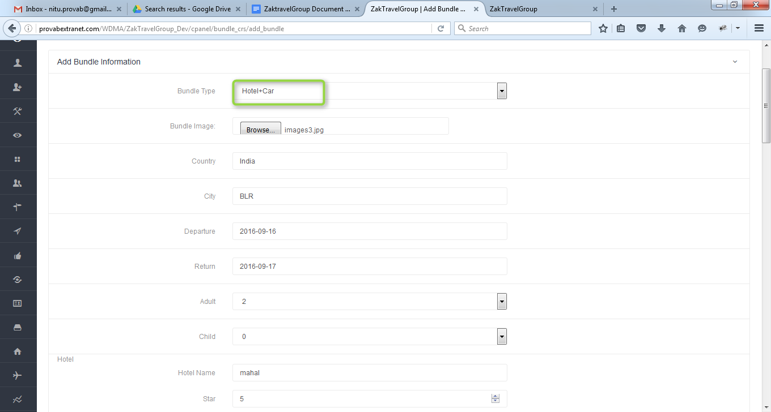

**13.1. Add/View Room type:** Need to add the room type and number of customers.

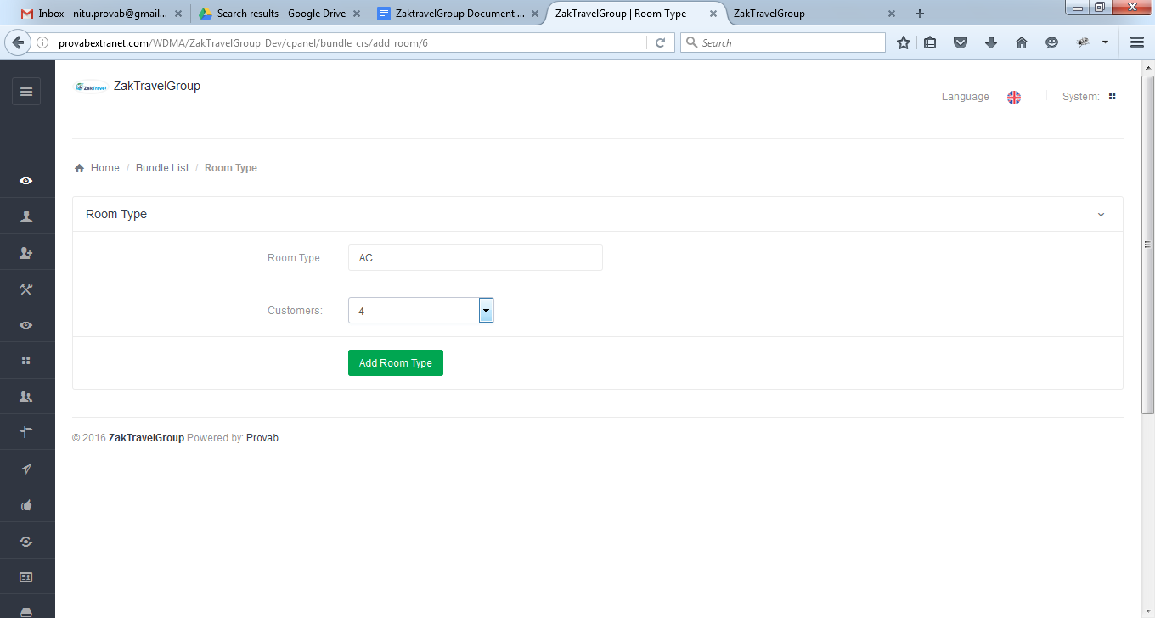

**13.2. Room Management (Add New Room):** In room management add new rooms and hotel price and hotel name will be pre populated because the hotel name is already provided while adding bundle information.

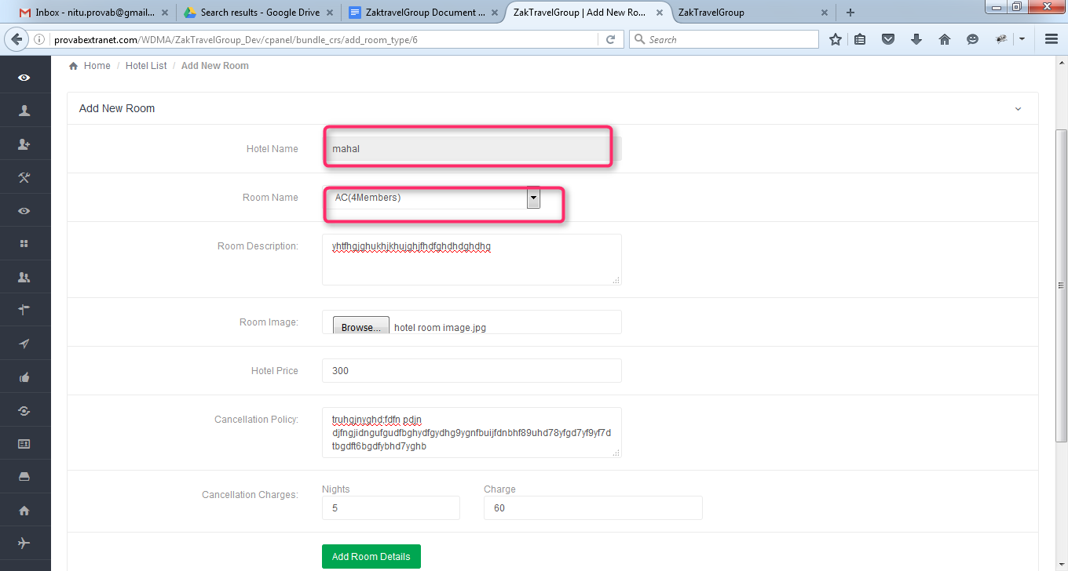

**13.3. Gallery management:** In the gallery management add hotel image and need to upload the same image.

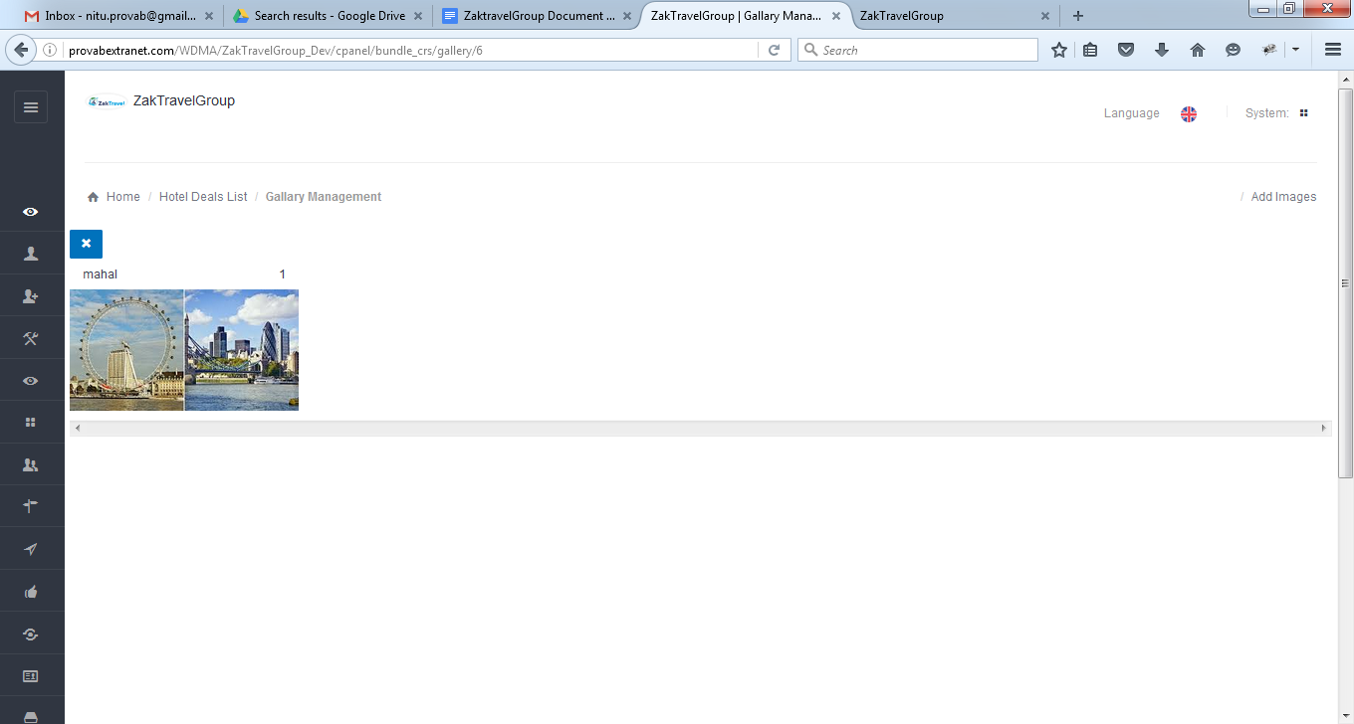

**13.4. Car Pricing:** Here need to add the adult price for the car with Baggage Allowance in kg and how many Suitcases should be carried .And the car will display in the list.

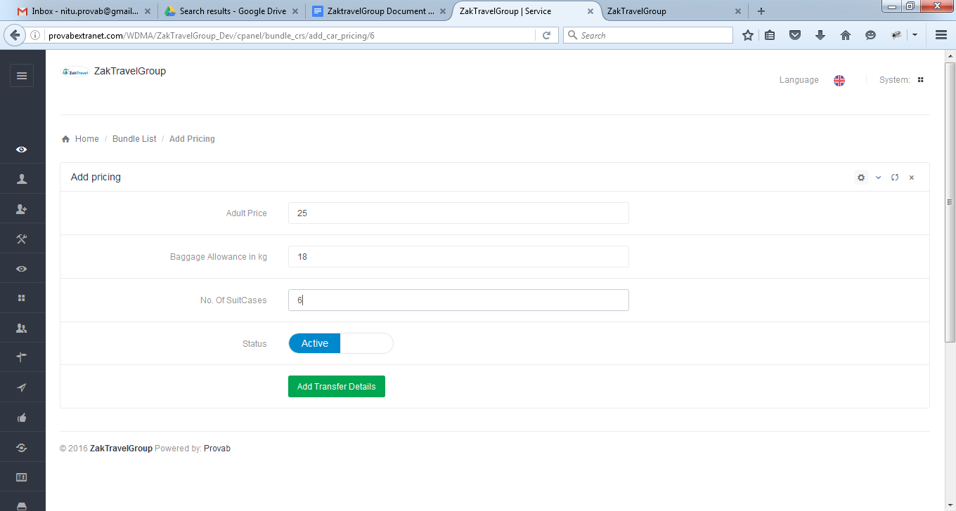

**13.5. Created bundle deals (Hotel Car)**

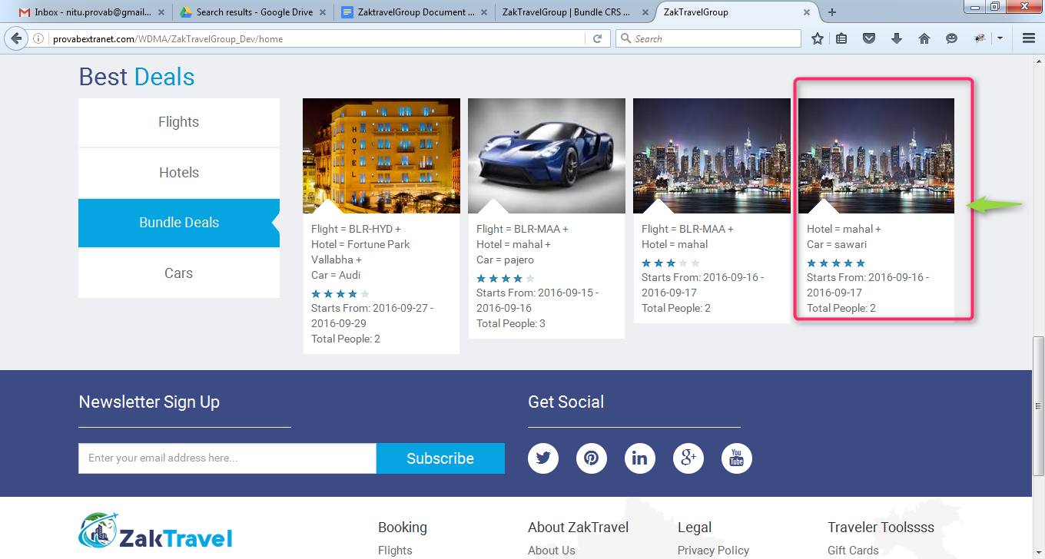

**13.6. Front End:** Created bundle will display on front end from where booking will be done.

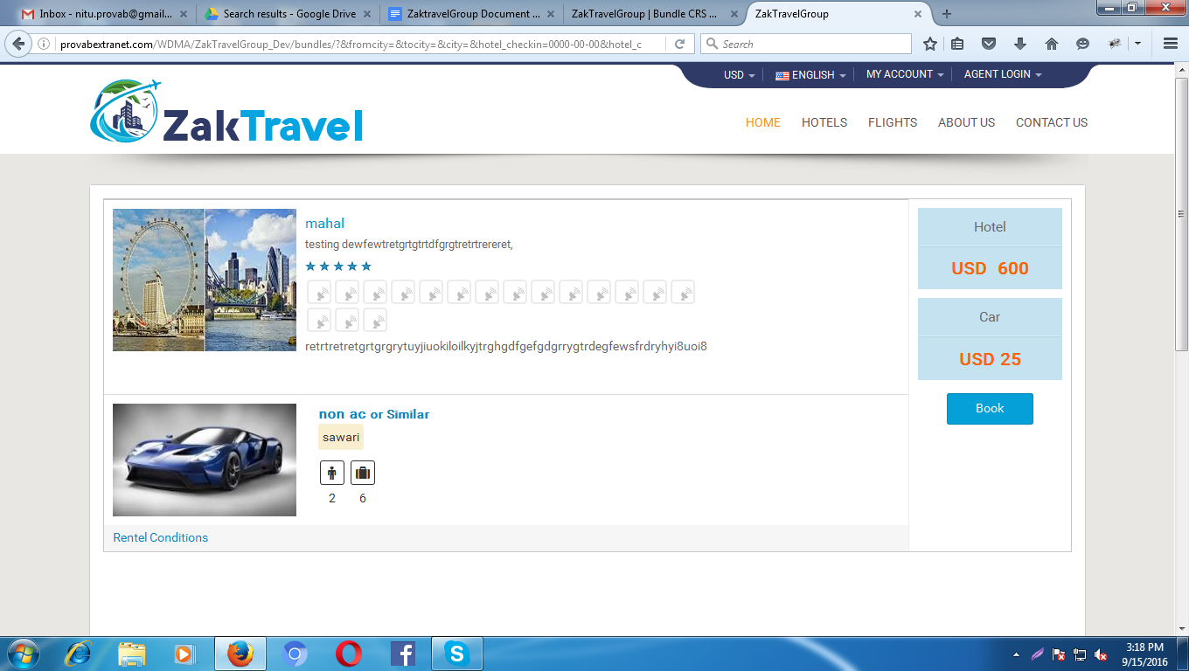

**13.7. Booking Page:** On the booking page all the information which is given by the user and total amount will be present.

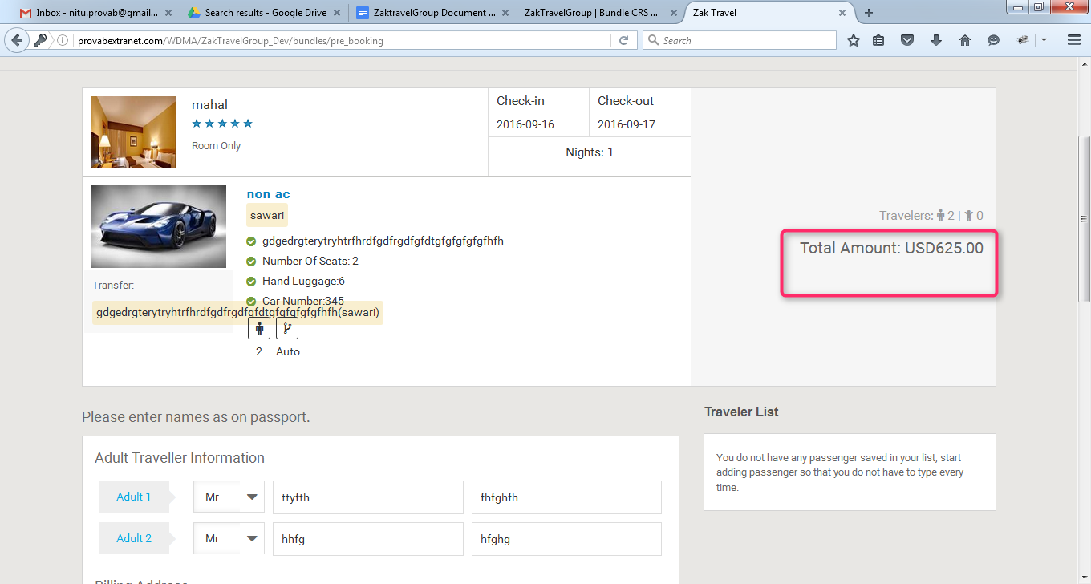

**13.8. Voucher Page:**After providing all the information and click on continue user will get confirmation letter.

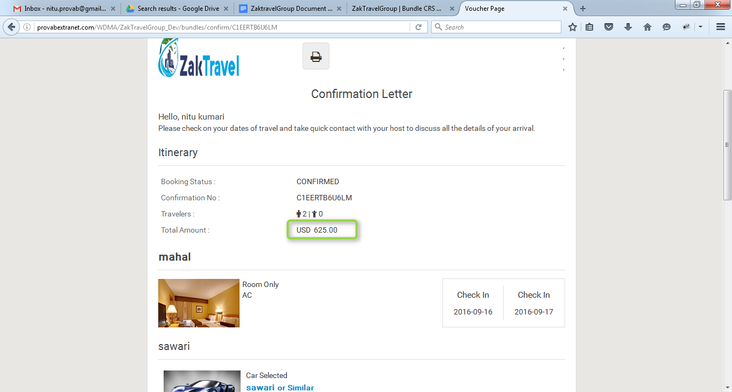

**13.9**. **Without Markup Bundle deals (B2B), (Hotel Car):** Markup is not added with total fare so whatever the amount is added at the time of rate management that amount will be display only and total fare will display without markup.

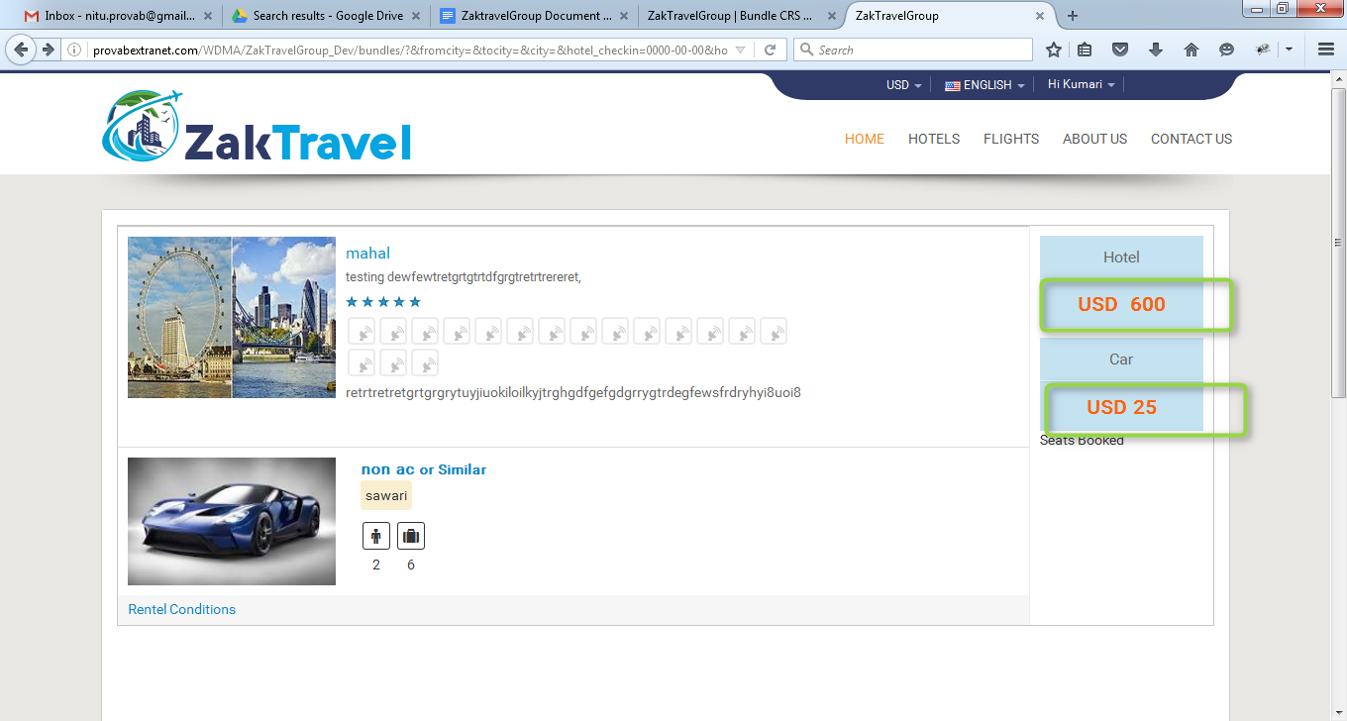

**13.9.1. Add Markup from Admin panel for bundle deals (B2B):** Add the markup from admin panel and the added markup will be displayed in the list.

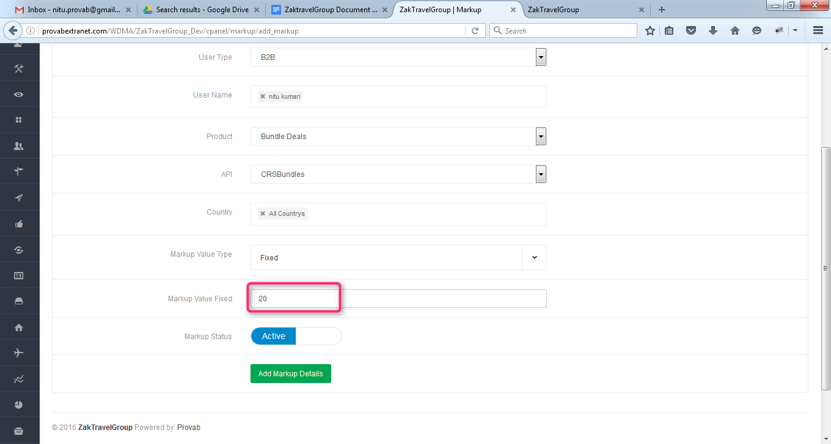

**13.9.2. With Markup Bundle deals (B2B), (Hotel Car):** Now the added markup will be display with the total fare and markup will be added according to number of days.

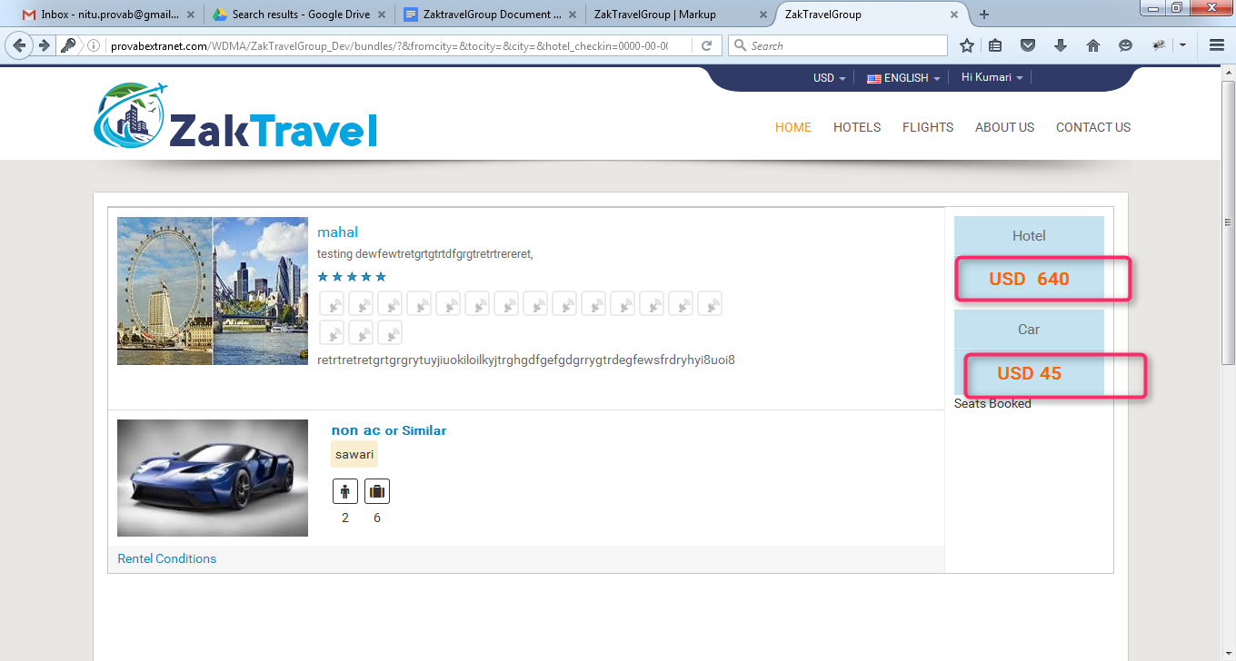

**14. BOOKINGS (Agent dashboard):** Here agent can see how many bookings have been done for flight, car, hotel, and bundle and over all booking, conformed booking, cancel booking and Failed / Pending / Hold etc.

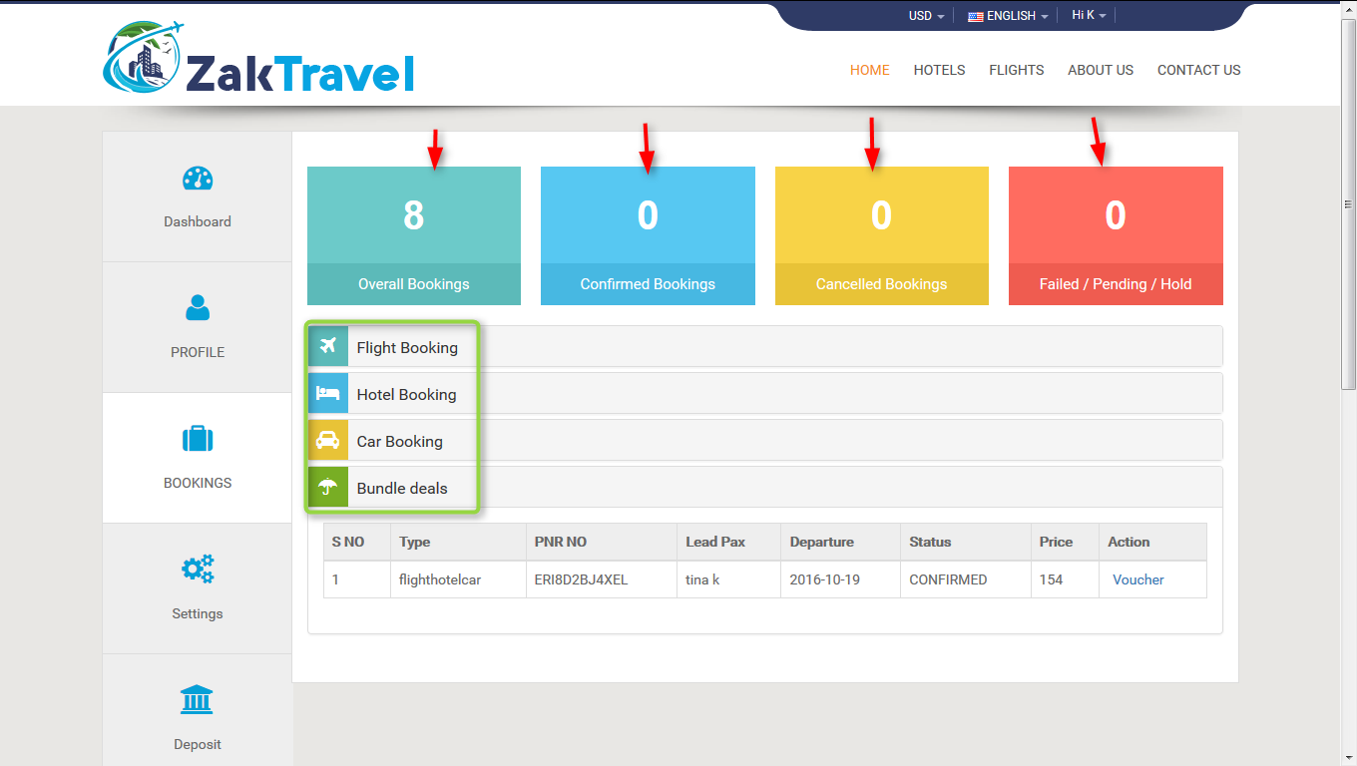

**14.1. Check flight booking:** After click on flight booking it will display how many booking have been done.

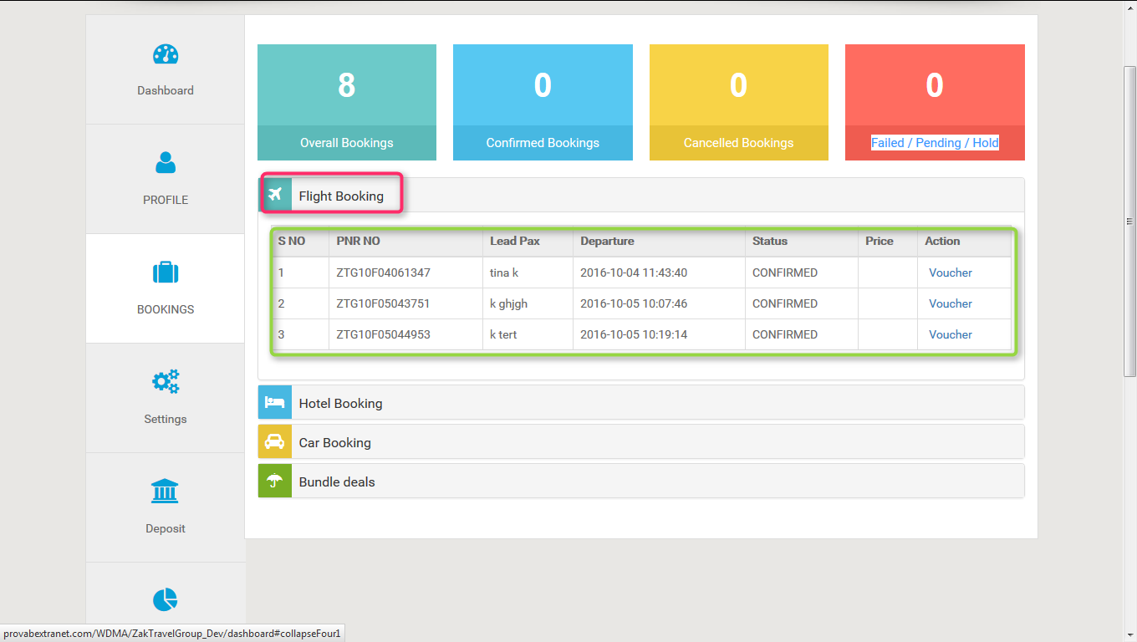

**14.2. Check hotel booking:** After click on hotel booking it will display how many booking have been done.

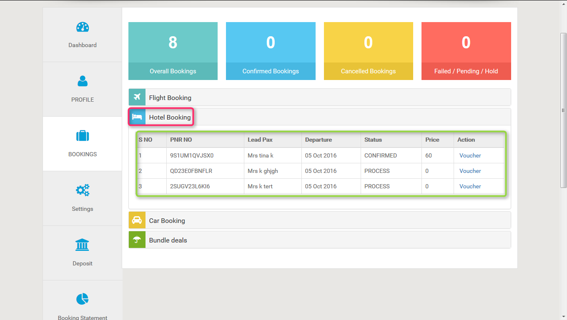

**15. White label:** White label to set up domain. From control panel agent can manage all the white label things, for that they should have to create his domain in here Settings-> setup domain

1) Temporary update gives the option to the agent to view the changes made by them clicking the preview.

2) Permanent update will make the site live.

3) Once the Domain is setup it will run under the host website (parent website)

http://host/whitelabel/home/agent_domain_name

The Home Page will be look like this.

4) The agent can manage the white label from his dashboard-> Control Panel

Control panel gives the option to view the B2B2B users, B2B2C users, B2B2B deposit and the bookings made by them.

<http://host/whitelabel/home/agent_domain_name>.

**Note:** More explanation about white label will be later at the time of B2B2B, B2B2C.

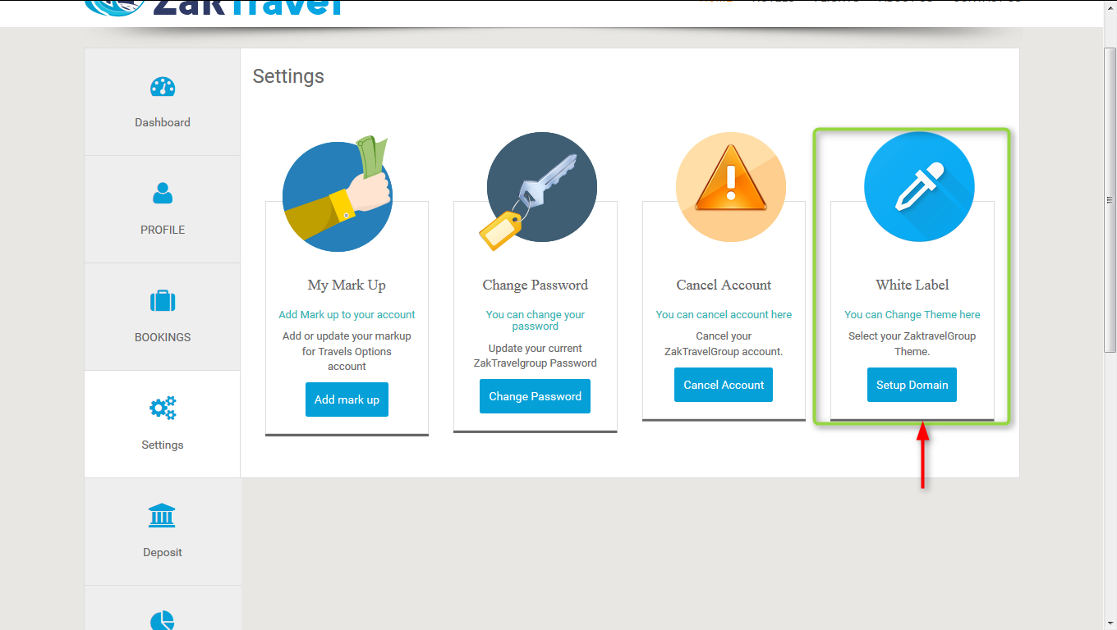

Now click on setup domain, white label information page will be opened.

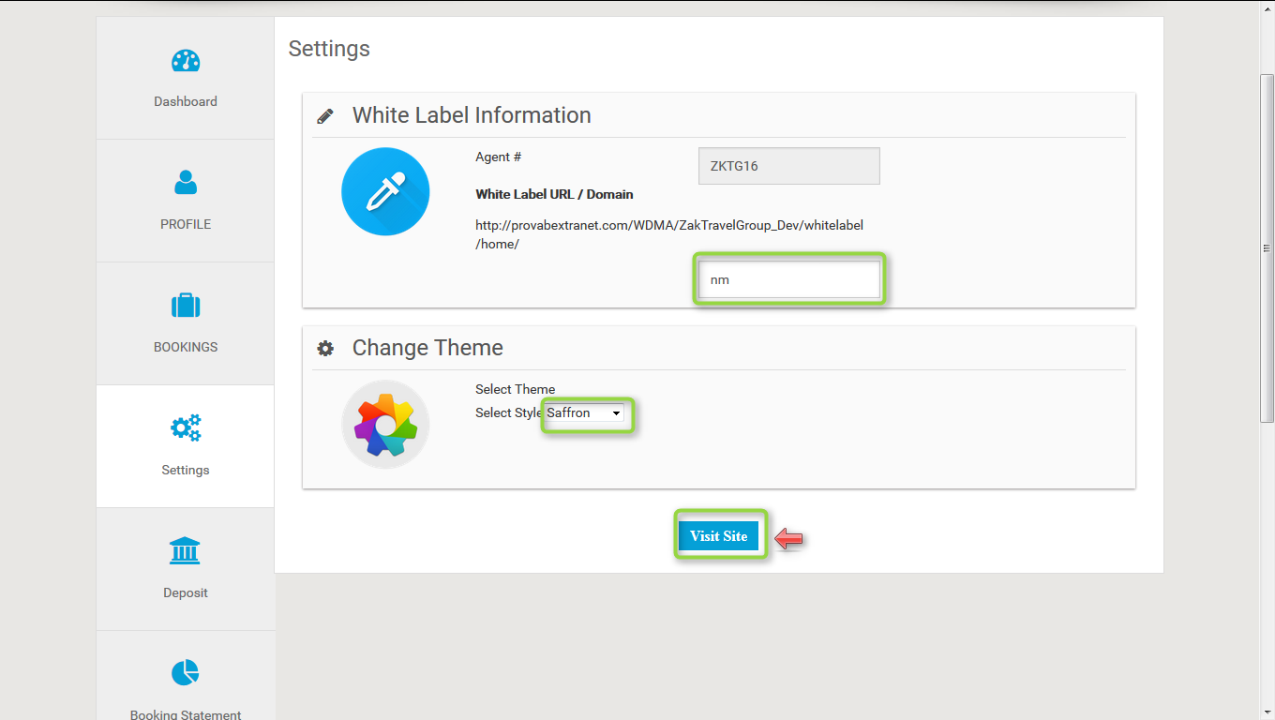

After that click on visit site it will display other Home Page and that will be look like this, from where B2B2B and B2B2C will be created.

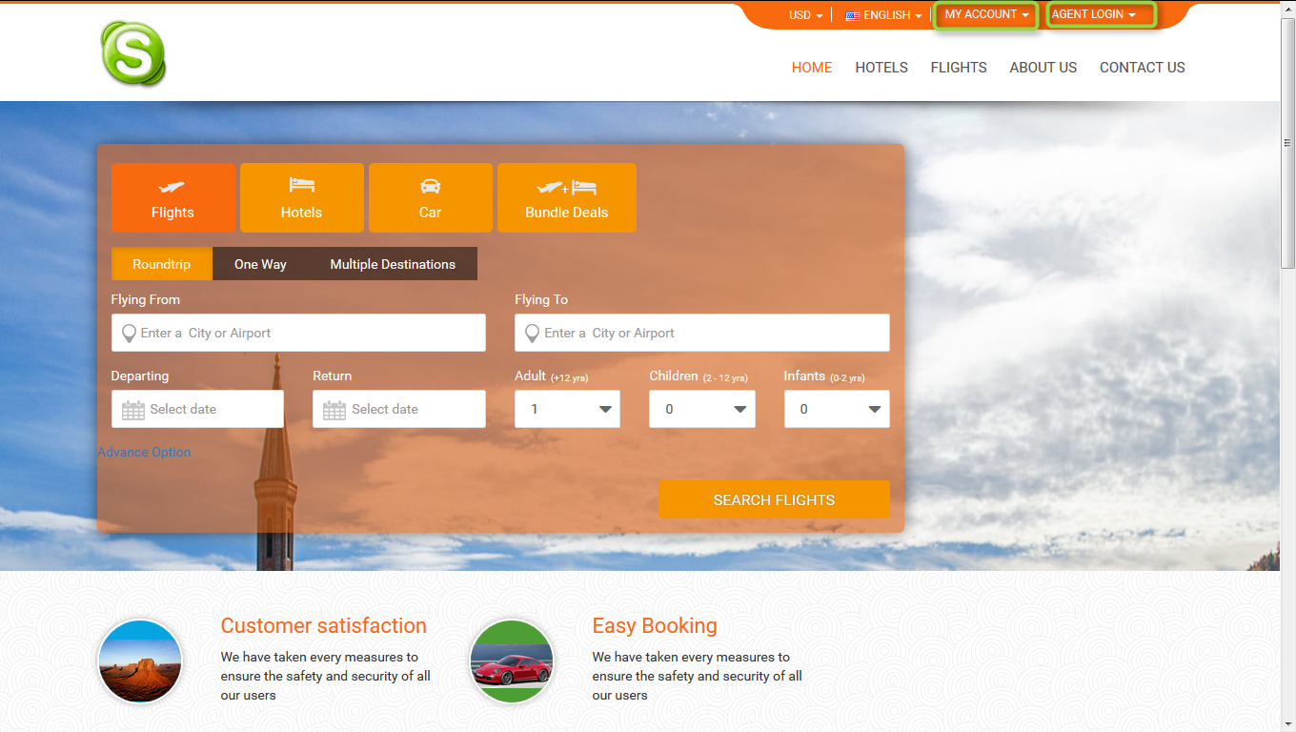

**16. Booking Statement:** In theBooking Statement agent can see how many booking has been done by them and the statement displayed serial number, PNR number, leadpax, Voucher Date, Transaction Status, Booking status, price and b2b profit.

